Sheet reference | BDC2022/Deep-sea_Sponge_Aggregations_OSPAR
Area Assessed | OSPAR Regions where the habitat occurs: I, II, IV, V [NB: case report refers to region III but there is no evidence of the habitat occurring in this region]  OSPAR Regions where species is under threat and/or decline: all regions where the habitat occurs
Title | Status Assessment 2022 - Deep-sea sponge aggregations
Key message | Deep-sea sponge aggregations are assessed as being in poor condition in Arctic Waters (Region I), Greater North Sea (Region II), Celtic Seas (Region III), bay of Biscay and the Iberian Coast (Region VI) and the Wider Atlantic (Region V) on account of their high vulnerability to, and slow recovery from, fishing impacts, which continue to occur throughout the habitat range. Knowledge on their distribution, extent, and condition has increased since the last assessment.  Explanation to table:  Distribution, Population size, Condition  Trends in status (since the assessment in the background document)  ↓ decreasing trend or deterioration of the criterion assessed  ↑ increasing trend or improvement in the criterion assessed  ←→ no change observed in the criterion assessed  ? trend unknown in the criterion assessed  Previous status assessment: if QSR 2010 then entry Regions where species occurs ( ○) and has been recognised by OSPAR to be threatened and/or declining (●) based on Chapter 10 Table 10.1 and Table 10.2. If a more recent status assessment is available, then enter ‘poor’/’good’  Status*(overall assessment)  red – poor  green – good  ? - status unknown.  NA - Not Applicable  *applied to assessments of status of the feature or of a criterion, as defined by the assessment values used in the QSR 2023 or by expert judgement.  Types of assessment:  1 – direct data driven,  2 – indirect data driven,  3 – third party assessment close-geographic match,  4 - third party assessment partial-geographic match  5 – expert judgement.  (Use more than one number when mixed methods were used)  Explanation to table:  Key Pressure  ↓ key pressures and human activities reducing  ↑ key pressures and human activities increasing  ←→ no change in key pressures and human activities  ? Change in pressure and human activities uncertain  Threats or impacts (overall assessment)  red – significant threat or impact;  green –no evidence of a significant threat or impact  Blue cells – insufficient information available  Types of assessment:  1 – direct data driven,  2 – indirect data driven,  3 – third party assessment close-geographic match,  4 - third party assessment partial-geographic match  5 – expert judgement.
  Assessment of status |  | Distribution | Extent | Condition | Previous OSPAR status assessment | Status (overall assessment)
  Region | I | ←→^{1,5} | ? ^{3,5} | ↓^{3,5} | ● | poor
  Region | II | ←→^{1,5} | ? ^{3,5} | ↓^{1,3,5} | ● | poor
  Region | III | N/A | N/A | N/A | N/A | N/A
  Region | IV | ←→^{1,5} | ? ^{3,5} | ↓^{3,5} | ● | poor
  Region | V | ←→^{1,5} | ? ^{3,5} | ↓^{3,5} | ● | poor
  Assessment of threats |  | Fishing | Climate change | Threat or impact
  Regions | I | ←→^{1,5} | ?^{3,5} | ←→⁵
  Regions | II | ↓^{1,5} | ?^{3,5} | ↓⁵
  Regions | III |  |  | N/A
  Regions | IV | ↑^{1,5} | ?^{3,5} | ↑⁵
  Regions | V | ←→^{1,5} | ?^{3,5} | ←→⁵
Confidence | Overall, there is medium confidence in the assessment.  There is high confidence on the overall distribution of the habitat across the OSPAR Maritime Area, but medium confidence within the various Regions, particularly where surveying and mapping efforts are fewer. There is low confidence on habitat extent (currently largely derived from species distribution models), due to the small geographical scales at which most surveys are conducted; confidence in that the habitat extent is unlikely to have changed since the last assessment is medium.  Confidence on the level of impacts of bottom-fisheries is low, due to the lack of comprehensive fishing effort datasets across the Regions, leading to some limitations and caveats in the data analyses. Similarly, there is low confidence on the impacts of climate change on this habitat due to the lack of direct and data-driven evidence.  Present habitat condition is assessed with low confidence, as assessments were undertaken for just a few case study areas. However, confidence that the overall condition of the habitat continues to deteriorate across all regions is medium, on account of persistent impacts from bottom fisheries year on year.
Background Information | Year added to OSPAR List: 2003 (OSPAR, 2008)  Deep-sea sponge aggregations were nominated (originally for Region V) as qualifying under the Texel-Faial criteria of rarity, sensitivity, and decline, also referring to threat posed by anthropogenic activities. (https://www.ospar.org/site/assets/files/44271/deep_sea_sponge_aggregations.pdf)  - Global/regional importance: although deep-sea sponge aggregations are widely distributed, the different types of sponge aggregations, that differ in community composition and structure, are restricted to smaller areas. Several types of sponge habitats are restricted to the OSPAR Maritime Area.  - Decline: the habitat was considered in decline in all Regions where it occurs, particularly in areas where its distribution overlaps with fishing (trawlable) grounds.  - Sensitivity: the habitat was considered particularly sensitive to anthropogenic impacts on account of life-history traits (slow growth rates, high longevity, and poorly known reproductive patterns) and structural fragility, which greatly limit its recovery potential.  - Anthropogenic pressures and biological factors: at the time of listing, disturbance of the seabed resulting from demersal fisheries was identified as the main pressure, with bioprospecting for compounds of pharmaceutical relevance also identified as a potential emerging pressure. In the background document climate change was identified (alongside with trawling) as the most significant threat to the distribution of sponge aggregations in the long term. In the 2010 QSR, “habitat damage” and “removal of target and non-target species” were highlighted as the key pressures.  Last status assessment: 2010. An updated evaluation of the habitat against the Texel-Faial criteria further concluded that sponge aggregations are both regionally and globally important and have a high ecological significance as biodiversity hotspots and as nursery grounds for various fish species. It also highlighted the habitat’s very high sensitivity to human impacts particularly to climate change and demersal trawling, also mentioning sensitivity to localized effects of oil and gas exploitation (OSPAR, 2010).
Geographical range and distribution | Deep-sea sponge aggregations comprise a range of habitats that are widely distributed across the OSPAR Maritime Area, being found in all Regions except Region III (Figure 1). They typically occur along continental shelves and slopes (upper bathyal), but are also found in deeper areas on oceanic ridges and islands, as well as offshore banks and seamounts (at lower bathyal depths), especially in Regions I and V. In some areas, such as Norwegian fjords (Region I) they can occur considerably shallower. At higher latitudes, sponge aggregations are also found in eastern Canada (Hudson Strait, Davis Strait, Baffin Bay, Newfoundland), whereas at lower latitudes some habitats are also known to occur along the Moroccan slope (northwest Africa) (Figure 1). Since the last assessment, knowledge of these habitats’ distribution has significantly expanded as a result of increasing surveying and data reporting efforts across all regions.  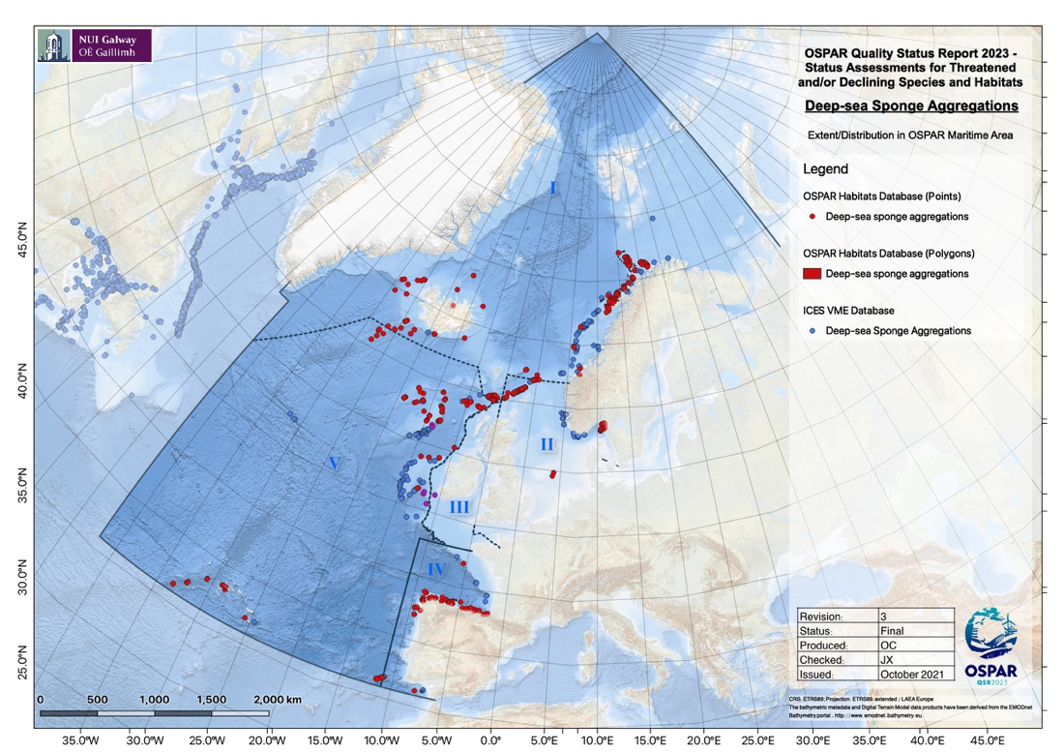  Figure 1 - Distribution of deep-sea sponge aggregations in the OSPAR maritime area, based on OSPAR T&D database (2018) and ICES VME database (2021).  Method of assessment: 3b
Extent (habitats) | The full extent occupied by sponge aggregations in the OSPAR Maritime Area is largely unknown given the relatively small geographical scales at which most surveys are conducted and due to the lack of systematic monitoring. However, habitat suitability models (HSMs) developed for Geodia spp. and Pheronema sponge aggregations, based on the occurrence of the characterizing species, predict these habitats to be widely distributed throughout the northern North Atlantic and the Arctic, and the temperate northeast Atlantic and Mediterranean Sea, respectively. These HSMs also show that the majority of Geodia grounds are likely to occur within the EEZs of Norway, Svalbard, Iceland, Greenland, and United Kingdom north of Shetland (Region I); and within the EEZs of Iceland (Region I), Spain (Region IV), the UK, Ireland and Azores (Region V). In the case of Pheronema grounds, considerably smaller proportions of suitable habitat is found in the areas beyond national jurisdiction. However, lack of comprehensive data on past and present extent of the habitat prevents an accurate assessment of the change in this criterion for the period considered (2010 to 2021).  Method of assessment: 3a.
Condition | The assessment of the condition (e.g., density, biomass, body-size distribution) of deep-sea sponge aggregations across the OSPAR Regions I, II, IV and V is quite challenging. This is mainly because baseline studies and monitoring for these habitats are very limited. A four-year study in the Schulz Bank, Arctic waters (Region I) showed a decrease in sponge density (e.g., in Geodia sp., Craniella sp.) in areas affected by human activities. Similar findings exist for the Porcupine Seabight (Region V) where decreases in the density, biomass and body diameter of Pheronema carpenteri have been found between 1983/4 and 2011. The condition of deep-sea sponge aggregations (morphological diversity; density and body-size distribution of Geodia and Phakellia) was enhanced in areas inside the Faroe-Shetland Channel Nature Conservation Marine Protected Area (Region II). Measures of genetic diversity based on hundreds of genomic markers indicate that Phakellia ventilabrum populations in the Cantabrian Sea, both in the Avilés Canyon and Le Danois Bank (Region IV) have lower genetic diversity than populations off Norway (Region I), Sweden (Region II), and much lower than in populations at Rockall Bank, on the Shetland Shelf and in the Faroe-Shetland Sponge Belt (Region V). Populations of Geodia hentscheli in Region I have similar levels of genetic diversity as Phakellia populations, with higher values of genetic diversity in populations on Vesterisbanken, Jan Mayen Ridge and Schulz Bank when compared with populations found in Iceland, Davis Strait, Svalbard, and Karasik Seamount.  Predictions of future trends (2020 to 2030) for the condition of deep-sea sponge aggregations are quite challenging. Models predict shifts in temperature, pH, oxygen and particulate organic carbon (i.e., food supply) in the bathyal zone (i.e., the zone where several deep-sea sponge aggregations have been found) for OSPAR Regions by 2100 under RCP8.5. Combining i) model predictions for abiotic/biotic conditions in bathyal habitats (see above); ii) scientific knowledge about the impacts of temperature, acidification, diet/feeding metabolism, it could be suggested that future environmental conditions in the OSPAR Maritime Area may contribute to the deterioration of the condition of deep-sea sponge aggregations. However, further research is needed to advance scientific knowledge on that front. The role of management measures (either in place or to be implemented - see section “Measures that address key pressures from human activities or conserve the species/habitat” for details) in the future condition of deep-sea sponge aggregations in all OSPAR Regions is expected to be positive. Direct evaluation of the role of these management measures in the conservation of the deep-sea sponge aggregations will be needed.  Method of assessment: 2c.
Threats and impacts | The QSR 2010 identified disturbance of the seabed resulting from demersal fisheries as the main pressure (with “habitat damage” and “removal of target and non-target species” as key pressures). In the background document climate change was identified (alongside with trawling) as the most significant threat to the distribution of sponge aggregations in the long term. The current assessment identifies bottom trawling and climate change as the main pressures.  Fishing  Negative effects from bottom trawling have been clearly demonstrated for sponge habitats with extensive damage and little sign of recovery several years later. Pressure from fishing on this habitat appears to remain steady across the OSPAR Maritime Area (Figures 2-3).  The OSPAR Intermediate Assessment 2017 (Region V not assessed) showed that up to 86% of the grid cells assessed in the Greater North Sea and Celtic Seas (Regions II and III) show evidence of some physical disturbance of the seafloor from bottom contacting fishing gears, of which 58% of areas show higher levels of disturbance. From the assessed area 74% experienced consistent year-on-year pressure, likely affecting the ability of habitats to recover. Fishing pressure varied during the assessment period of 2010-2020 but there was no overall trend across regions. The overlap of OSPAR and ICES sponge aggregation occurrence data and Global Fishing Watch (an analysis which comes with various assumptions), suggests there has been little change on the overall impact of fishing on the habitat since 2016, when Regulation EU 2016/2336 was adopted. Within UK waters, regulation (EU) 2016/2336 is transposed into the Common Fisheries Policy and Aquaculture (Amendment etc.) (EU Exit) Regulations 2019, with the same fishing restrictions and prohibitions in place. In Region I the fishing pressure mainly decreases or remains unchanged. In Norwegian waters, Regulation 2011/755 restricts bottom fishing on vulnerable benthic habitats in areas deeper than 1 000 m in the Norwegian Economic Zone, including the Fisheries Protection Zone near Svalbard and in the Fisheries Zone at Jan Mayen. In Region II fishing pressure is mainly unchanged or decreases slightly. Region IV remains unchanged or shows a slight increase, while Region V is mainly unchanged with decrease in areas where bottom trawling is still allowed. However, with Regulation (EU) 2019/1241, large areas of Region V are under bottom trawling protection, which will decrease the fishing pressure in those areas.  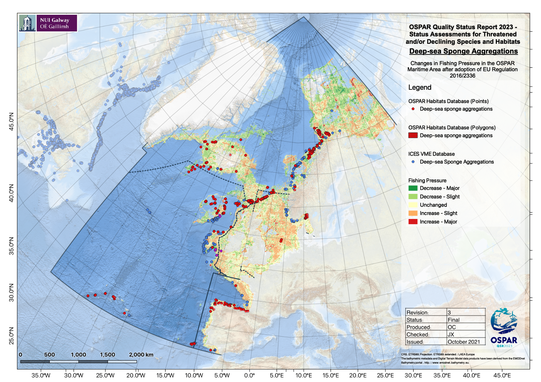  Figure 2 - Relative change in fishing pressure across the OSPAR maritime area after introduction of the EU regulation 2016/2336.  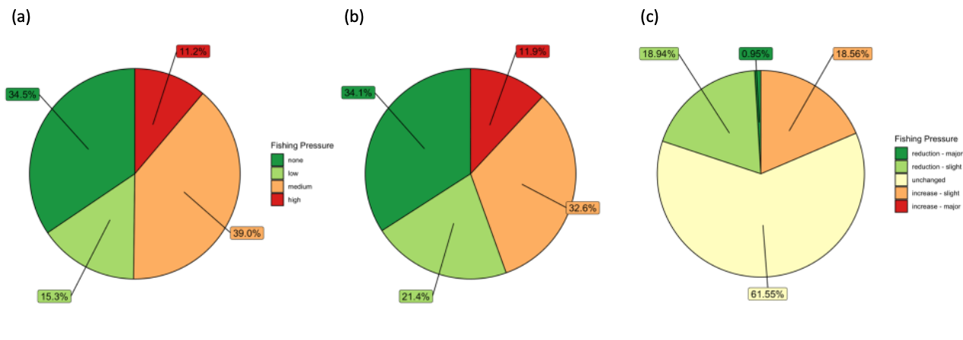  Figure 3 - Habitat/Fishing pressure overlap across the OSPAR maritime area (a) before and (b) after introduction of the EU regulation 2016/2336, and (c) relative change in fishing pressure (years 2012-2016 vs 2017-2020) in cells known to contain records of deep-sea sponge aggregations. Based on data from the Global Fishing Watch aggregated to a resolution of 25km².  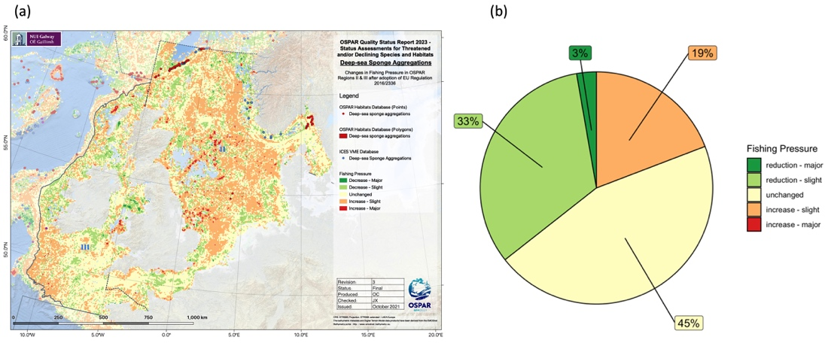  Figure 4 - (a) Relative change in fishing pressure in OSPAR Region II after introduction of EU regulation 2016/2336 and (b) change in fishing pressure in those cells known to contain records of deep-sea sponge aggregations. Based on data from the Global Fishing Watch aggregated to a resolution of 25km²  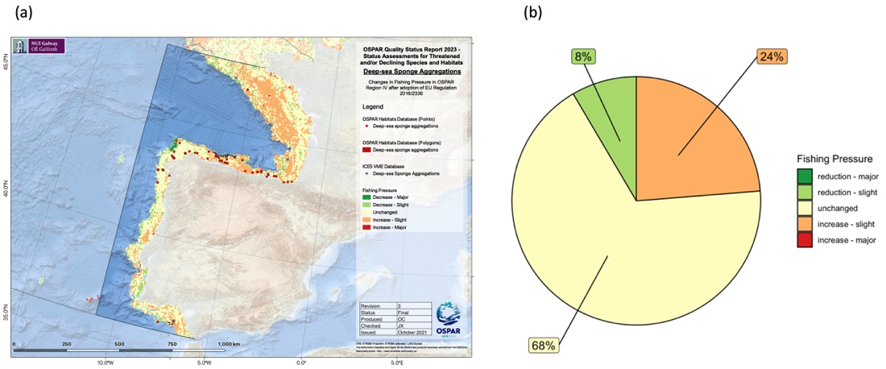  Figure 5 - (a) Relative change in fishing pressure in OSPAR Region IV after introduction of EU regulation 2016/2336 and (b) change in fishing pressure in those cells known to contain records of deep-sea sponge aggregations. Based on data from the Global Fishing Watch aggregated to a resolution of 25km²  Climate change  Although all OSPAR Regions are being affected by climate stressors, namely pH decrease, temperature increase, changes in POC flux and in dissolved oxygen, the contemporary and immediate future impacts on sponge aggregations are difficult to quantify. These habitats mainly occur in bathyal depths, at which the highest climate velocity is expected to occur under various climate change scenarios. The northernmost regions of the North Atlantic are predicted to experience the greatest impacts under worst-case scenario predictions. Increased temperature and lower pH will drastically reduce the suitable habitat for ecosystem-engineer species, and lead to declines in population densities, loss of biodiversity and reduced biogeographic distribution that might compromise connectivity at large scales and long-term survival. The reductions in carbon fluxes can in oligotrophic areas be even more serious. By 2100 predicted effects of climate change over deep-sea sponge aggregations are changes in distribution, extent and condition. Changes in circulation due to the slowdown of the Atlantic Meridional Overturning Circulation (which affects all OSPAR Regions) will have influence on regional and local circulation patterns which will also alter the patterns of population connectivity.
Measures that address key pressures from human activities or conserve the species/habitat  - 100 words | Since 2010, 34 nationally and collectively designated MPAs encompassing deep-sea areas have been designated (Regions I, II, IV, V) covering an area of nearly 551 000 km². Of these, seven (spanning over 465 000 km²) are located in Areas Beyond National Jurisdiction (ABNJ), all in Region V. These encompass important deep-sea habitat topographic elements such as mid-ocean ridge and fracture zones (Charlie-Gibbs North and South, and MAR North of the Azores High Seas MPAs), as well as seamounts (Altair, Antialtair, Josephine, and the Milne seamount complex), which are likely to harbour sponge aggregations, although, at present, records are scarce for these areas. Two deep-sea MPAs (Avilés canyon system and Gulf of Cadiz mud volcanoes) have also been designated by Spain (Region IV). Despite the existing MPAs and NEAFC closure areas, the vast majority (nearly 72%) of the areas where deep-sea sponge habitats occur remains unprotected, with considerable variability across Regions. The proportion of records under protection (by one or both measures) varies between just 3% in Region I and 64% in Region II. In Regions IV and V, 32% and 47% of the records lay in areas currently under protection (Figures 6-7). However, these values do not account for other protective actions taken beyond the scope of the OSPAR/NEAFC measures.  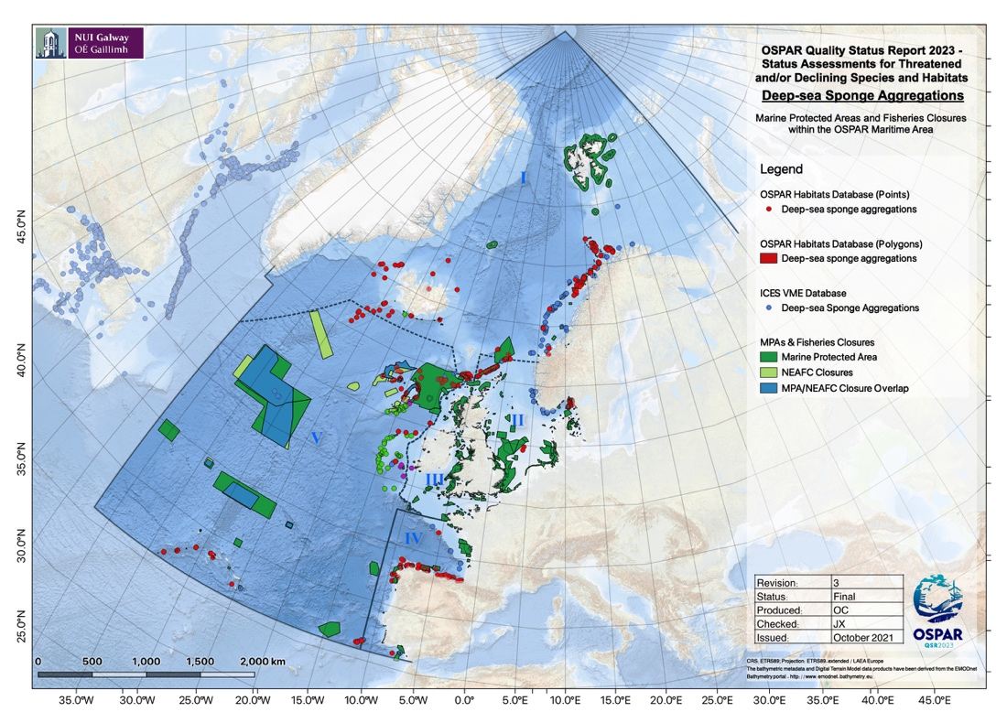  Figure 6 - Deep-sea sponge aggregations distribution in relation to Marine Protected Areas and NEAFC bottom-fisheries closures in place across the OSPAR maritime area.  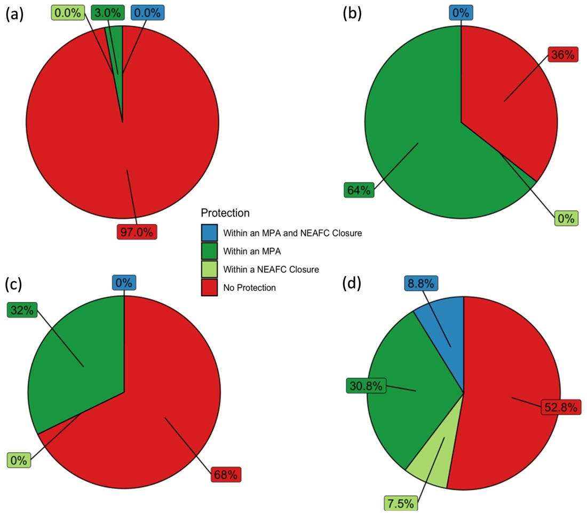  Figure 7 - Proportion of deep-sea sponge aggregations within Marine Protected Areas and/or NEAFC closures in (a) OSPAR Region I; (b) OSPAR Region II; (c) OSPAR Region IV; and (d) OSPAR Region V.  (i) Summarised information on implementation status of OSPAR measures  Actions towards the recommendations were summarised below using the 2019 implementation reports (submitted by France, Iceland, Ireland, Norway, Spain and the United Kingdom) together with additional information from Contracting Parties. Together these submissions provide information on parts of the Arctic Waters (I), Greater North Sea (II), Celtic Seas (III), the Bay of Biscay and Iberian Coast (IV), and the Wider Atlantic (V):  3.1.a Protection for Deep-Sea Sponge Aggregations is covered by the environmental objectives for the implementation of the Marine Strategy Framework Directive (MSFD). Specifically, the objectives "Reduce physical disturbance and physical loss of broad and particular habitats linked to maritime works, activities and uses", and "Prevent abrasion and smothering of the most representative areas of deep habitats (VME) and reduce abrasion on particular geomorphological structures" have direct relevance to Deep-Sea Sponge Aggregations. These habitats are also covered under the Habitats Directive [92/42/EEC]. Additionally, Deep-Sea Sponge Aggregations are legally protected under the following European legislation:  - European Communities (Birds and Natural Habitats) Regulations (2011-2015);  - European Union (Birds and Natural Habitats) (Sea-Fisheries) Regulations (2013-2014).  The United Kingdom has designated six offshore Special Areas of Conservation to protect EU Habitats Directive listed Reef habitat and associated vulnerable marine ecosystems; at least four of these sites are known to contain Deep-sea sponge aggregations. Within these SAC sites fishing with bottom trawls is prohibited below 800 m depth; pelagic fishing that excludes contact with the seafloor or benthic features is permitted. Deep-Sea Sponge Aggregations may be the subject of a prefectural order for the protection of natural habitats in metropolitan France under this Directive.  The new EU Biodiversity Strategy for 2030 (adopted in May 2020) aims to strengthen the protection of marine ecosystems and to restore them to achieve “good environmental status”, including tackling practices that damage the seabed.  National legislation for the protection for Deep-Sea Sponge Aggregations in the UK has been through:  - The Conservation of Habitats and Species Regulations 2017;  - The Conservation (Natural Habitats, &c) Regulations (Northern Ireland) 1995 (as amended);  - The Conservation (Natural Habitats &c) Regulations (Scotland) 1994 (as amended);  - The Conservation of Offshore Marine Habitats and Species Regulations 2017;  - The Marine and Coastal Access Act 2009;  - The Marine (Scotland) Act 2010;  - Nature Conservation (Scotland) Act 2004.  Furthermore, the United Kingdom has adopted regulations prohibiting fishing in waters deeper than 1 000 m, and require reports catches of deep-sea sponges in shallower waters and to move away if catches exceed a set threshold value.  Closures for bottom-contact fishing operations in further areas of deep-sea sponge aggregations have been implemented in Region V through the NEAFC Recommendation 19 2014: Protection of VMEs in NEAFC Regulatory Areas, as amended by Recommendations 09:2015 and 10:2018.  Iceland has banned fishing with trawls in four areas where Deep-Sea Sponge Aggregations are known to occur (regulation No 959/2019) and in Norway regulations have been put in place since 2011 applicable to all fishing gear likely to touch the seafloor during normal operations in all waters under Norwegian fisheries jurisdiction. Assessments were done and the 2011 regulations were amended as of July 2019 establishing some closed areas around Svalbard and prohibited fishing deeper than 800 m in the same area.  3.1.b The effectiveness of the existing management measures for the protection of Deep-Sea Sponge Aggregations have not been directly evaluated. A Norwegian national red list assessment reviewed the status of key species and habitats and in 2018 considered Deep-Sea Sponge Aggregations with Geodia as ‘near threatened’. The El Cachucho MPA is included in the OSPAR MPA Network. Its management plan (2011-2017) included actions to prevent Deep-Sea Sponge Aggregations from the impact of fisheries and other possible pressures. The assessment of their effectiveness conducted by the Spanish Institute of Oceanography (IEO) concluded that these measures have been effective. In the United Kingdom, management for the protection of Deep-Sea Sponge Aggregations occurs through United Kingdom legislation implementing the EC Habitats Directive and via fisheries closure through the Common Fisheries Policy and North East Atlantic Fisheries Commission (NEAFC), the latter in Region V. There is evidence from monitoring of fishing activity that fishermen are obeying these closures to a very large extent. In Ireland's maritime area management measures for the protection of Deep-sea Sponge Aggregations are considered to be effective where these features are conserved by existing area-based protection (i.e., Special Areas of Conservation) or fishing restrictions.  3.1.c Monitoring, surveillance, and mapping programmes to determine the extent, distribution and condition of Deep-sea Sponge Aggregations have been reported by Iceland, Ireland, Spain, Norway and the United Kingdom.  3.1.d The EU deep-sea regulation (https://eur-lex.europa.eu/eli/reg/2016/2336/oj), introduced in 2016, includes obligations for increased monitoring and reporting of VME (including sponges) bycatch by vessels trawling in waters between 400-800 m. Fishing vessels encountering VMEs are obligated to report the event to national competent authorities and these data are used to inform VME mapping. The explicit involvement of commercial fishermen in data collection for research and monitoring purposes also has occurred in Iceland, Norway, Spain and the United Kingdom. Sponge identification guides have been developed to aid reporting in Iceland. In Spain, the draft management plan for the El Cachucho MPA includes establishing arrangements between the Spanish Institute of Oceanography and the fisheries sector to monitor and assess the management measures, with scientific observers on board.  3.1.e Collection of information on fishing activities has been improved. Vessel Monitoring System (VMS) data are used to map fishing effort at higher resolution, and to assess the risk of damage to vulnerable habitats. In Norway these data products are available to the public. In the United Kingdom, VMS data are available for all vessels over 12 m fishing in United Kingdom’s waters. The SIFIDS project in Scotland aims to determine the movements and numbers of fishing vessels not monitored by VMS (i.e., < 15 m), leading to an integrated system for the collection, collation, analysis and interrogation of data from the inshore fishing fleet and enhance the evidence for management decisions (https://www.masts.ac.uk/research/emff-sifids-project/). Consultations on the introduction of inshore Vessel Monitoring System (iVMS) and increased catch recording for the English and Welsh under 12 m fleet were undertaken in 2018/2019 and are expected to be rolled out in the coming years. Consultation for iVMS in Northern Ireland is expected at a later date.  3.1.f Records of Deep-sea Sponge Aggregations are regularly submitted to OSPAR and ICES in response to their respective data calls. New SeaRover survey data concerning all Deep-sea Sponge Aggregations encountered in 2017, 2018 and 2019 will be reported by Ireland to the OSPAR habitat mapping database in due course. It is anticipated that these data will significantly augment the data from Ireland that are already held in the OSPAR database.  3.1.g&h In addition to the general protections afforded to deep sea habitats where sponges co-occur with other benthos, three countries have reported protections put in place to specifically protect deep-sea sponges. In France, Deep-sea Sponge Aggregations are a protected feature (Habitat 1170 Reefs) in a Natura 2000 site designated in 2017 (FR5302015 - Mers Celtiques - Talus du golfe de Gascogne). In Spain, Deep-sea Sponge Aggregations provided justification of the El Cachucho, MPA, as well as the designation of the SCIs Banco de Galicia, Volcanes de fango del golfo de Cádiz and Sistema de cañones submarinos de Avilés, which host this habitat, in 2014. In the United Kingdom, Deep-sea Sponge Aggregations are protected as part of Annex I reef features in two Special Area of Conservation (SACs), and as a feature within four Nature Conservation Marine Protected Areas in Scottish waters. All these MPAs have been formally notified as OSPAR MPAs. The development of management plans for these areas has begun but plans are not yet adopted.  3.1.i Potential impacts of fishing on Deep-sea Sponge Aggregations have been explicitly analysed by Spain, in the framework of the implementation of the MSFD, by calculating the number of points significantly affected by all existing pressures within Spanish jurisdictional waters. All reporting Contracting Parties work through ICES and/or NEAFC to assess impacts of fishing on vulnerable marine ecosystems (VMEs), including Deep-sea Sponge Aggregations. ICES has most recently completed a general assessment of fishing overlap in relation to VMEs, in response to a request from the EU (https://www.ices.dk/sites/pub/Publication%20Reports/Advice/2021/Special_Requests/eu.2021.01.pdf).  (ii) Actions taken beyond the scope of the OSPAR measure  In 2006, the United Nations General Assembly called upon States to take action through Regional Fisheries Management Organisations (RFMOs) to, inter alia, protect vulnerable marine ecosystems (VMEs) from destructive fishing practices and prevent significant adverse impacts (SAIs) (UNGA Resolution 61/105). VMEs and SAIs are further defined in FAO (2009) and VMEs include the OSPAR habitats deep-sea sponge aggregations, coral gardens, cold-water coral reefs, seamounts and hydrothermal vents/fields.  Within the North-East Atlantic Fisheries Commission (NEAFC) Regulatory Area, measures to protect VMEs include the implementation of bottom fishing closure areas and the use of “move-on” rules for fishing vessels, related to encounters of specific quantities of VME indicators within by-catch from bottom-contacting gears. For sponge aggregations, threshold levels are 400 kg of live sponge for a trawl tow (800 kg in 2010) and the presence of sponge VME indicators on 10 hooks per 1 000 hook segment or per 1 200 m section (for a longline set) (NEAFC Recommendation 19 2014). Currently, there are 13 VME closures in place covering an area of 374 000 km² (all in Region V). Three of the closures (Edora’s Bank, Hatton-Rockall Basin and Hatton Bank 2) were implemented after the 2010 assessment, representing an increase of approx. 14 800 km² ,3.9%). All closures currently in place will be reviewed in 2022.  Within EU waters, Regulation (EU) 2016/2336 restricts bottom fishing >400 m to the 2009-2011 fishing footprint, prohibits bottom fishing >400 m where VMEs are known or likely to occur (through designation of VME closures) and places a complete ban on bottom trawling deeper than 800 m. Within UK waters, regulation (EU) 2016/2336 is transposed into the Common Fisheries Policy and Aquaculture (Amendment etc.) (EU Exit Regulations 2019), with the same fishing restrictions and prohibitions in place. In Norwegian waters, Regulation 2011/755 restricts fishing with bottom gear on vulnerable benthic habitats in areas deeper than 1 000 m in the Norwegian Economic zone, including the Fisheries Protection Zone near Svalbard, and the Fisheries Zone around Jan Mayen.  Council regulation no. 1568/2005 established a ban on the use of bottom-contacting gears (gillnet, entangling and trammel nets, bottom trawl or similar towed nets) at depths below 200 m in certain areas of the Atlantic Ocean including the Azores archipelago (region V).  In Portugal, since 2016, the Marine Park of the Azores which is currently constituted by 17 MPAs, covers an area of approximately 246 000 km² (Decreto Legislativo Regional n.º 28/2011/A, modified by the Decreto Legislativo Regional n.º 13/2016/A and Portaria n.º 68/2019).  In Swedish MPAs Bratten and Kosterfjorden-Väderöfjorden fisheries regulation measures for e.g. Deep-sea Sponge Aggregations have been implemented (via EU Common Fisheries Policy). Both Bratten and Kosterfjorden-Väderöfjorden have managements plans and adaptive management.
Conclusion (including management considerations) | The overall condition of deep-sea sponge aggregations is considered to be deteriorating across all OSPAR Regions due to persistent impacts from bottom fisheries over time, and the habitat's high sensitivity to such impacts. Impacts from climate change are difficult to assess but presumed to become detrimental in the future, alongside other emerging pressures such as deep-sea mining.  Deep-sea sponge aggregations continue to meet the Texel-Faial criteria, and new research further emphasises their regional and global importance, as well as ecological significance and sensitivity.  Various area-based management tools (OSPAR MPAs) and other effective conservation measures (NEAFC closures) have been developed, but these are largely located in ABNJ (in Region V) whereas most of the habitat occurs within countries’ EEZs resulting in a large proportion of the habitat (72%) being unprotected. Increased protection in Region I, an area for which there is a particularly good knowledge base of this habitat distribution and functioning, is desirable.  Status re-assessments should be performed on mid- to long-term cycles (6-10 years) to allow for substantial new data to be collected and changes in condition and recovery arising from the establishment of protection areas to be noticeable.
Knowledge gaps (brief) | Deep-sea sponge aggregations comprise a range of habitats differing in community composition and structure as well as spatial and bathymetric distributions. At higher latitudes, sponge aggregations dominated by tetractinellid sponges (Geodia spp., Stelletta spp., Stryphnus sp.) are widely distributed spanning across the northern Atlantic and the Arctic regions whereas at lower latitudes different types of aggregations are usually patchier in distribution and restricted to considerably smaller areas (a few ecoregions). Defining the different types of sponge habitats (biotopes) and considering them separately in future assessments would be beneficial. This would facilitate the assessment and understanding of distribution/extent through development of ‘type’ (biotope) specific habitat models. Further data are required on distribution from undersampled areas, density (in order to establish presence of aggregations), and drivers of distribution.  Knowledge on baseline conditions (in “pristine” areas) and natural variability is lacking making it difficult to assess changes, and except for a few areas (such as the Barents Sea - Region I), monitoring data are largely lacking. Establishing long-term monitoring programmes in selected stations as well as through multi-annual demersal fisheries surveys conducted by contracting parties could be a way forward. Local ecological knowledge of demersal fishers is also an untapped source of data that could further inform both distribution and extent as well as changes and recent trends.  Understanding potential responses to the climate-related threat would benefit from collection of fundamental life history characteristics and physiological data across climate-related variables. In terms of life history characteristics major knowledge gaps exist regarding the nature, behaviour and distribution of deep-sea sponge larvae as well as how changes in ocean circulation (e.g., basin scale shifts and environmental conditions) affect larval distribution and connectivity among deep-sea sponge populations. More generally, information on genetic connectivity between sponge grounds is lacking. Longevity, growth rates, fecundity and reproductive patterns are also important population dynamic gaps that are fundamental to model and predict effects on the populations and habitats.  Furthermore, experimental work assessing the (synergistic) impacts of climate-related stressors on the health of deep-sea sponges will substantially advance the scientific knowledge about the status of deep-sea sponge aggregations under future environmental conditions.  Agreement on the scientific indicators to be used for the assessment of the status of deep-sea sponge aggregations (e.g., density, biomass, areal coverage), use of common measurement units, deposition of collected (meta)data in online repositories (e.g., ICES VME database, GBIF, OBIS, EMODnet, PANGAEA) and making publications available in open access will play an important role in future progress.
References | Extent:  Ross RE, Howell KL (2013) Use of predictive habitat modelling to assess the distribution and extent of the current protection of ‘listed’ deep-sea habitats. Diversity and Distributions 19, 433–445.  Howell KL, Piechaud N, Downie AL, Kenny A (2016) The distribution of deep-sea sponge aggregations in the North Atlantic and implications for their effective spatial management. Deep-Sea Research I 115, 309–320.  Burgos JM, Buhl-Mortensen L, Buhl-Mortensen P, Ólafsdóttir SH, Steingrund P, Ragnarsson SÁ, Skagseth Ø (2020) Predicting the Distribution of Indicator Taxa of Vulnerable Marine Ecosystems in the Arctic and Sub-arctic Waters of the Nordic Seas. Front. Mar. Sci. 7:131.  Condition:  Beazley L, Kenchington E, Murillo JM, Brickman D, Wang Z, Davies AJ, Roberts EM, Rapp HT (2021) Climate change winner in the deep sea? Predicting the impacts of climate change on the distribution of the glass sponge Vazella pourtalesii. Mar. Ecol. Prog. Ser. 657: 1-23.  Bell JB, Alt CHS, Jones DOB (2016) Benthic megafauna on steep slopes at the Northern Mid-Atlantic Ridge. Marine Ecology 37, 1290-1302.  Bennett HM, Altenrath C, Woods L, Davy SK, Webster NS, Bell JJ (2017) Interactive effects of temperature and pCO2 on sponges: from the cradle to the grave. Glob. Change Biol. 23, 2031-2046.  Brito-Morales, I., Schoeman, D.S., Molinos, J.G., Burrows, M.T., Klein, C.J., Arafeh-Dalmau, N., Kaschner, K., Garilao, C., Kesner-Reyes, K. and Richardson, A.J., 2020. Climate velocity reveals increasing exposure of deep-ocean biodiversity to future warming. Nature Climate Change, 10(6), pp.576-581.  Busch K, Taboada S, Riesgo A, Koutsouveli V, Rios P, Cristobo J, Franke A, Getzlaff K, Schmidt C, Biastoch A, Hentschel U (2021) Population connectivity of fan-shaped sponge holobionts in the deep Cantabrian Sea. Deep Sea Res. 167:103427.  Cathalot C, van Oevelen D, Cox TJS, Kutti T, Lavaleye M, Duineveld G, Meysman FJR (2015) Cold-water coral reefs and adjacent sponge grounds: hot spots of benthic respiration and organic carbon cycling in the deep sea. Front. Mar. Sci. 2:37. doi: 10.3389/fmars.2015.00037  de Kluijver A, Bart MC, van Oevelen D, de Goeij JM, Leys SP, Maier SR, Maldonado M, Soetaert K, Verbiest S, Middelburg JJ (2021) An integrative model of carbon and nitrogen metabolism in a common deep-sea sponge (Geodia barretti). Front. Mar. Sci 7:596251.  Dinwoodie K, Perry J, Last EK, Robson LM (2021) Pheronema carpenteri field on Atlantic lower bathyal mud. In Tyler-Walters H. and Hiscock K. (eds) Marine Life Information Network: Biology and Sensitivity Key Information Reviews, [on-line]. Plymouth: Marine Biological Association of the United Kingdom. [cited 29-10-2021]. Available from: https://www.marlin.ac.uk/habitat/detail/1232  FAO (2009) The FAO International Guidelines for the Management of Deep-sea Fisheries in the High Seas. Activities pages. In: FAO Fisheries and Aquaculture Department [online]. Rome. Updated 30 April 2013. http://www.fao.org/fishery/topic/166308/en  IPCC (2019) Summary for Policymakers. In: IPCC Special Report on the Ocean and Cryosphere in a Changing Climate [H.-O. Pörtner, D.C. Roberts, V. Masson-Delmotte, P. Zhai, M. Tignor, E. Poloczanska, K. Mintenbeck, M. Nicolai, A. Okem, J. Petzold, B. Rama, N. Weyer (eds.)].  Kazanidis G, van Oevelen D, Veuger B, Witte UFM (2018) Unravelling the versatile feeding and metabolic strategies of the cold-water ecosystem engineer Spongosorites coralliophaga (Stephens, 1915). Deep-Sea Res. I 141:71-82.  Kazanidis G, Vad J, Henry L-A, Neat F, Berx B, Georgoulas K and Roberts JM (2019) Distribution of Deep-Sea Sponge Aggregations in an Area of Multisectoral Activities and Changing Oceanic Conditions. Front. Mar. Sci. 6:163. doi: 10.3389/fmars.2019.00163  Klitgaard AB, Tendal OS (2004) Distribution and species composition of mass occurrences of large-sized sponges in the northeast Atlantic. Prog. Oceanogr. 61:57-98.  McIntyre FD, Drewery J, Eerkes-Medrano D, Neat FC (2016) Distribution and diversity of deep-sea sponge grounds on the rosemary bank seamount. NE Atlantic. Mar. Biol. 63, 142–152. doi: 10.1007/s00227-016-2913-z  Morrison KM, Meyer HK, Roberts EM, Rapp HT, Colaço A and Pham CK (2020) The First Cut Is the Deepest: Trawl Effects on a Deep-Sea Sponge Ground Are Pronounced Four Years on. Front. Mar. Sci. 7:605281. doi: 10.3389/fmars.2020.605281  Puerta P, Johnson C, Carreiro-Silva M, Henry L-A, Kenchington E, Morato T, Kazanidis G, Rueda JL, Urra J, Ross S, Wei C-L, González-Irusta JM, Arnaud-Haond S and Orejas C (2020) Influence of Water Masses on the Biodiversity and Biogeography of Deep-Sea Benthic Ecosystems in the North Atlantic. Front. Mar. Sci. 7:239. doi: 10.3389/fmars.2020.00239  Purser A, Orejas C, Gori A, Tong R, Unnithan V, Thomsen L (2013) Local variation in the distribution of benthic megafauna species associated with cold-water coral reefs on the Norwegian margin. Cont. Shelf Res. 54, 37–51. doi: 10.1016/j.csr.2012.12.013  Robertson LM, Hamel JF, Mercier A (2017) Feeding in deep-sea demosponges: Influence of abiotic and biotic factors. Deep-Sea Res. I 127:49-56.  Strand R, Whalan S, Webster NS, Kutti T, Fang J KH, Luter HM, Bannister RJ (2017) The response of a boreal deep-sea sponge holobiont to acute thermal stress. Sci. Rep. 7:1660. doi: 10.1038/s41598-017-01091-x  Sweetman K, Thurber AR, Smith CR, Levin LA, Mora C, Wei C.-L, Gooday AJ, Jones DOB, Rex M, Yasuhara M, Ingels J, Ruhl HA, Frieder CA, Danovaro R, Würzberg L, Baco A, Grupe BM, Pasulka A, Meyer KS, Dunlop KM, Henry L.-A, Roberts JM (2017) Major impacts of climate change on deep-sea benthic ecosystems. Elem. Sci. Anth. 5:4.  Thornalley DJR, Oppo DW, Ortega P, Robson JI, Brierley CM, Davis R, Hall IR, Moffa-Sanchez P, Rose NL, Spooner PT, Yashayaev I, Keigwin LD (2018) Anomalously weak Labrador Sea convection and Atlantic overturning during the past 150 years. Nature 556:227-230.  van Duyl FC, Hegeman J, Hoogstraten A, Maier C (2008) Dissolved carbon fixation by sponge–microbe consortia of deep water coral mounds in the northeastern Atlantic Ocean. Mar. Ecol. Prog. Ser. 358:137–150.  Vieira R, Bett BJ, Jones DOB, Durden JM, Morris KJ, Cunha MR, Trueman CN, Ruhl HR (2020) Deep-sea sponge aggregations (Pheronema carpenteri) in the Porcupine Seabight (NE Atlantic) potentially degraded by demersal fishing. Prog. Oceanogr. 183, 102189.  Threats and impacts:  Brito-Morales, I., Schoeman, D.S., Molinos, J.G., Burrows, M.T., Klein, C.J., Arafeh-Dalmau, N., Kaschner, K., Garilao, C., Kesner-Reyes, K. and Richardson, A.J., 2020. Climate velocity reveals increasing exposure of deep-ocean biodiversity to future warming. Nature Climate Change, 10(6), pp.576-581.  Buhl-Mortensen, L., Ellingsen, K. E., Buhl-Mortensen, P., Skaar, K. L., and Gonzalez-Mirelis, G. (2016). Trawling disturbance on megabenthos and sediment in the Barents Sea: chronic effects on density, diversity, and composition. ICES J. Mar. Sci. 73, 98–114. doi: 10.1093/icesjms/fsv200  Morrison KM, Meyer HK, Roberts EM, Rapp HT, Colaço A and Pham CK (2020) The First Cut Is the Deepest: Trawl Effects on a Deep-Sea Sponge Ground Are Pronounced Four Years on. Front. Mar. Sci. 7:605281. doi: 10.3389/fmars.2020.605281  Puerta P, Johnson C, Carreiro-Silva M, Henry L-A, Kenchington E, Morato T, Kazanidis G, Rueda JL, Urra J, Ross S, Wei C-L, González-Irusta JM, Arnaud-Haond S and Orejas C (2020) Influence of Water Masses on the Biodiversity and Biogeography of Deep-Sea Benthic Ecosystems in the North Atlantic. Front. Mar. Sci. 7:239. doi: 10.3389/fmars.2020.00239  Vieira R, Bett BJ, Jones DOB, Durden JM, Morris KJ, Cunha MR, Trueman CN, Ruhl HR (2020) Deep-sea sponge aggregations (Pheronema carpenteri) in the Porcupine Seabight (NE Atlantic) potentially degraded by demersal fishing. Prog. Oceanogr. 183, 102189.  Knowledge gaps:  Kazanidis, G., Orejas, C., Borja, A., Kenchington, E., Henry, L.-A., Callery, O., Carreiro-Silva, M., Egilsdottir, H., Giacomello, E., Grehan, A., Menot, L., Morato, T., Ragnarsson, S. A., Rueda, J. L., Stirling, D. E., Stratmann, T., van Oevelen, D., Palialexis, A., Johnson, D., & Roberts, J. M. (2020). Assessing the environmental status of selected North Atlantic deep-sea ecosystems. Ecological Indicators, 119, 106624.
(explanatory notes associated to rows above, if the category is indicated for: Method used) | Main source of information:  - OSPAR data assessment only  - Assessment derived from third party assessment  - Assessment derived from a mix of OSPAR data assessment and assessments from third parties  Assessment is based upon:  - complete survey or a statistically robust estimate (e.g. a dedicated mapping or survey or a robust predictive model with representative sample of occurrence data, calibration and satisfactory evaluation of its predictive performance using good data on environmental conditions across entire species range);  - based mainly on extrapolation from a limited amount of data (e.g. other predictive models or extrapolation using less complete sample of occurrence and environmental data);  - based mainly on expert opinion with very limited data;  - insufficient or no data available.

AUDIT TRAIL

AUDIT TRAIL  Optional.  No word limit  Archived | Additional Evidence and Information  Please insert below any relevant additional evidence and information that provides essential background and rationale to the assessments above. Include citations of the sources of evidence and information and provide full references in the relevant section below  The audit trail is not published as part of the assessment. It is archived for future reference purposes. The assessment in the rows above needs to be written so that it can be read without accessing information in the audit trail.
Assessment methods  (additional information, in particular how the overall assessment in the summary table was reached) | Assessed as part of a group of deep-sea habitat assessments, chaired by Louise Allcock (National University of Ireland Galway, Ireland). Deep-sea sponge aggregations habitat assessment by Joana Xavier (Interdisciplinary Centre of Marine and Environmental Research, Portugal; habitat lead), Christine Morrow (Queen's University Belfast, UK), Paco Cárdenas (Uppsala University, Sweden), Ana Colaço (Universidade dos Açores, Portugal), Ana Riesgo (Museo Nacional de Ciencias Naturales de Madrid, Spain), Tina Kutti (Institute of Marine Research, Norway), Andrew Davies (University of Rhode Island, USA), Georgios Kazanidis (University of Edinburgh, UK), Brian Bett (National Oceanography Centre, UK), Laura Robson (Joint Nature Conservation Committee, UK), David Stirling (Marine Scotland Science, UK), Liam Matear (Joint Nature Conservation Committee, UK), David Lyons (National Parks and Wildlife Service, Ireland), Kerry Howell (University of Plymouth, UK), Ellen Kenchington (Fisheries and Oceans Canada, Canada), with further contributions from the participants of the OSPAR deep-sea habitat assessment workshop, held online 6th-8th September 2021. GIS analyses by Oisín Callery (NUI Galway, Ireland) and Anthony Grehan (NUI Galway, Ireland).
Geographical range and distribution (additional evidence & information) | Habitat Distributions  The primary sources of data on the distribution of deep-sea habitats used in this assessment were: (i) the Vulnerable Marine Ecosystem (VME) database provided by the International Council for the Exploration of the Sea (ICES, https://vme.ices.dk/webservices.aspx); these encompassed the records on the presence of the VME (not indicator species) that were publicly available (downloaded on 29/08/2021), and restricted records provided by Laura Robson (chair of the WGDEC) with data owners’ consent; (ii) the latest version (2020) of the OSPAR Threatened or Declining Habitats Database; downloaded from the EMODnet Seabed Habitats website, www.emodnet-seabedhabitats.eu on 05/10/2021;  In Figures 8-11 the distribution of deep-sea sponge aggregations in each OSPAR region (I, II, IV, V) are presented.  Bathymetric data for the OSPAR area were extracted from the GEBCO_2021 Grid obtained from the GEBCO website. This is a global terrain model compiled using data from various sources to provide full global coverage for ocean and land at a resolution of 15 arc-seconds.  Spatial data layers delineating the boundaries of the OSPAR Maritime Area and its Regions were downloaded from ODIMS.  All point and polygon data were reprojected from their native coordinate reference systems (usually WGS 84, EPSG:4326) to the ETRS89-LAEA Europe coordinate reference system (EPSG:3035).  References  ICES VME Database:  https://vme.ices.dk/download.aspx  OSPAR Threatened or Declining Habitats Database v2020:  https://www.emodnet-seabedhabitats.eu  ODIMS boundaries of the OSPAR Maritime Area and its Regions  (https://odims.ospar.org/en/maps/map-maritime-area-and-its-regions)  GEBCO_2021 Bathymetry Grid  www.gebco.net/data_and_products/gridded_bathymetry_data  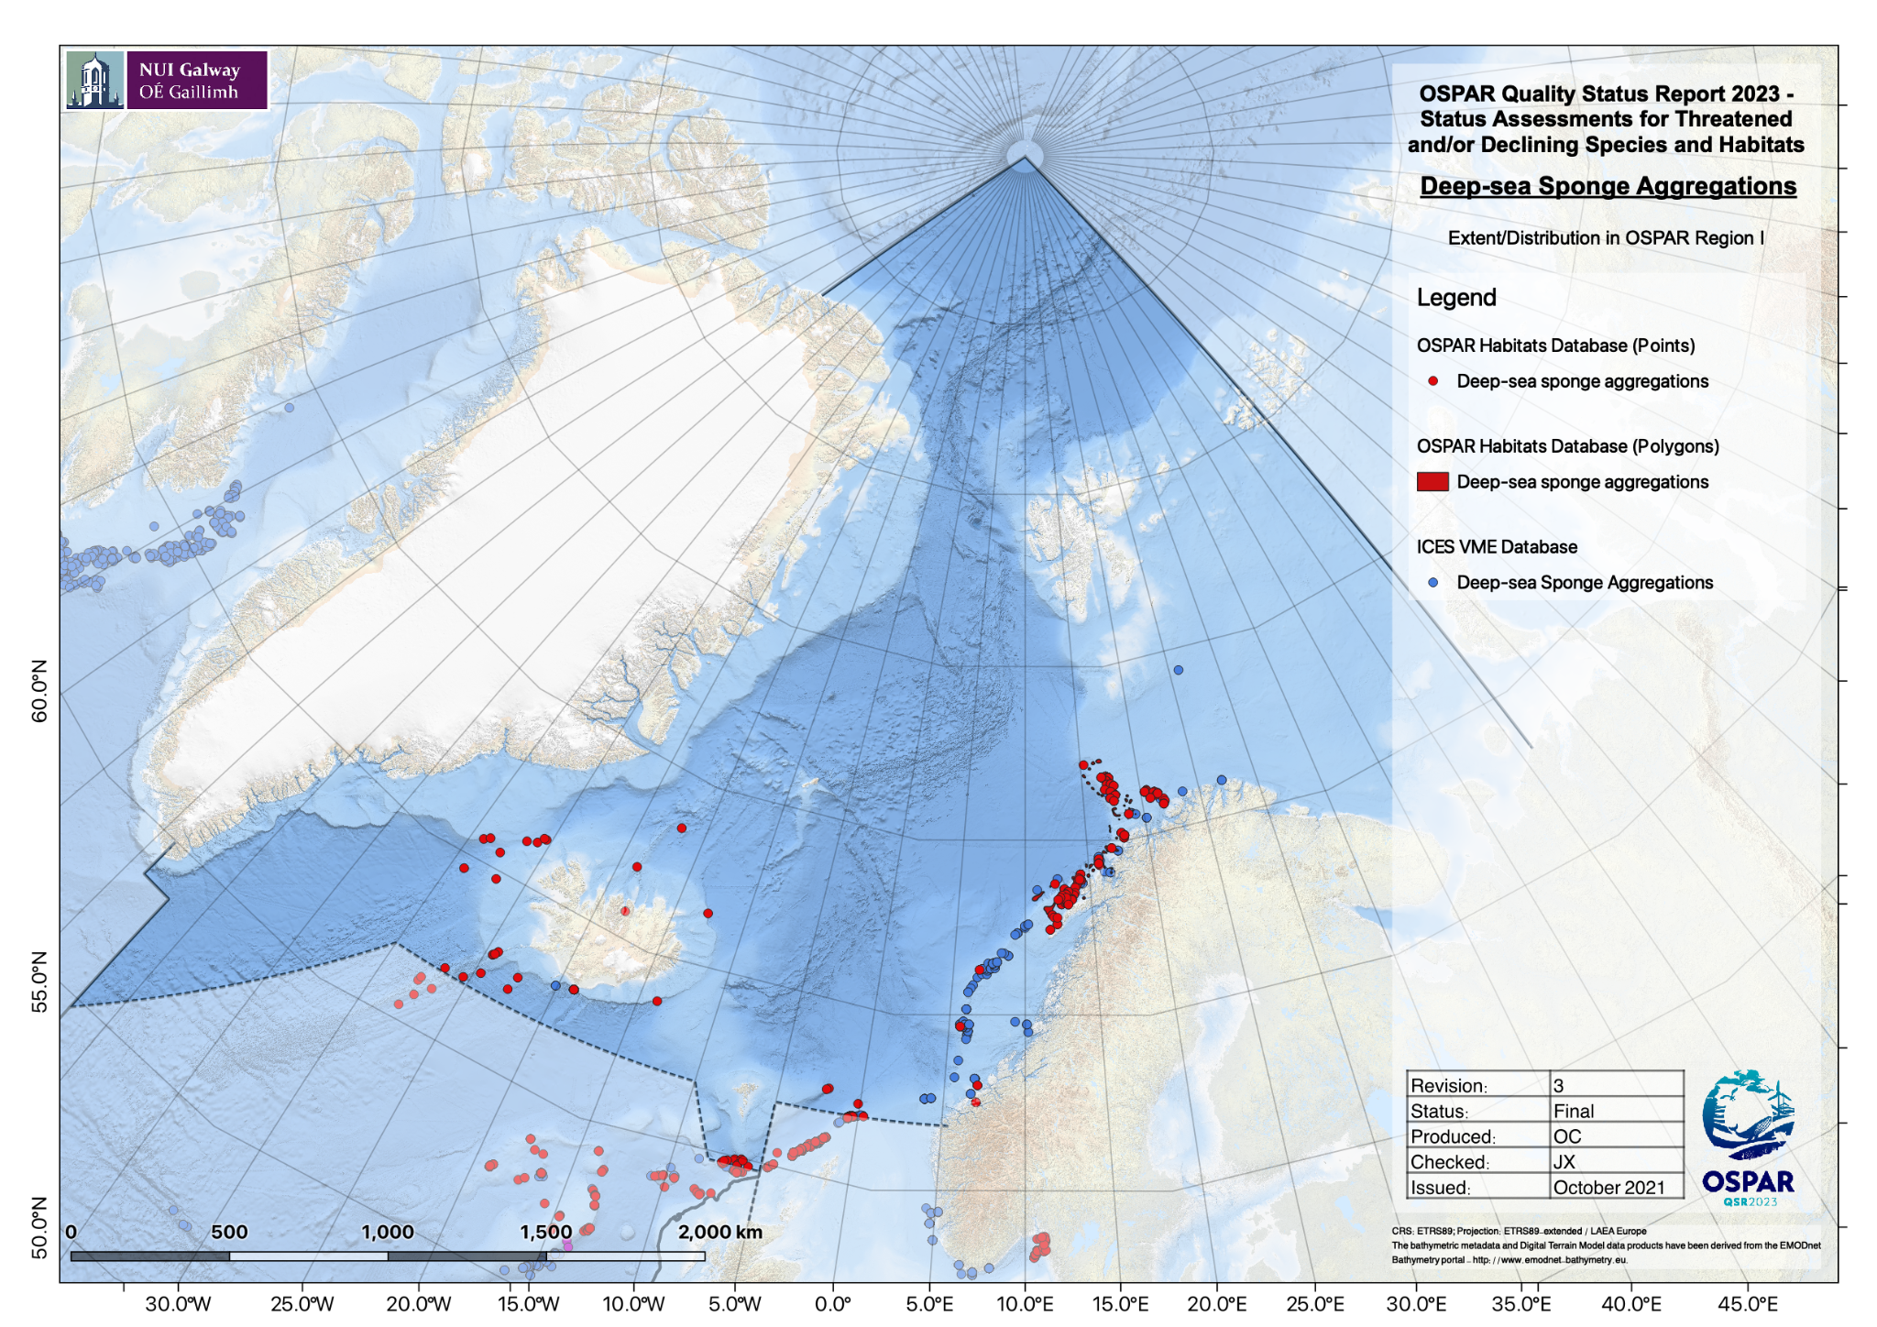  Figure 8 - Distribution of deep-sea sponge aggregations in OSPAR Region I, based on OSPAR T&D database (2018) and ICES VME database (2021).  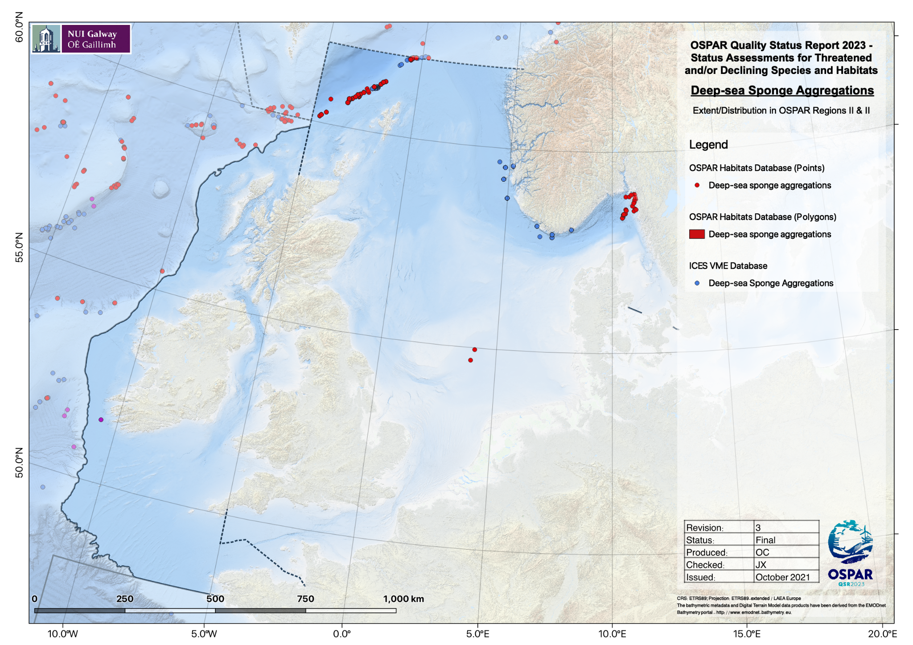  Figure 9 - Distribution of deep-sea sponge aggregations in OSPAR Region II, based on OSPAR T&D database (2018) and ICES VME database (2021).  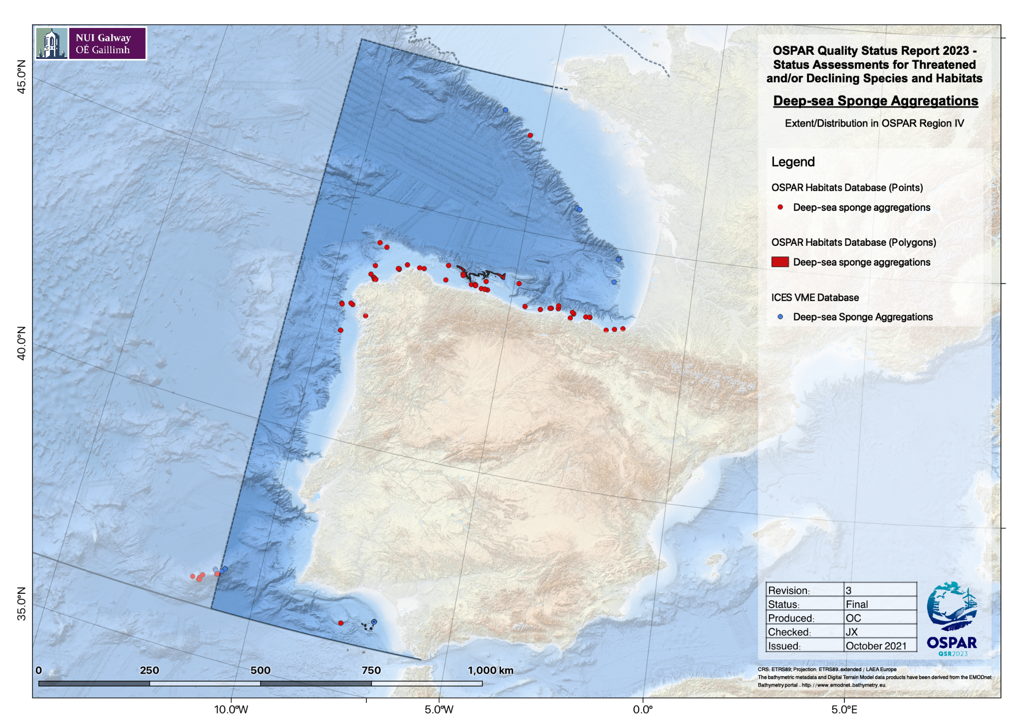  Figure 10 - Distribution of deep-sea sponge aggregations in OSPAR Region IV, based on OSPAR T&D database (2018) and ICES VME database (2021).  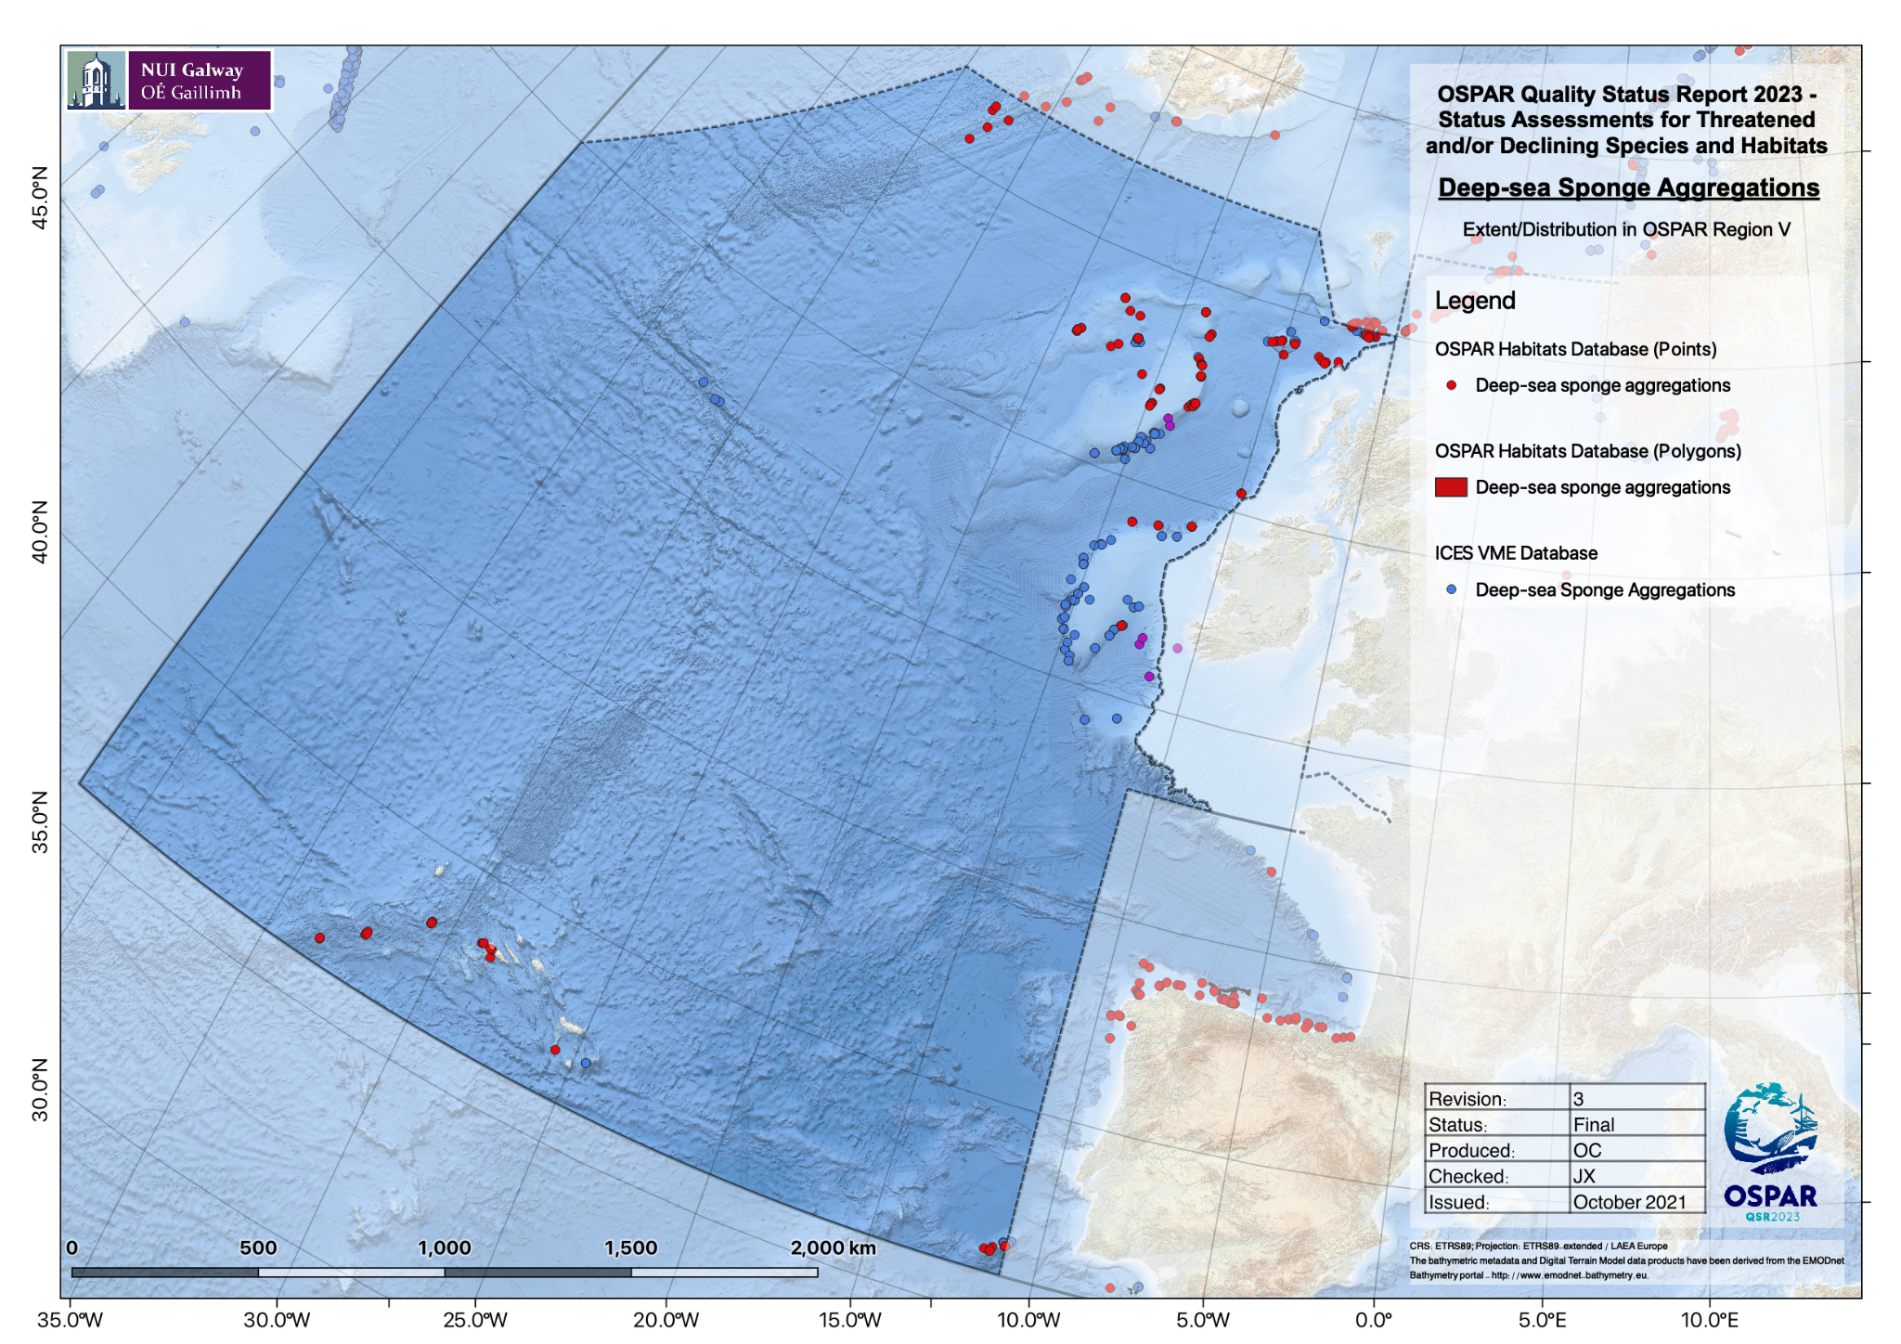  Figure 11 - Distribution of deep-sea sponge aggregations in OSPAR Region V, based on OSPAR T&D database (2018) and ICES VME database (2021).
Population/abundance (species)  (additional evidence & information) | N/A
Condition  (additional evidence & information) | A series of studies have provided information on density, biomass, and areal coverage of deep-sea sponge aggregations in OSPAR areas I, II, IV and V. However, largely due to the absence of baselines, monitoring over time and/or comparison with reference areas it is quite challenging to draw firm conclusions on the condition of these sponge aggregations. However, information given in these studies is still highly valuable and can be considered in future assessments of condition of deep-sea sponge aggregations in the OSPAR areas.  Density  Geodia barretti’s density in the Traena Reef (Norway) ranged from 0.026 to 0.139 ind/m² (Purser et al., 2013), in Rosemary Bank Seamount the average value was 0.038±0.025 ind/m² (McIntyre et al., 2016), and in Faroe-Shetland Channel the average Geodia spp. density reached 0.2 ind/m² (Kazanidis et al., 2019).  Coverage  Estimates of sponge coverage (as percentage of the total area surveyed) are given for the Rosemary Bank Seamount (ranging from ~0.6% for the species Geodia macandrewii to ~71% for Craniella longipilis) (McIntyre et al., 2016). Estimates of coverage (as % to total area coverage) are also given for unidentified demosponges in the Charlie-Gibbs Fracture Zone (i.e., 0.504±0.179% in Northeast stations, 0.454±1.88% in Northwest, 0.011±0.003 in Southeast and 0.020±0.012% in Southwest) (Bell et al., 2016).  Biomass  Knowledge on the biomass of deep-sea sponge aggregations has also improved over the last 10 years, although to a lesser extent compared to density. Values of biomass for Geodia spp. and unidentified Porifera are given for the Traena Coral Field in Norway (0.31±0.26 kg DW/m²) (Cathalot et al., 2015).
Threats and impacts  (additional evidence & information) | Regulation EU 2016/2336, restricts deep-sea fishing to areas already fished in the past, bans trawling below 800m depth, and requires closure of bottom fishing below 400 m in areas with vulnerable marine ecosystems. However, VME closures have not yet been put in place. Global Fishing Watch data were analysed to determine any change in the overlap of fishing on sponge aggregations since the adoption of the Regulations in 2016. The analysis included only those sponge aggregations whose data had been submitted to the ICES VME database or the OSPAR habitats database.  Fishing Effort data processing  Spatial data layers of apparent fishing effort based on automatic identification system (AIS) transmissions were prepared using data downloaded from the Global Fishing Watch website (www.globalfishingwatch.org). The data provided by Global Fishing Watch (GFW) are produced by running AIS data through two convolutional neural networks: (i) a “vessel characterisation” model which identifies and classifies fishing vessels, and (ii) a “fishing detection” model which predicts when these vessels are fishing and when they are in non-fishing positions (e.g. transiting, in port etc.).  The “vessel characterisation” model identifies fishing vessels using a comprehensive database of vessel registry information and also outputs predictions of fishing gear types and vessel sizes allowing for separation of different fishing activities (e.g. trawling, longlining, etc.). The “fishing detection” model identifies when vessels are fishing based on vessel movements and other parameters such as distance to shore and bathymetry. For this analysis, only fishing activity identified by GFW as “trawling” was considered. Detailed information on these models can be found in the supplementary materials of GFW’s Science paper (Kroodsma et al., 2018).  With fishing vessels and fishing activity identified, the sum of the fishing hours for all fishing vessels in an area can be computed to produce maps of apparent fishing activity across a range of fishing gear types. These outputs are gridded at a resolution of 0.01°x0.01° and are provided by GFW in CSV format (see the accompanying R-script for “rasterising” GFW CSV data).  There are a number of important limitations and caveats associated with using AIS data to monitor fishing activity:  1) Only a small fraction of fishing vessels use AIS, with coverage being higher for larger vessels, however, such vessels (i.e. those with AIS) do account for a large proportion of fishing effort beyond 100 nautical miles from land (up to ~70% (Kroodsma et al., 2018)).  2) AIS reception is affected by numerous factors including satellite coverage, interference from other vessels’ transmissions, and the strength and frequency of the AIS broadcast.  3) The number of vessels transmitting AIS data has increased year-on-year since GFW began their analyses (2012) and, when comparing data from one time period to data from another, it is difficult to differentiate between increases in AIS availability and actual increases in the intensity of fishing activity.  4) It is not possible to distinguish between demersal and pelagic trawling activity. To address this (in so far as possible) all trawling activity in water depths greater than 1500m was assumed to be pelagic and was therefore not considered in this assessment.  Fishing effort in each 25km² square of the OSPAR area grid was taken to be the sum of the effort of all 0.01°x0.01° cells of the GFW dataset that were within that square. Where a cell from the GFW dataset was only partially overlapped by a 25km² square of the OSPAR area grid, the contribution of that cell to the total fishing effort within the square was taken to be the product obtained by multiplying the fishing effort in the 0.01°x0.01° cell by the fraction of that cell covered by the square. Once the fishing effort data had been aggregated to the resolution of the 25km² OSPAR area grid, cells with zero or very low fishing effort (taken to be values below the 5% quantile as calculated using the quantile function in R with default settings) were discarded.  As described above, one of the limitations associated with using the GFW fishing effort layers is that the amount of activity in the AIS dataset has increased each year, the result being that apparent year-on-year increases in the amount of fishing activity within a grid-square do not necessarily represent actual increases in fishing activity; such increases may simply reflect greater data availability. To allow for comparisons to be made between different time periods, annual fishing effort data within each 25km² square were standardised in R using the empirical cumulative distribution function (ECDF). The ECDF function at any fishing effort value returns the proportion of effort values that are less than or equal to that value based on all fishing activity recorded in the OSPAR area in that year. This method identified areas of comparatively high/low fishing effort within the OSPAR region, thereby allowing for year-to-year comparisons to be made based on changes in relative annual fishing effort.  To ascertain any potential effects of Regulation (EU) 2016/2336 in 2016 – hereafter referred to as the Deep-Sea Access Regulations (DSAR) – mean fishing effort in each grid cell was calculated for the pre-DSAR period (2012-2017 inclusive), and the post-DSAR period (2018-2020 inclusive); despite the DSAR being established in 2016, there was a “cross-over” period where fishing permits already issued were still valid during 2017, and for this reason data from 2017 was included in the pre-DSAR period. Variations in fishing pressure of less than 10% were considered as no change; changes in fishing pressure between 10 and 50% were considered as minor increases or decreases; changes in fishing pressure of greater than 50% were considered as major increases or decreases.  Fishing impacts  Overall, there was little change in fishing pressure over the period (Figures 18, 19) and little change in individual OSPAR regions (Figures 20-27). In most OSPAR regions there has been no change in fishing pressure in the majority of grid cells containing sponge aggregations, and a mix of slight increase and slight reduction in fishing pressure in the remaining grid cells containing sponge aggregations. The exception is Region II which experienced no change in fishing pressure in 45% of grid cells containing sponge aggregations and a slight reduction in 33%. while slightly increase was 19% (Figures 22, 23), indicating an overall decrease in fishing pressure, albeit a minor one, and region IV which experienced no change in fishing pressure in 68% of grid cells containing sponge aggregations and a slight increase in 24%. while slightly decrease was 8% (Figures 24, 25),  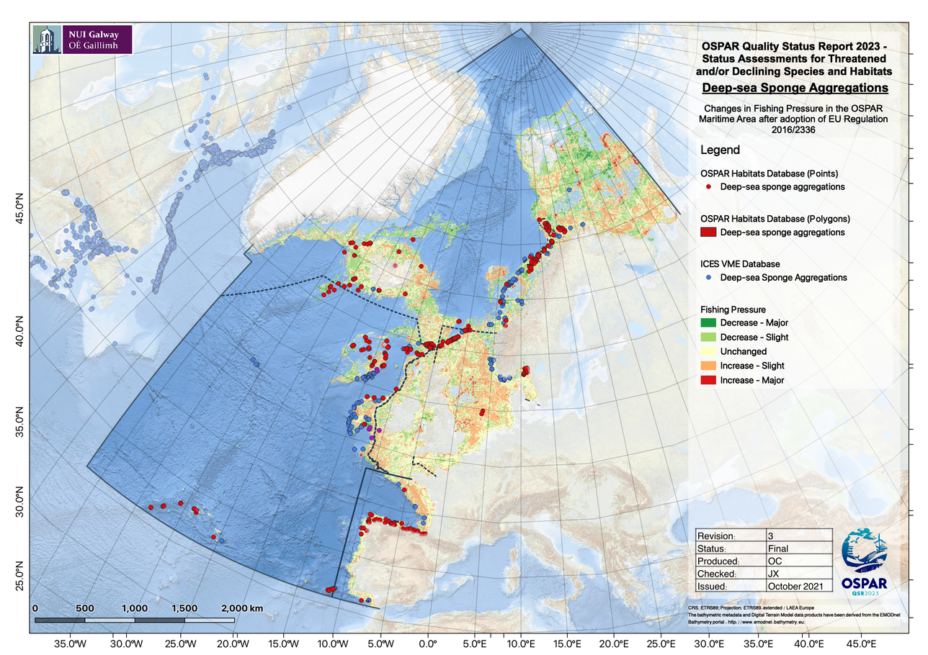  Figure 12 - Changes in fishing pressure in the entire OSPAR region since the introduction of Regulation EU 2016/2336 and the overlap of that fishing pressure with sponge aggregation habitat.  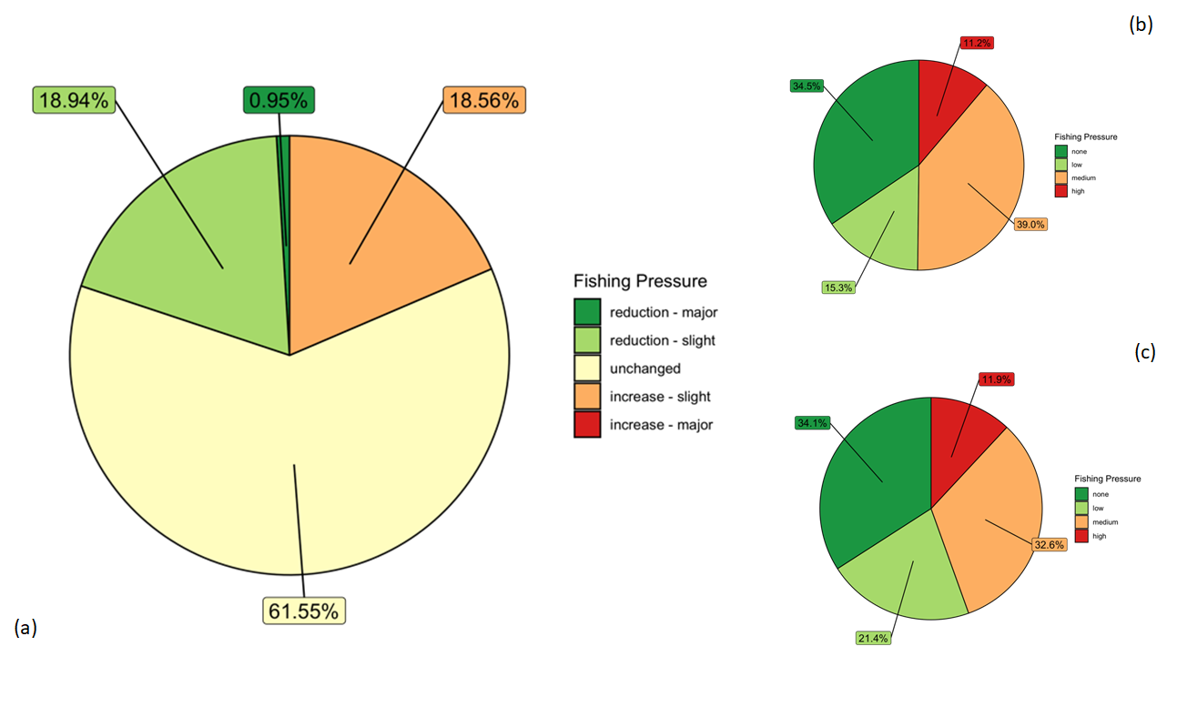  Figure 13 - Fishing pressure in the entire OSPAR region (a) Changes in fishing pressure since the introduction of Regulation EU 2016/2336 in grid cells that contain sponge aggregation habitat; (b) Relative fishing pressure prior to the introduction of Regulation EU 2016/2336 in grid cells that contain sponge aggregation habitat.; (c) Relative fishing pressure after the introduction of Regulation EU 2016/2336 in grid cells that contain sponge aggregation habitat.  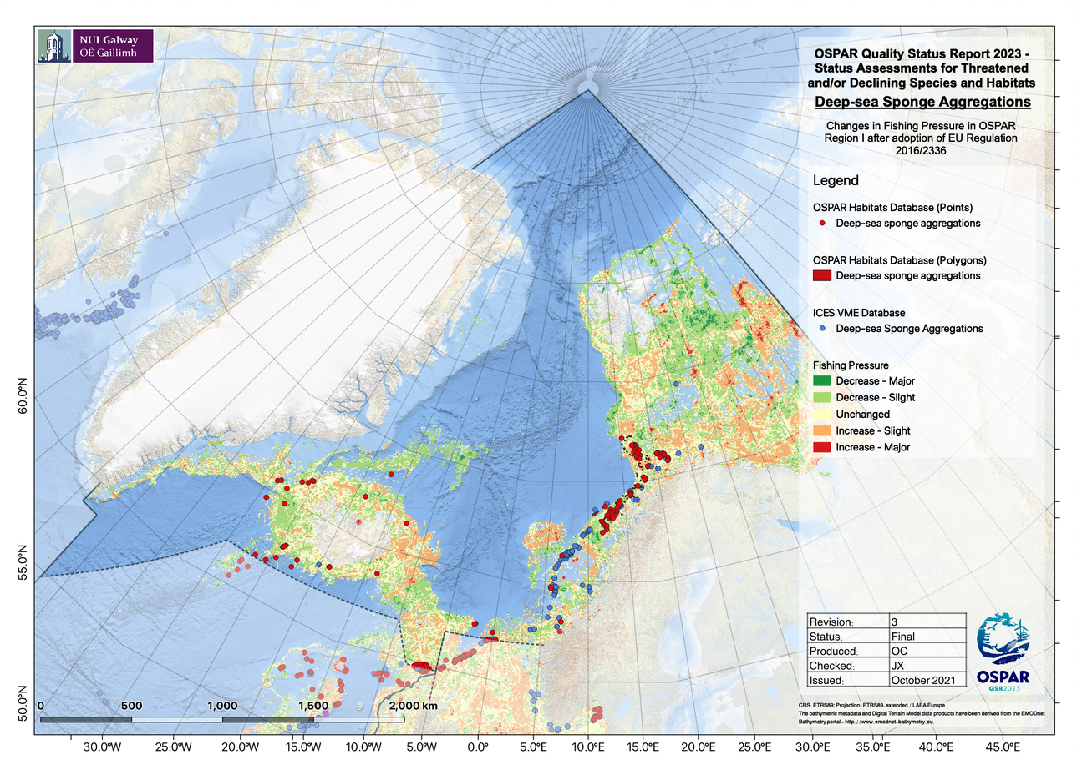  Figure 14 - Changes in fishing pressure in OSPAR region I since the introduction of Regulation EU 2016/2336 and the overlap of that fishing pressure with sponge aggregation habitat.  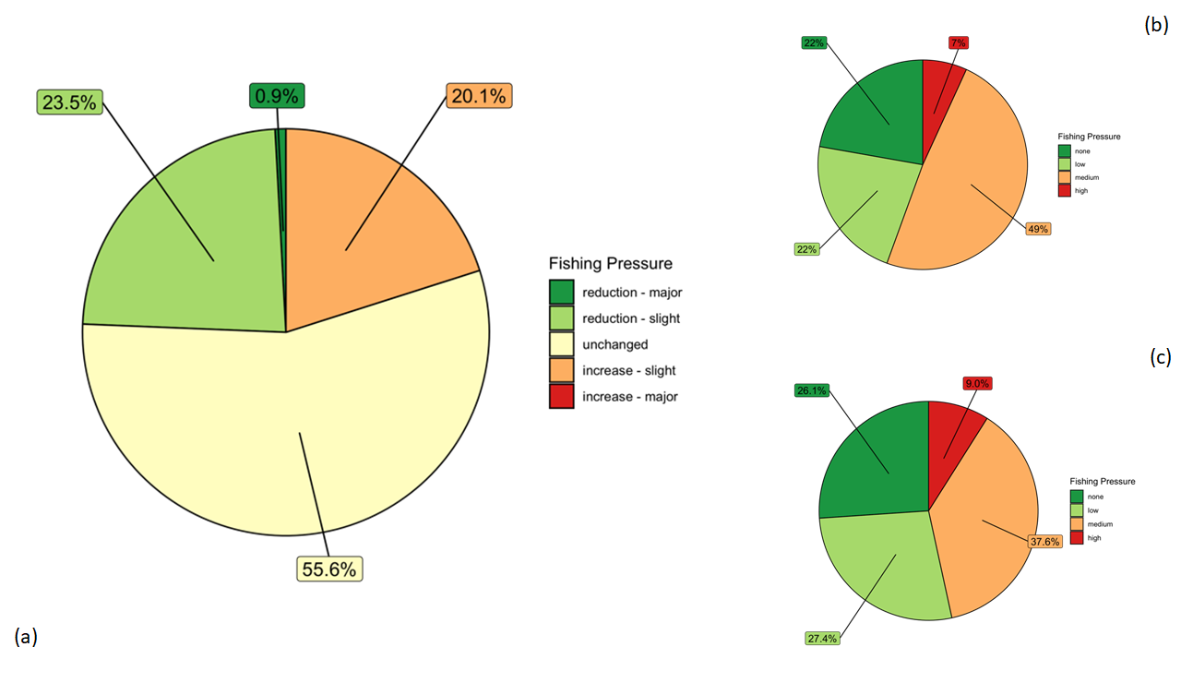  Figure 15 - Fishing pressure in OSPAR region I (a) Changes in fishing pressure since the introduction of Regulation EU 2016/2336 in grid cells that contain sponge aggregation habitat.; (b) Relative fishing pressure prior to the introduction of Regulation EU 2016/2336 in grid cells that contain sponge aggregation habitat; (c) Relative fishing pressure after the introduction of Regulation EU 2016/2336 in grid cells that contain sponge aggregation habitat.  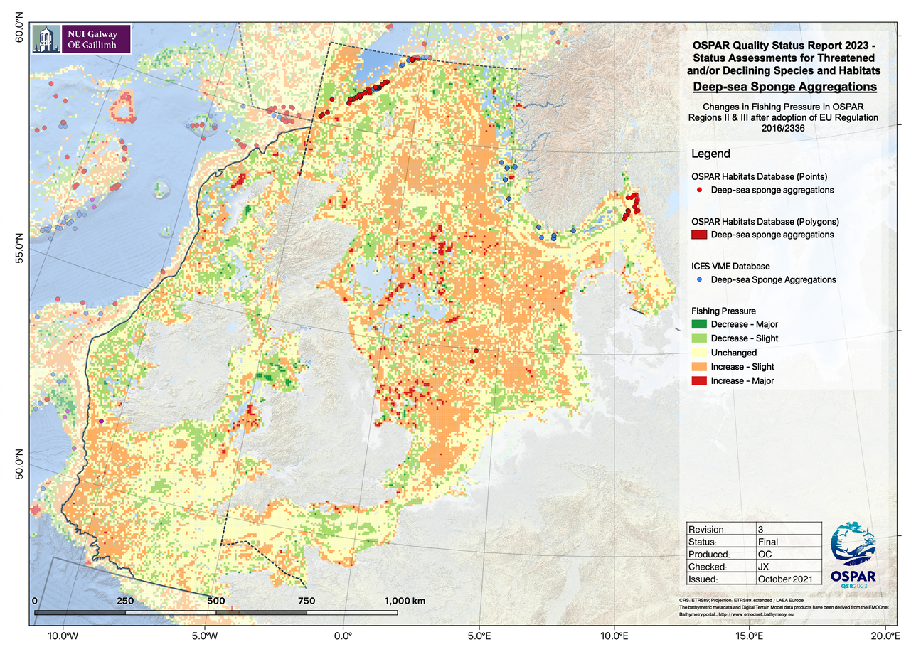  Figure 16 - Changes in fishing pressure in OSPAR region II since the introduction of Regulation EU 2016/2336 and the overlap of that fishing pressure with sponge aggregation habitat.  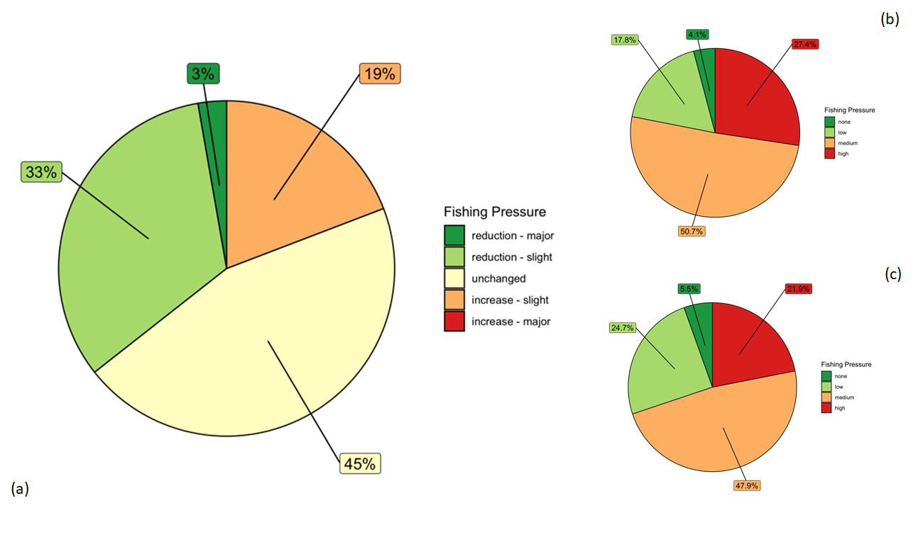  Figure 17 - Fishing pressure in OSPAR region II (a) Changes in fishing pressure since the introduction of Regulation EU 2016/2336 in grid cells that contain sponge aggregation habitat.; (b) Relative fishing pressure prior to the introduction of Regulation EU 2016/2336 in grid cells that contain sponge aggregation habitat; (c) Relative fishing pressure after the introduction of Regulation EU 2016/2336 in grid cells that contain sponge aggregation habitat.  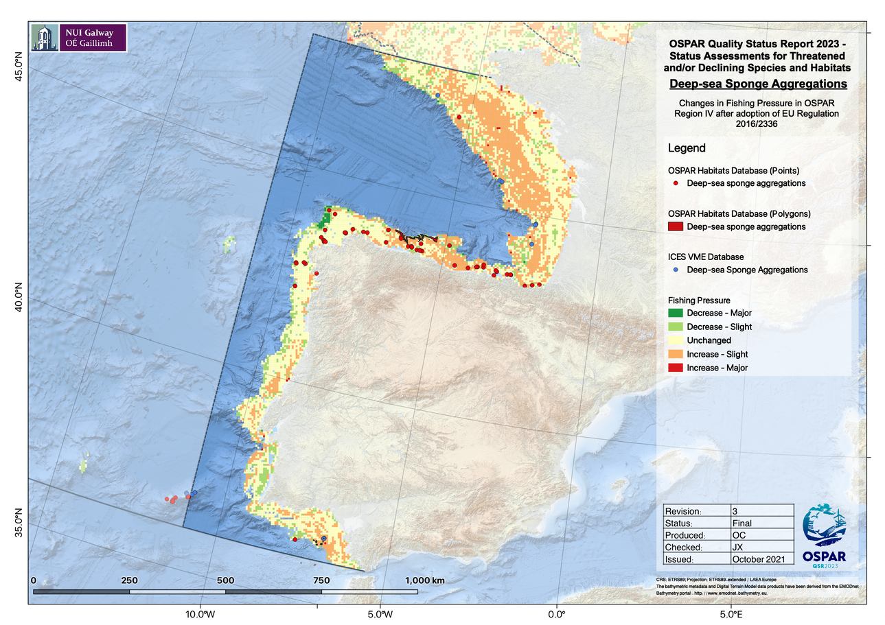  Figure 18 - Changes in fishing pressure in OSPAR region IV since the introduction of Regulation EU 2016/2336 and the overlap of that fishing pressure with sponge aggregation habitat.  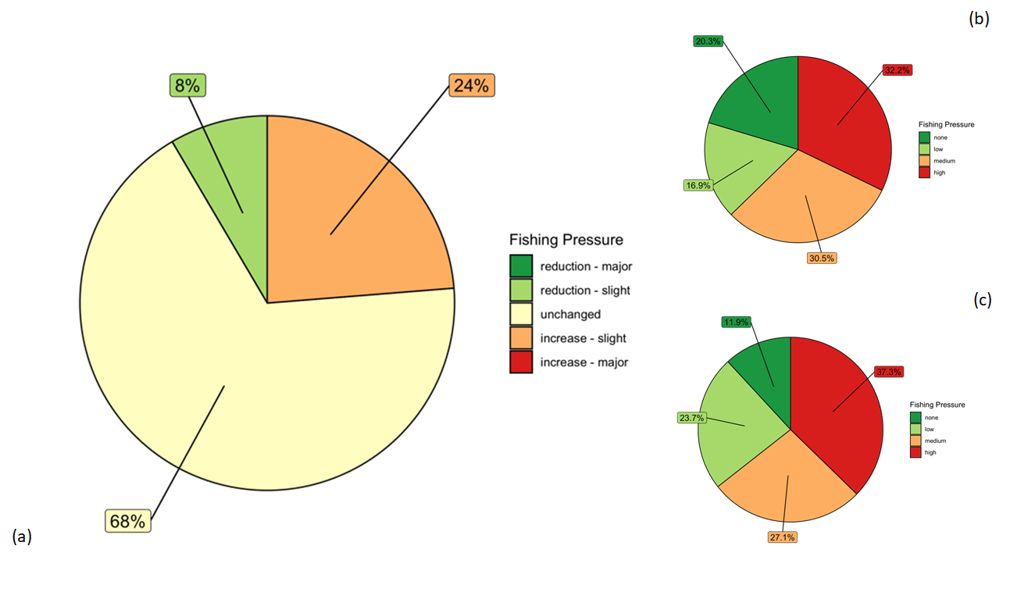  Figure 19 - Fishing pressure in OSPAR region IV (a) Changes in fishing pressure since the introduction of Regulation EU 2016/2336 in grid cells that contain sponge aggregation habitat.; (b) Relative fishing pressure prior to the introduction of Regulation EU 2016/2336 in grid cells that contain sponge aggregations habitat; (c) Relative fishing pressure after the introduction of Regulation EU 2016/2336 in grid cells that contain sponge aggregation habitat.  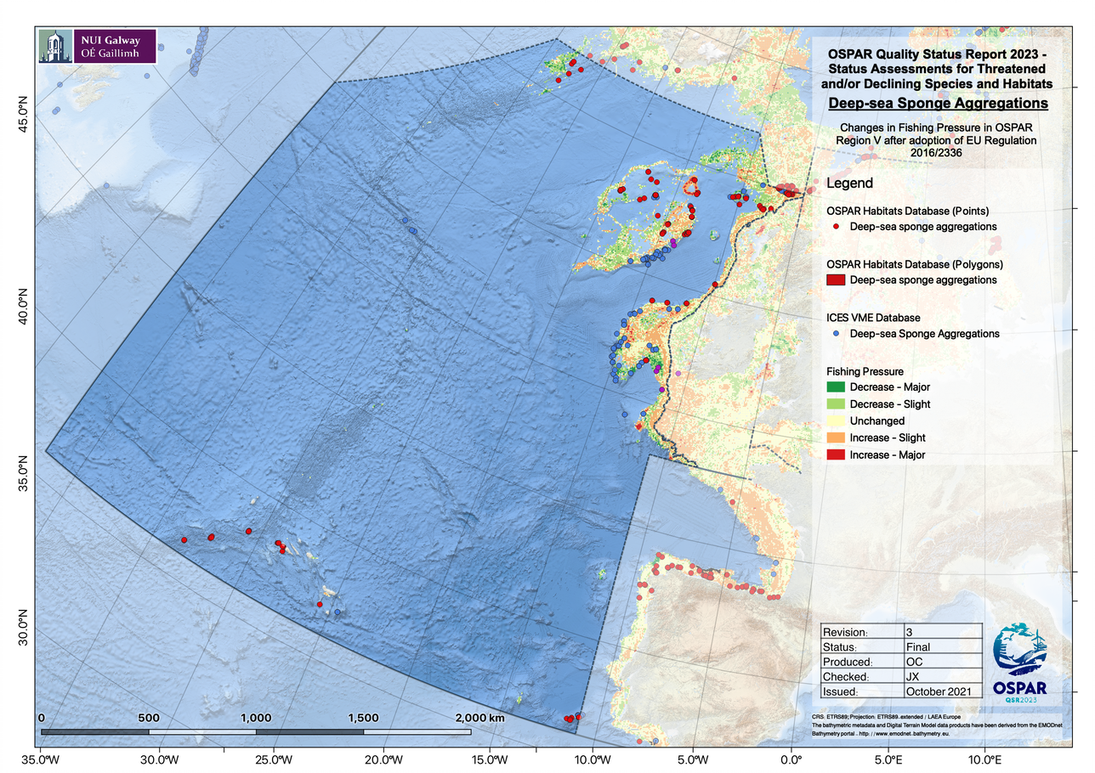  Figure 20 - Changes in fishing pressure in OSPAR region V since the introduction of Regulation EU 2016/2336 and the overlap of that fishing pressure with sponge aggregations habitat.  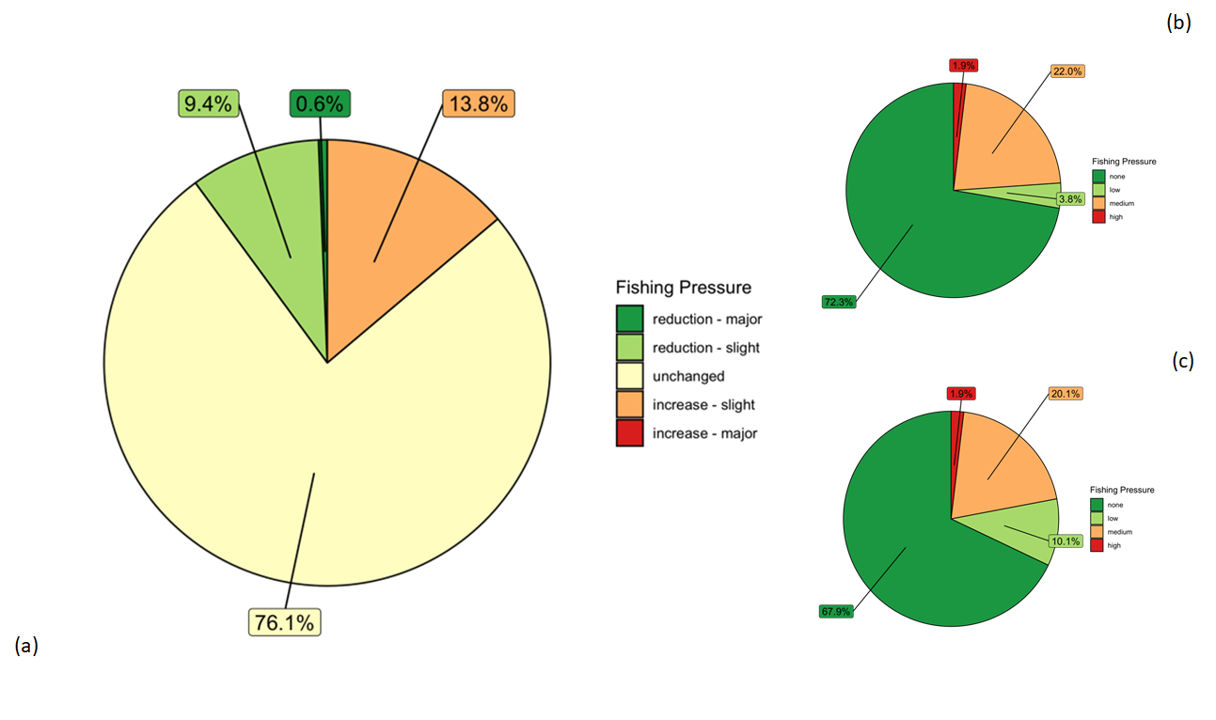  Figure 21 - Fishing pressure in OSPAR region V (a) Changes in fishing pressure since the introduction of Regulation EU 2016/2336 in grid cells that contain sponge aggregation habitat.; (b) Relative fishing pressure prior to the introduction of Regulation EU 2016/2336 in grid cells that contain sponge aggregations habitat; (c) Relative fishing pressure after the introduction of Regulation EU 2016/2336 in grid cells that contain sponge aggregations habitat.  Further threats to sponge aggregations include marine litter, pollution, and deep-sea mining.  Deep-sea mining:  Exploration contracts have been granted internationally for deep-sea mining activity, with potential threats to sponge aggregations from physical disturbance and sediment plumes. Currently there is no commercial deep-sea mining within the OSPAR area however, under the Subsea Minerals Act, the Norwegian government has initiated an opening process for offshore mineral activity, including an impact study (EIHA (WP) 21/01/02-Add.5Rev1). Given the demand for key metals in applications such as renewable technologies, deep-sea mining is likely to increase in coming decades, but our understanding of the environmental impacts is as yet uncertain.  Marine Litter:  Litter was found to be present in deep-sea European waters. Pham et al (2014) reported the highest litter density occurring in submarine canyons, whilst the lowest density could be found on continental shelves and on ocean ridges. Plastic was the most prevalent litter item found on the seafloor. Litter from fishing activities (derelict fishing lines and nets) was particularly common on seamounts, banks, mounds and ocean ridges.  Climate refugia:  Climate change refugium is a concept that gains momentum and it will be needed in the future to facilitate the survival of species under climate change conditions, and allow time for the biota to adapt to the climate change effects (Johnson et al.,, 2019). There are two complementary definitions: habitats that components of biodiversity retreat to, persist in, and can potentially expand from under changing environmental conditions (Keppel et al., 2012); areas relatively buffered from contemporary climate change over time that enable persistence of valued physical, ecological, and sociocultural resources (Morelli et al., 2016). Some current policies ask for identification of refugia to cold water areas, Johnson, D.E. and Kenchington, E.L., 2019 ask on their work that this should be considered for marine spatial planning and conservation measures development and applied, where appropriate, to all open ocean waters and deep sea habitats.  References  Harris, P.T., Macmillan-Lawler, M., Rupp, J., Baker, E.K., 2014. Geomorphology of the oceans. Mar. Geol., 50th Anniversary Special Issue 352, 4–24.  https://doi.org/10.1016/j.margeo.2014.01.011  Kroodsma, D.A., Mayorga, J., Hochberg, T., Miller, N.A., Boerder, K., Ferretti, F., Wilson, A., Bergman, B., White, T.D., Block, B.A., Woods, P., Sullivan, B., Costello, C., Worm, B., 2018. Tracking the global footprint of fisheries. Science 359, 904–908. https://doi.org/10.1126/science.aao5646  Somoza, L., Ercilla, G., Urgorri, V., León, R., Medialdea, T., Paredes, M., Gonzalez, F.J., Nombela, M.A., 2014. Detection and mapping of cold-water coral mounds and living Lophelia reefs in the Galicia Bank, Atlantic NW Iberia margin. Mar. Geol. 349, 73–90. https://doi.org/10.1016/j.margeo.2013.12.017  Johnson, D.E. and Kenchington, E.L., 2019. Should potential for climate change refugia be mainstreamed into the criteria for describing EBSAs?. Conservation Letters, 12(4), p.e12634.  Keppel, G., Van Niel, K. P., Wardell-Johnson, G. W., Yates, C. J., Byrne, M., Mucina, L., … Franklin, S. E. (2012). Refugia: Identifying and understanding safe havens for biodiversity under climate change. Global Ecology and Biogeography, 21(4), 393– 404.  Morelli, T. L., Daly, C., Dobrowski, S. Z., Dulen, D. M., Ebersole, J. L., Jackson, S. T., … Beissinger, S. R. (2016). Managing climate change refugia for climate adaptation. PLoS ONE, 11(8), e0159909. https://doi.org/10.1371/journal.pone.0159909  Pham CK, Ramirez-Llodra E, Alt CHS, Amaro T, Bergmann M, Canals M, et al. (2014) Marine Litter Distribution and Density in European Seas, from the Shelves to Deep Basins. PLoS ONE 9(4): e95839. https://doi.org/10.1371/journal.pone.0095839
Measures that address key pressures from human activities or conserve the species/habitat  (additional information) | Habitat distribution and MPA Overlap Analyses  For analysis of overlap of sponge aggregations with OSPAR Marine Protected Areas and NEAFC Closures, the OSPAR Marine Protected Areas Network (2021-07-16) was accessed from ODIMS (ODIMS, https://odims.ospar.org/en), and a layer of NEAFC Closures obtained from (https://www.neafc.org).  The analysis included only those sponge aggregations whose data had been submitted to the ICES VME database or the OSPAR threatened or declining habitats database (see above).  All point and polygon data were reprojected from their native coordinate reference systems (usually WGS 84, EPSG:4326) to the ETRS89-LAEA Europe coordinate reference system (EPSG:3035). Before any spatial analyses were conducted, habitat data obtained as points were first aggregated to an equal-area square grid which was specifically created for the purposes of conducting the assessments; this grid covered the entirety of the OSPAR Area with a grid-cell resolution of 25km² (see accompanying R-script). Aggregating the point data in this manner ensured that any data represented in multiple databases were not “double counted”. Also, where multiple point occurrences of a habitat were recorded in close proximity to one another, for example along the path taken by a remotely operated underwater vehicle (ROV) over the course of a survey transect, these habitats in a single small area would be considered (for the purposes of these analyses) as part of a single contiguous habitat.  To analyse the overlap between MPAs and known habitat occurrences, a simple spatial overlay was conducted in R. Habitat polygons were converted to points located at the centroids of all grid cells in which those polygons were present. In this manner, multiple small polygons within a single grid cell would be counted as a single point record and large polygons overlapping multiple grid cells would be counted as multiple point records placed at the centroids of each grid cell overlapped by the large polygon. For the MPA analyses it was determined whether each habitat point datum was (i) within an MPA, (ii) within a NEAFC closure, (iii) within an overlap between both an MPA and a NEAFC closure, or (iv) outside a protected area. The results of these analyses were used to produce pie charts summarising the percentage of habitat occurrences in each of the aforementioned four categories.  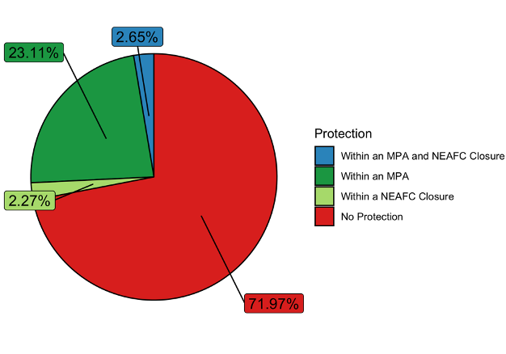  Figure 22 - Proportion of deep-sea sponge aggregations occurrence records found within Marine Protected Areas and NEAFC bottom-fisheries closures across the OSPAR maritime area.  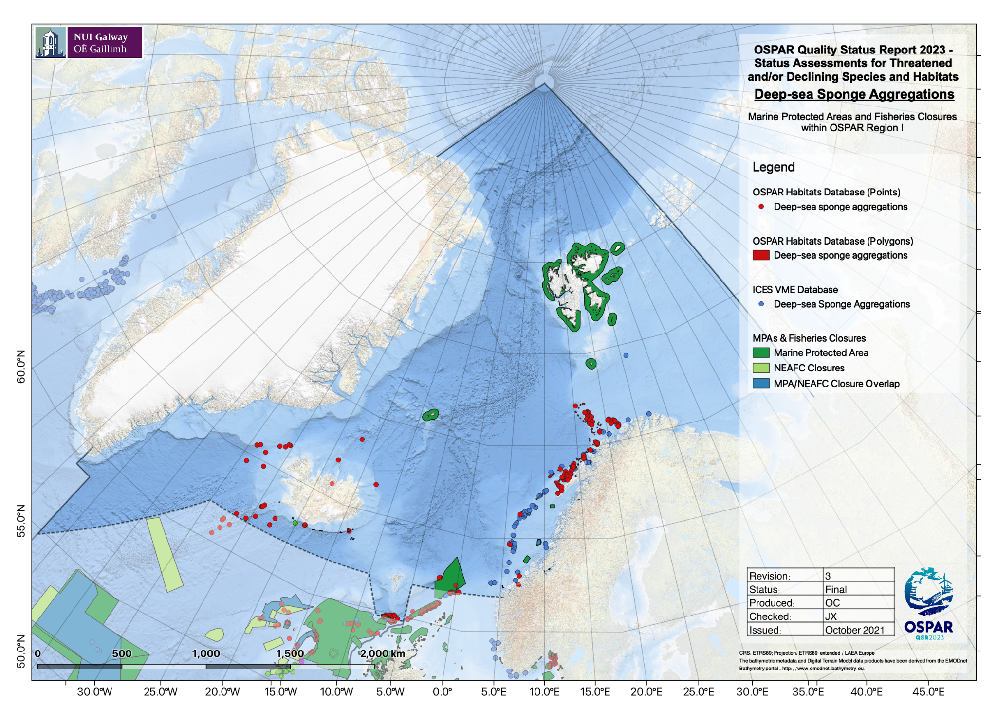  Figure 23 - Deep-sea sponge aggregations distribution in OSPAR region I in relation to Marine Protected Areas and NEAFC bottom-fisheries closures currently in place.  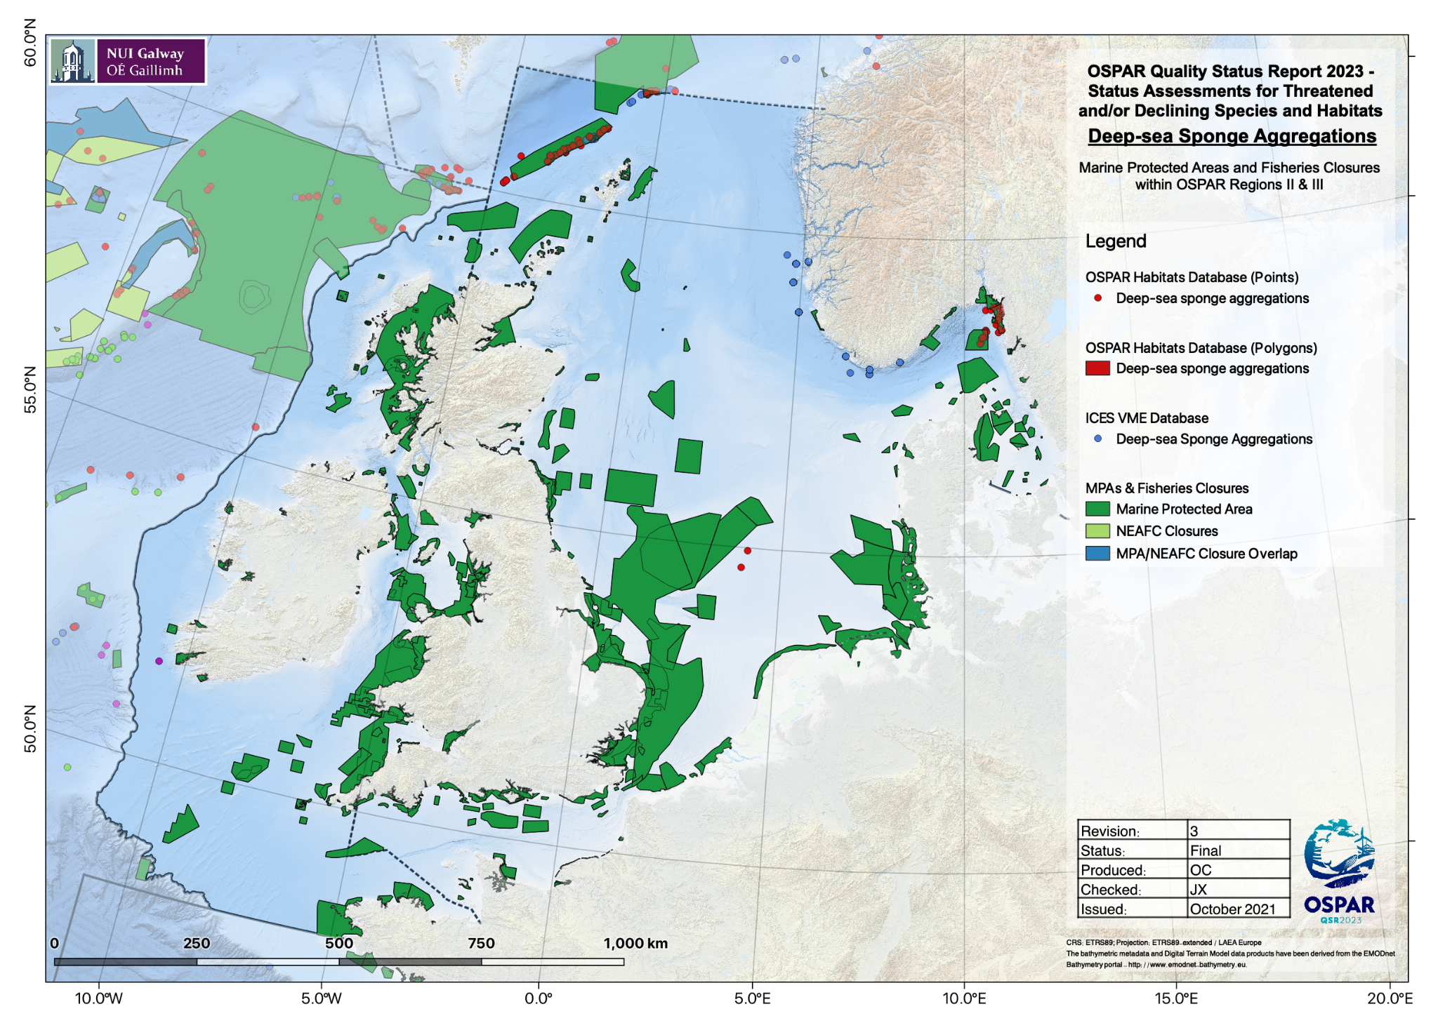  Figure 24 - Deep-sea sponge aggregations distribution in OSPAR region II in relation to Marine Protected Areas and NEAFC bottom-fisheries closures in place.  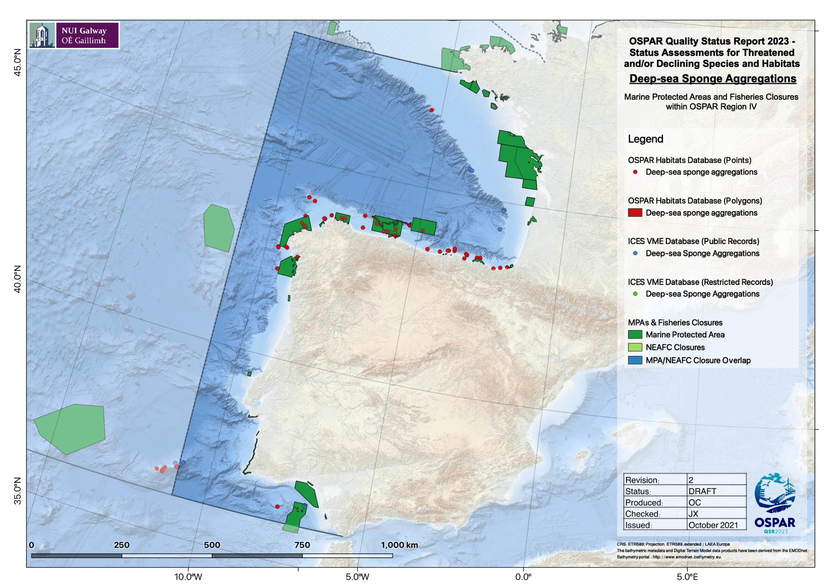  Figure 25 - Deep-sea sponge aggregations distribution in OSPAR region IV in relation to Marine Protected Areas and NEAFC bottom-fisheries closures in place.  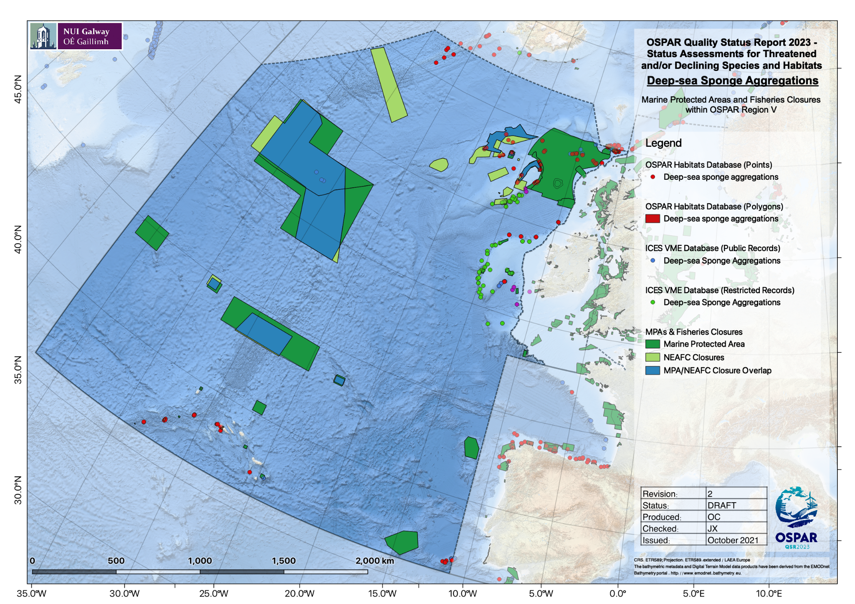  Figure 26 - Deep-sea sponge aggregations distribution in OSPAR region V in relation to Marine Protected Areas and NEAFC bottom-fisheries closures in place.
Knowledge gaps (additional information)
References

https://www.ospar.org/documents?v=7234

