Sheet reference | BDC2022/Carbonate_Mounds
Area Assessed | OSPAR Regions where it occurs: I, V  OSPAR Regions where habitat is under threat and/or decline: V (Background Document, OSPAR Commission, 2010)
Title | Status Assessment 2022 - Carbonate Mounds

Key message  – 50 words maximum | Given the (i) ongoing threat, potential displacement and intensification, and significant impacts to carbonate mounds posed by demersal fisheries, (ii) lack of marine protected areas and/or fisheries management measures covering carbonate mounds, (iii) ongoing evidence of fisheries damage including lost fishing gear on carbonate mounds, and (iv) vulnerability and sensitivity of other Threatened and Declining listed habitats on carbonate mounds, this habitat type has been assessed as likely having overall poor status.  Explanation to table:  Distribution, Population size, Condition  Trends in status (since the assessment in the background document)  ↓ decreasing trend or deterioration of the criterion assessed  ↑ increasing trend or improvement in the criterion assessed  ←→ no change observed in the criterion assessed  ? trend unknown in the criterion assessed  Previous status assessment: if QSR 2010 then enter Regions where species occurs (○) and has been recognised by OSPAR to be threatened and/or declining (●) based on Chapter 10 Table 10.1 and Table 10.2. If a more recent status assessment is available, then enter ‘poor’/’good’  Status*(overall assessment)  red – poor  green – good  ? - status unknown.  NA - Not Applicable  *applied to assessments of status of the feature or of a criterion, as defined by the assessment values used in the QSR 2023 or by expert judgement.  Types of assessment:  1 – direct data driven,  2 – indirect data driven,  3 – third party assessment close-geographic match,  4 - third party assessment partial-geographic match  5 – expert judgement.  (Use more than one number when mixed methods were used)  Explanation to table:  Key Pressure  ↓ key pressures and human activities reducing  ↑ key pressures and human activities increasing  ←→ no change in key pressures and human activities  ? Change in pressure and human activities uncertain  Threats or impacts (overall assessment)  red – significant threat or impact;  green –no evidence of a significant threat or impact  Blue cells – insufficient information available  Types of assessment:  1 – direct data driven,  2 – indirect data driven,  3 – third party assessment close-geographic match,  4 - third party assessment partial-geographic match  5 – expert judgement.  (Use more than one number when mixed methods were used)
  Assessment of status |  | Distribution | Population size (for species) or extent (for habitats) | Condition (for habitats) or Demographics (for species if applicable, e.g. productivity) | Previous OSPAR status assessment | Status (overall assessment)
  Region | I |  |  |  | ○
  Region | II
  Region | III
  Region | IV
  Region | V | ←→ ^{1,5}​ | ←→ ^{1,5}​ | ? ^{1,2,3,5} | ● | poor
  Assessment of threats |  | Habitat loss/degradation through physical damage from demersal fisheries | Habitat loss or alteration through community shifts and/or increasing ocean acidification due to climate change | Threat or impact
  Region | I
  Region | II |  |  | NA
  Region | III |  |  | NA
  Region | IV |  |  | NA
  Region | V | ←→^{1,2,5} | ?^{1,3,5} | ←→^{1,2,5}
Confidence | Overall, there is medium confidence in the status assessment.  There is medium confidence in the evidence for the Distribution and Extent criteria. Direct data-driven evidence comes from the OSPAR threatened and/or declining habitats database, an increasing number of publicly funded exploration programmes since 2010 to ground-truth and expand Distribution records across Region V, e.g., from Galicia Bank (Somoza et al., 2014) where OSPAR currently has no records, SeaRover2017 (Picton et al., 2021), and from Bonneau et al. (2018) who confirmed ages of SW Rockall corals on Logachev Mound of ~128ka (using U/Th series dating) for carbonate mounds in this area that the OSPAR database does already capture.  Confidence in Distribution could be strengthened either through extensive habitat mapping and ground-truthing programmes in the OSPAR Maritime Area and/or through the use of predictive modelling approaches (e.g., Diesing and Thorsnes, 2018) as these are improving in accuracy and reliability when scaled up to the OSPAR Regions.  There is low to medium confidence in the evidence for the Condition criterion. A major issue is that no Contracting Party undertakes regional scale monitoring of carbonate mounds or Condition of the feature. The OSPAR common indicator BH3 Extent of Physical Damage to Predominant and Special Habitats (OSPAR Commission, 2017), does not have sufficient spatial coverage to allow for an assessment of condition of carbonate mounds and can only be used to partially assess Condition (the indicator is designed to assess “Structure and Function” instead of “Condition” as referred to in the EU Marine Strategy Framework Directive) of United Kingdom offshore reefs which were assessed as being in an “Unfavourable-Bad” status with declining future prospects. Besides partial assessments, direct data-driven evidence for Condition since 2010 has come from various research expeditions that documented presence or abundance of key species (black corals in particular; De Clippele et al. 2019; Picton et al., 2021), quality of abiotic components such as substrate but also marine litter (De Clippele et al., 2019; Picton et al., 2021), and information on processes supporting the feature such as hydrodynamics and food supply including the threats posed by climate change (Soetaert et al., 2016; Lim et al., 2018; van der Kaaden et al., 2021). Climate-ocean state projections with a close geographic match suggest all carbonate mounds in the Wider Atlantic (Region V) are likely to be impacted by climate change by 2100 (Morato et al., 2020; Puerta et al., 2020).  By proxy, there is medium confidence that ongoing threats and impacts from demersal fisheries and lack of fisheries restrictions have contributed to the deterioration of this habitat. This is especially true for those threatened and/or declining listed habitats that occur on carbonate mounds and, according to expert judgement, have high sensitivities to impacts of demersal fishing gears, i.e., cold-water coral reefs, coral gardens and sponge aggregations.
Background Information  - 100 words maximum | - Carbonate mounds were added to the OSPAR list in 2003 (see the Case Report for nomination to OSPAR, 2008; https://www.ospar.org/site/assets/files/44271/carbonate_mounds.pdf  - The feature was last assessed in 2010; https://www.ospar.org/documents?v=7219  The habitat occurs in Arctic Waters (Region 1), but is listed as Threatened and/or Declining only in Region V where clusters of coral carbonate mounds formed by successive periods (>10 000 years) of coral reef development, sedimentation and (bio)erosion are known to occur (Background Document, OSPAR Commission, 2010). The full extent of carbonate mounds in the OSPAR Maritime Area is not fully known yet.  - Region V met several Texel-Faial criteria for listing carbonate mound habitat. Condition of habitats and associated epifauna on carbonate mounds still targeted by demersal fisheries will likely decline through physical abrasion from mobile gear (OSPAR Commission, 2008). Carbonate mounds frequently occur in clusters, e.g., in the Rockall and Porcupine Basins they are abundant and concentrated in areas on the basins’ slopes. Since the last assessment, mounds have been discovered on the Iberian margin (Somoza et al., 2014) but require further mapping effort. Habitats on carbonate mounds can be dominated by fragile and long-lived filter- and suspension-feeders that in themselves form other OSPAR Threatened and Declining listed habitats such as Lophelia reefs, deep-sea sponge aggregations and coral gardens, all of which are sensitive to siltation and mortality caused by demersal mobile fishing gear. The topographic highs and hard substrata on many carbonate mounds offer numerous ecological niches from the summit to their flanks, supporting a high biological diversity of invertebrates and fish including those of commercial importance.  - Table 10.3 in the QSR 2010 report (OSPAR, 2010) identified habitat damage to be the main key pressure, which was reinforced by Table 1 in the 2010 carbonate mound status assessment (OSPAR Commission, 2010).  - Carbonate mounds nomination to the Threatened and Declining list in OSPAR’s Case Report 2008/358 (OSPAR Commission, 2008) lists this feature in Regions I and V, but only Region V was nominated under Texel-Faial criteria​. The 2010 assessment of carbonate mounds (OSPAR Commission, 2010: https://www.ospar.org/documents?v=7219), concluded that habitats associated with the mounds were in decline through damage caused by demersal fisheries. The assessment noted that the OSPAR Maritime Area is globally important for this feature as it contains the greatest concentration and the largest examples of coral carbonate mounds worldwide, with Region V of high importance. Sensitivity of cold-water coral reefs occurring on carbonate mounds was noted, with the 2010 assessment calling for more research on sensitivity of other Threatened and Declining habitats to impacts of demersal fishing gear. The assessment underlined the ecological significance of carbonate mounds in supporting high biodiversity and other Threatened and Declining species such as, e.g., orange roughy. The assessment noted that carbonate mounds were not immediately threatened by anthropogenic activities but that the habitats occurring on carbonate mounds were threatened.
Geographical range and distribution  - 100 words + map/ infographic) | 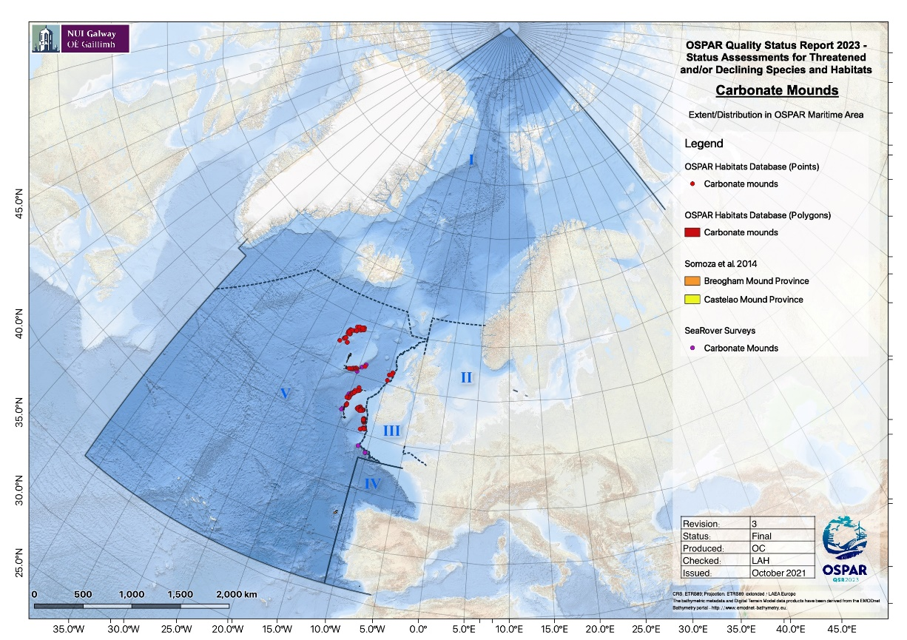  Figure 1: Distribution of carbonate mounds in the OSPAR maritime area  Carbonate mounds occur in Regions I and V, but only Region V was nominated under Texel-Faial criteria (OSPAR Commission, 2008). OSPAR itself does not hold any records of this feature in Region I, as the last status assessment (OSPAR Commission, 2010) used a modified definition to refer to specific types of carbonate mounds that excluded those features in Region I. OSPAR Agreement 2014/10 (OSPAR Commission, 2014) calls for measures only in Region V where these specific types of coral carbonate mounds occur. They tend to cluster in provinces off Ireland, the northwest and southwest Rockall Bank, with a high likelihood of occurrence on Hatton Bank. Recent discoveries of coral carbonate mounds on Galicia Bank (Somoza et al., 2014) extend the known distribution of this feature further across Region V, in close proximity to the Bay of Biscay and Iberian Coast (Region IV). It is highly likely that the known extent of carbonate mound distribution in Region V in particular will expand as exploration continues.  Main method of assessment: 3b
Extent (habitats)  - 100 words + figure) | 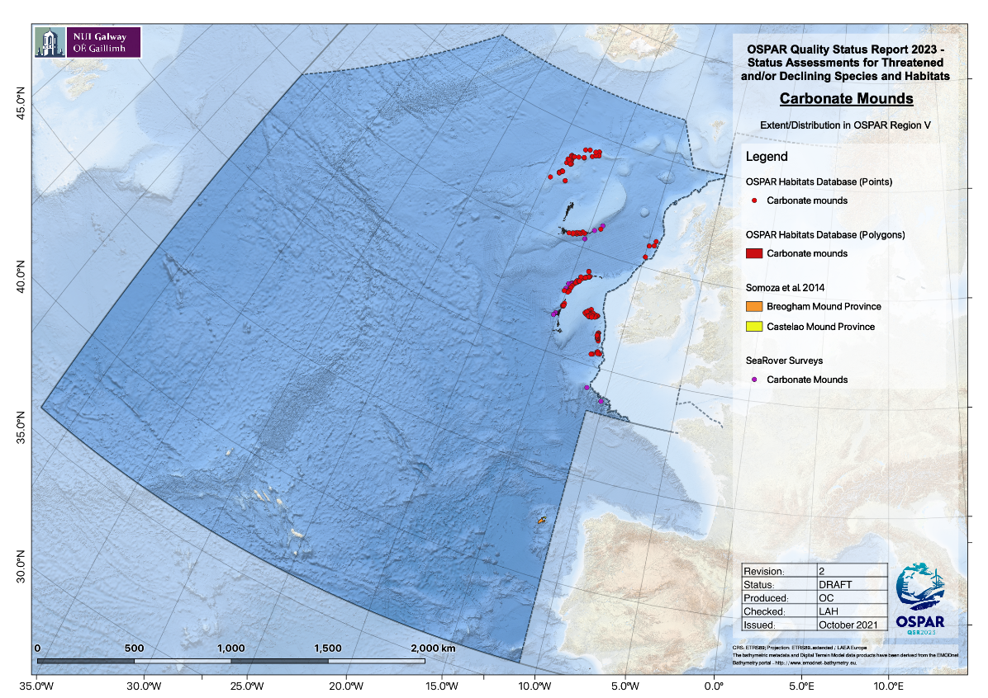  Figure 2: Extent of carbonate mounds in Region V, indicating the recent discoveries of carbonate mounds on Galicia Bank (yellow arrow).  There has been no actual change in the extent of carbonate mounds since the last assessment, the feature being geologically stable over thousands to millions of years, e.g., the latter being the case of Challenger Mound in the Porcupine Seabight. High densities of carbonate mounds occur around Rockall Bank, Hatton Bank, the Porcupine Seabight and Porcupine Bank (Figure 2). However, a recent discovery of coral carbonate mounds on Galicia Bank significantly expanded the known extent of this feature on the eastern boundary of Region V (Figure 3).  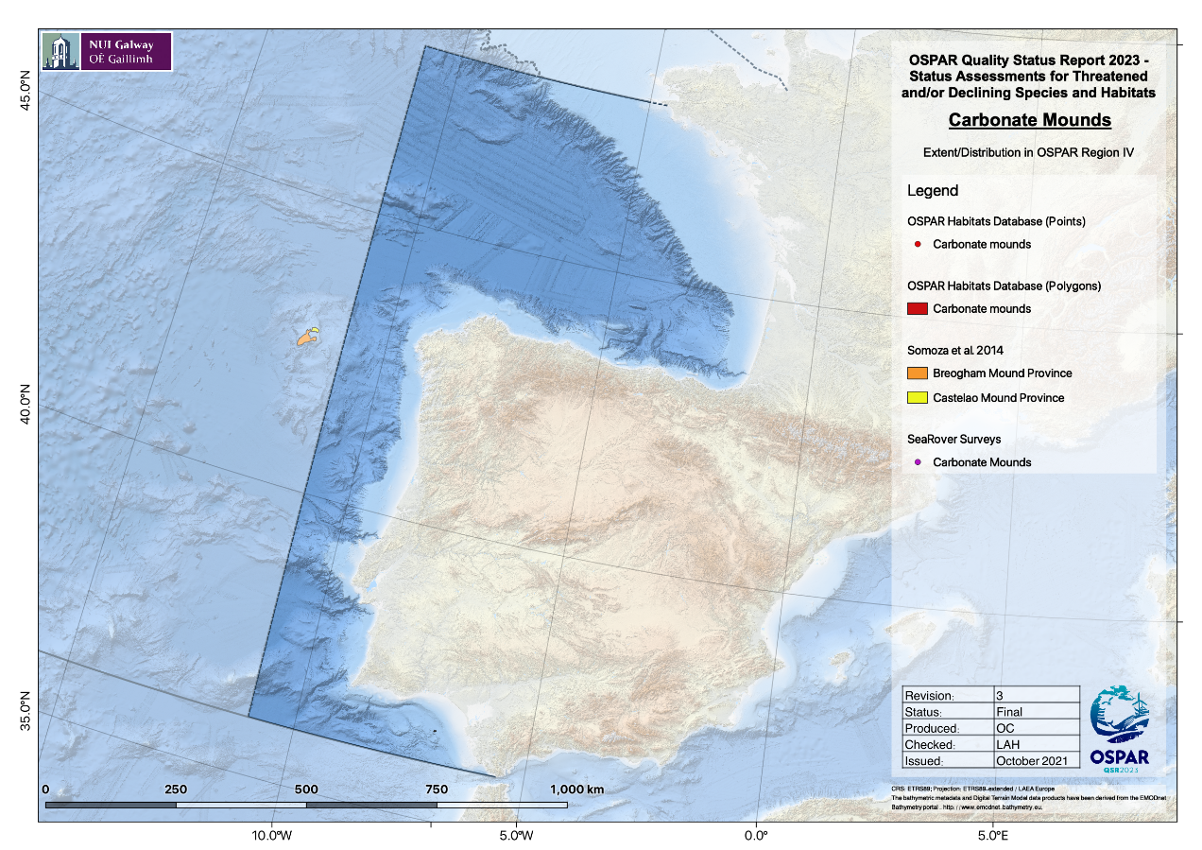Figure 3: Recent discovery of two carbonate mound provinces on Galicia Bank significantly expand the known extent of this feature with Region V, in very close proximity to OSPAR Region IV shown here.  It is anticipated that more mounds will be discovered in the future, thus our knowledge of their extent will change. In the future, extent is unlikely to change unless an industry sector develops that has the potential to damage or remove significant portions of a carbonate mound, e.g., extensive aggregate removal.  Main method of assessment: 3b
Condition  - 100 words + figure | Overall, condition of carbonate mounds is not known in the whole OSPAR Maritime Area, but there has been an improvement in the understanding of current and future prospects at a limited number of carbonate mounds since the last assessment in 2010. New evidence is based mainly on data from third parties but note that these have very limited spatial and temporal extent. Proxy data based on MPAs, management measures, and on demersal fisheries from OSPAR and third parties are available.  This evidence reveals a wider range of other Threatened and Declining listed habitat types associated with carbonate mounds than was known in 2010. These include different types of Vulnerable Marine Ecosystems (VMEs) and VME indicator taxa (de Clippele et al., 2019; Picton et al., 2021; Price et al., 2021). High associated biological diversity including shrimps, crabs, crinoids and ophiuroids have been recorded now, with the Challenger Mound topped by Cidaris cidaris urchin aggregations (Picton et al., 2021). The ecological importance of these features to demersal fish and especially early life history stages of oviparous elasmobranchs is supported by new evidence. Underwater camera transects show lost fishing gear on carbonate mounds and trawl marks. Regional fisheries pressure proxies and introduced management measures suggest a reduction of pressures for some mounds but possible intensification of pressures on others.  Carbonate mounds are not listed under the Habitats Directive or regularly assessed by other 3rd parties, but Reefs are Annex I listed (Reefs – 1170). Every six years, Member States of the European Union are required under Article 17 of the Directive to report on implementation of the Habitats Directive. Conservation Status (2013-2018) of Marine Atlantic Reef habitats (Habitats Directive, Article 17) by EU Member States were last recorded as “Unfavourable-Inadequate (Ireland) and “Unfavourable-Bad” (UK) (see https://jncc.gov.uk/jncc-assets/Art17/H1170-OFF-Habitats-Directive-Art17-2019.pdf). Kazanidis et al. (2020) conducted a mock-GES assessment for Porcupine Seabight based on expert judgement to conclude that carbonate mounds in this sector of Region V were likely to have good environmental status despite fisheries pressure elsewhere.  It is estimated that 59% of carbonate mounds in Region V are not spatially protected other than by the Deep-Sea Access Regulations (Figure 4).  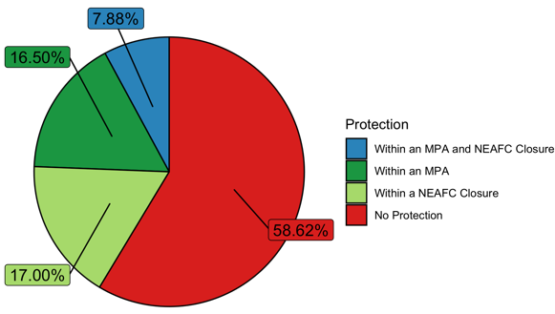  Figure 4: Distribution of carbonate mound records with respect to MPAs and fisheries closures within OSPAR Region V.  Limited but highly detailed studies on hydrodynamic and food supply controls on carbonate mound condition suggest declining future prospects, but these cannot yet be evidenced directly. Carbonate mounds in Region V are tightly coupled to hydrodynamics, linking mixing, nutrients and food supply to coral mound growth, mound coalescence, and ecosystem functioning (Mohn et al., 2014; Cyr et al., 2016; Lim et al., 2018; de Froe et al., 2019). Expert judgement concluded that carbonate mound structure and functioning, and thus habitat quality, are highly sensitive and likely to deteriorate in future due to climate-induced changes in primary production, local hydrodynamics, organic matter flux and ocean acidification. Combined with the lack of protection from demersal fisheries, the occurrence of other Threatened and Declining habitats, overall habitat quality and the processes that support the feature could decline in the near future.  Main method of assessment: 3b
Threats and impacts  - 100 words | Demersal fisheries  Since the last QSR assessment in 2010 (OSPAR Commission, 2010), fisheries and climate change continue to pose detrimental threats and impacts on carbonate mounds in Region V. However, such pressures could not be confidently assessed across the entire region due to lack of data accessibility to perform this assessment (e.g., vessel monitoring system (VMS) data would provide for a more robust estimate of exerted fishing pressure) and the timescales for climate-induced changes to have impacted carbonate mounds in ways that can be measured.  Overall, habitat loss/degradation through physical damage from demersal fisheries has likely declined in Region V over the time-period 2010 to 2016, but demersal fisheries activity proxied by subsurface bottom fishing intensity (swept-area ratio) seem to have intensified in particular areas within Region V (Figure 5), potentially indicating fishing effort displacement from carbonate mounds like Hatton Bank and southwest Rockall to Porcupine Bank.  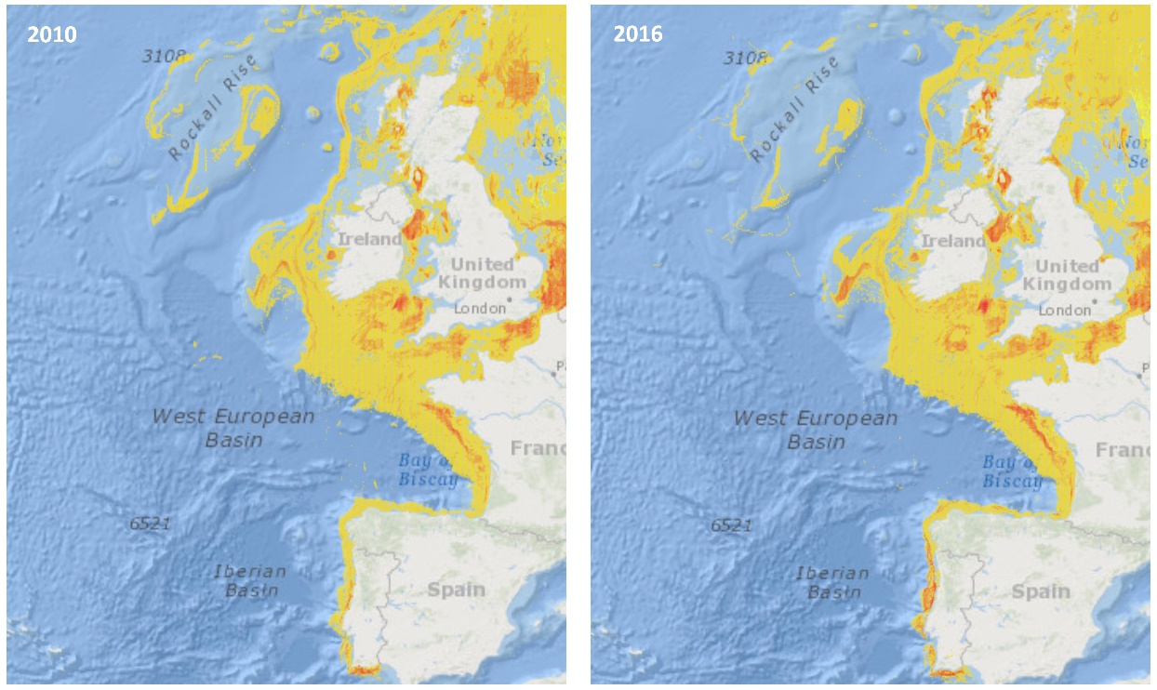  Figure 5: Subsurface bottom fishing intensity (swept-area ratio) submitted by ICES to OSPAR BDC (reported in draft EIHA Feeder Report​) since the last assessment in 2010 (left panel) and in 2016 (right panel), showing a possible displacement of bottom fishing activity on Porcupine Bank over time (https://odims.ospar.org/en/submissions/ospar_bottom_f_intensubsur_2016_01/)  Global Fishing Watch automatic identification system (AIS) tracking data were used as proxy for demersal fisheries activity since the introduction of the Deep-Sea Access Regulation EU 2016/2336, which restricts deep-sea fishing to areas already fished in the past and banning trawling below 800m depth. This showed that demersal fisheries pressure has very likely not changed on more than half of the carbonate mounds in OSPAR Region V (Figure 6).  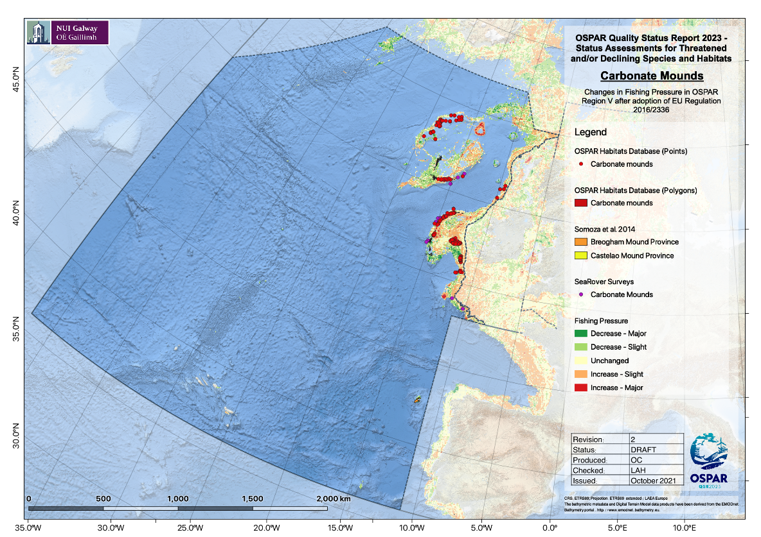  Figure 6: Changes in fisheries pressure after 2016 following the implementation of the EU Deep-Sea Access Regulation EU 2016/2336.  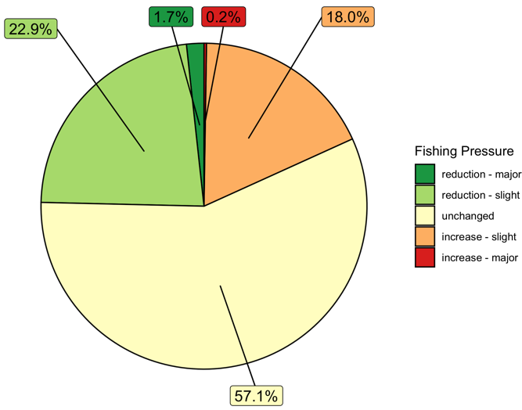  Figure 7 supports the subsurface swept-area ratio data (Figure 5), in that there appears to be reductions in fishing pressures in some places (major and minor reductions totaling 24,6%) and increasing fishing pressure elsewhere (major and minor increases totaling 18,2%), with no change in fishing in 57,1% of areas with carbonate mounds (Figure 7).  Figure 7: Change in habitat/fishing pressure overlap pre- and post-introduction of 2016 Deep-Sea Access Regulations in OSPAR Region V, according to analysis of Global Fishing Watch AIS data.  Pham et al. (2014) reported 1,9±0,8 items litter/ha on Hatton Bank, 87,5% of which was fishing gear found during ROV/towed camera surveys 2005 to 2011. Separately, 13 ROV dives as part of the SeaRover programme were conducted on carbonate mounds; two dives recorded fishing gear (one with trawl marks) in addition to three dives with plastics as well (Picton et al. 2021).  Key pressure 2: climate change and ocean acidification  Climate change threatens to induce significant shifts in biological communities on carbonate mounds and impact processes that support these features in Region V through altered hydrodynamic regimes, a re-distribution of primary productivity and availability of organic matter to the seafloor, and ocean acidification, e.g., for the latter, ICES (2014) predicted that under RCP4,5, waters surrounding Hatton and Porcupine Banks will be approaching aragonite undersaturation by 2100. Climate change and ocean acidification impacts on carbonate mounds remain unknown even since the last assessment and may not have either occurred yet or have not been measured in situ on these listed features. However, expert judgement suggests these impacts could have started to take place as even short-term exposure to decreased pH can impact cold-water corals, and these pressures are likely to increase over the next six to 12 years.
Measures that address key pressures from human activities or conserve the species/habitat  - 100 words | (i) Information on implementation status of OSPAR measures  For the 2019 reporting cycle that was received in time for the present status assessment, Ireland had implemented all eight recommendations (3.1(a)-3.1(h)) e.g., Regulation (EU) 2016/2336, European Communities (Birds and Natural Habitats) Regulations (2011-2015), EU Habitats Directive (92/42/EEC), European Union (Birds and Natural Habitats) (Sea-Fisheries) Regulations (2013-2014). Six SACs have been designated to protect EU Habitats Directive listed Reef habitat incorporating Carbonate Mounds.  The UK had implemented four of the eight Recommendations, e.g., the full extent of verified carbonate mound records in the Hatton Bank candidate SAC (the only location of this feature in UK waters) are now closed to bottom-contact fishing operations under NEAFC Recommendation 19 2014; Protection of VMEs in NEAFC Regulatory Areas, as amended by Recommendation 09:2015 and 10:2018. EU regulation 2016/2336, which bans the use of bottom trawls in depths below 800 m in the North-East Atlantic, affords additional protection to carbonate mounds in depths below 800 m. The UK did not implement anything new since 2016 regarding 3.1(c) consider monitoring distribution, extent and quality, 3.1 (d) consider ways to broaden the knowledge base on carbonate mounds with other relevant actors or seeking ways to gather new data, 3.1(e) consider sites for MPAs and the OSPAR MPA network, or 3.1(h) consider acting within the framework of other competent authorities.  By 2019, Spain had also implemented four of the eight. e.g., Banco de Galicia has now been designated as a Site of Community Importance (SCI) under Ministerial Regulations AAA/1299/2014 of 9 July 2014 and AAA/2280/2014, of 1 December 2014.​They have also been included in the OSPAR MPA Network in 2014 and 2016. Spain did not implement 3.1(a) on implementing new legislation, (b) consider management effectiveness, (f) consider minimizing adverse impacts or (h) consider acting within the framework of other competent authorities.  Notably, it is not apparent from the 2019 Implementation Reports whether it has been determined what, if any, further measures are needed to address potential climate change impacts.  (ii) Actions taken beyond the scope of the OSPAR measure, e.g,. by other competent authorities OR to address threats to the species outside the OSPAR area  In total, 58,6% of carbonate mounds in Region V remain unprotected either by MPAs or fisheries management measures besides the Deep-Sea Regulation 2016/2336 with 17% of carbonate mounds protected from fisheries by NEAFC closures and 16,5% designated as MPAs (Figure 4). NEAFC closures are therefore the more common type of action taken to address key pressures and threats to carbonate mounds in Region V to date (Figure 8).  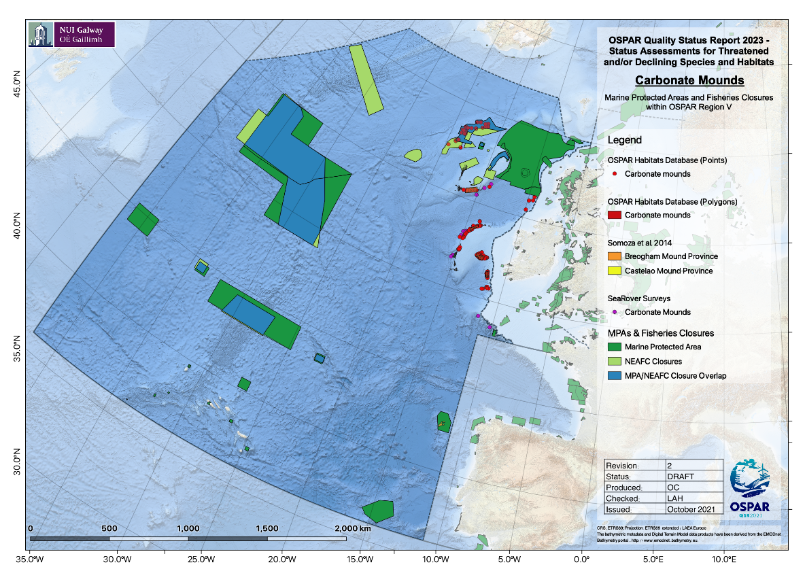  Figure 8: Marine protected areas and NEAFC fisheries closures in Region V.  UNGA Resolution 61/105 calling for measures such as “move-on” rules for fishing vessels related to encounters of specific quantities of VME indicator taxa has been implemented through NEAFC Recommendation 19 (2014). Within EU waters, Regulation (EU) 2016/2336 restricts bottom fishing >400 m to the 2009 to 2011 fishing footprint, prohibits bottom fishing >400 m where VMEs are known or likely to occur (through designation of VME closures) and places a complete ban on bottom trawling deeper than 800 m. Within UK waters, regulation (EU) 2016/2336 is transposed into the Common Fisheries Policy and Aquaculture (Amendment etc.) (EU Exit) Regulations 2019, with the same fishing restrictions and prohibitions in place.  The zero Total Allowable Catch (TAC) for orange roughy (another Threatened and Declining listed feature) implemented in 2010 until 2024 will also have reduced fishing pressures on carbonate mounds.  The Convention on Biological Diversity’s process of the identification of Ecologically or Biologically Significant marine Areas (EBSAs; CBD/EBSA/WS/2019/1/4) has resulted in the Hatton and Rockall Banks and the Hatton-Rockall Basin being proposed as an EBSA via the CBD’s 15th Conference of the Parties (not concluded at the time of publication). Identification carries no management measures, but the evidence collected in the description process can be used to inform area-based management tools. For carbonate mounds, the evidence used for the EBSA criterion on Naturalness was also used as evidence for Threats and Impacts in this assessment, noting human impacts on Hatton Bank in the form of lost fishing gear for example (Pham et al., 2014).
Conclusion (including management considerations)  - 250 words | The condition of carbonate mounds is likely deteriorating based on multiple lines of evidence mostly from demersal fisheries. Evidence from multiple sources suggest possible displacement and intensification of fisheries activity in some areas with carbonate mounds, and direct data-driven evidence shows trawl marks and lost fishing gear on carbonate mounds. There is an on-going lack of fisheries protection and/or MPAs designated for including carbonate mounds, with 58% of carbonate mounds covered by nothing more than the EU Deep-Sea Regulation 2016/2336. Yet high densities of coral framework and particularly the living coral exists above 800 m (van der Kaaden et al., 2021). Climate change and ocean acidification is increasing but evidence of impacts since the QSR 2010 assessment is still lacking. ​  The feature continues to meet the Texel-Faial criteria and there is now an even stronger evidence base for the pressures affecting the habitat (resulting in decline of habitats found on carbonate mounds), the ecological significance of carbonate mounds, their sensitivity and threats. A comment on rarity: since coral carbonate mounds of Holocene origins are not included in the current OSPAR definition (thus excluding mounds in OSPAR Region I and some in Region V) there is increased perception of rarity, but, regardless of definition, the OSPAR Maritime Area is an important area for this feature worldwide.  Overall, there was low to medium confidence in this status assessment, due mainly to the heavy use of proxy-based data on fisheries pressures and efforts to extrapolate results from spatially and temporally restricted but highly detailed studies on carbonate mound condition.  In terms of management, implementation reporting appears uneven across Contracting Parties (Spain, UK, Ireland) but the full reporting process was not considered. Many area-based management tools such as SACs, SCIs, and NEAFC closures have been implemented since 2010, but still 58% of carbonate mounds are not covered by any management measure beyond the EU ban on demersal fishing at depths >800m with the majority of the living coral cover occurring at shallower depths (van der Kaaden et al., 2021). Additionally, Ireland has banned new oil and gas exploration on its shelf, which may de facto help protect carbonate mounds from impacts from the hydrocarbon sector.  There was no explicit reporting on climate change under Recommendation 3.1b – “assessing whether existing management measures for the protection of carbonate mounds are effective, and determine whether further measures are needed to address the key threats, including the potential impacts from climate change and ocean acidification”.  Overall, it is anticipated that a 10-year cycle of re-assessment is required. This extends the 6-year cycle suggested by the earlier status assessment in 2010 as it was thought at the time of the current assessment that changes would not be detectable in under a decade.
Knowledge gaps (brief)  - 100 words | Overall, the present status assessment suffered from insufficient direct data-driven evidence. Specifically, this is an issue for assessing distribution and extent (though that gap is closing) but particularly condition as there is still no regional monitoring programme implemented by any Contracting Party. This is the most significant issue with sufficiency of data and therefore evidence. A coordinated monitoring programme across all deep-sea threatened and/or declining listed habitats could solve many data deficiencies. Vessel Monitoring System (VMS) data would also have significantly advanced this assessment, even if coarsely gridded.  Further consideration of a technical definition of the habitat should be progressed to determine whether the next cycle should consider the full range of carbonate mounds (and thus Region I) and take the next steps in recording these data in the OSPAR threatened and/or declining habitats database.  Changes in relation to natural variability (e.g., distribution of habitats over space and time, environmental drivers of variability, and the roles that ocean physics and dynamics have in structuring carbonate mounds and the processes that support them) are not well investigated and such studies are required to increase the evidence base for future assessments
References | Bonneau, L., Colin, C., Pons-Branchu, E., Mienis, F., Tisnerat-Laborde, N., Blamart, D., Elliot, M., Collart, T., Frank, N., Foliot, L., Douville, E. 2018. Imprint of Holocene climate variability on cold-water coral reef growth at the SW Rockall Trough Margin, NE Atlantic. Geochemistry, Geophysics, Geosystems 19: 2437-2452  Cyr, F., van Haren, H., Mienis, F., Duineveld, G., Bourgault, D. 2016. On the influence of cold-water coral mound size on flow hydrodynamics, and vice versa, Geophysical Research Letters 43: 775–783  De Clippele, L.H., Huvenne, V.A.I., Molodstova, T.N., Roberts, J.M. 2019. The diversity and ecological role of non-scleractinian corals (Antipatharia and Alcyonacea) on scleractinian cold-water coral mounds. Frontiers in Marine Science 6: 184  de Froe, E., Rovelli, L., Glud, R.N., Maier, S.R., Duineveld, G., Mienis, F., Lavaleye, M. van Oevelen, D. 2019. Benthic oxygen and nitrogen exchange on a cold-water coral reef in the north-east Atlantic Ocean. Frontiers in Marine Science 6: 665  Diesing, M., Thorsnes, T. 2018. Mapping of cold-water coral carbonate mounds based on geomorphometric features: an object-based approach. Geosciences 8: 34.  Kazanidis, G., et al. 2020 Assessing the environmental status of selected North Atlantic deep-sea ecosystems. Ecological Indicators 119: 106624  Lim, A., Huvenne, V.A.I., Vertino, A., Spezzaferrie, S., Wheeler, A.J. 2018. New insights on coral mound development from groundtruthed high resolution ROV-mounted multibeam imaging. Marine Geology 403: 225-237  Mohn, C. Rengstorf, A., White, M., Duineveld, G., Mienis, F., Soetaert, K., Grehan, A. 2014. Linking benthic hydrodynamics and cold-water coral occurrences: a high-resolution model study at three cold-water coral provinces in the NE Atlantic. Progress in Oceanography 122: 92-104  Morato, T. et al. 2020. Climate-induced changes in the suitable habitat of cold-water corals and commercially important deep-sea fishes in the North Atlantic. Global Change Biology 26: 2181-2202  OSPAR. 2010. Quality Status Report 2010. OSPAR Commission, London. 176pp  OSPAR Commission. 2008. Case Reports for the OSPAR List of Threatened and/or Declining Species and Habitats: 191-194  OSPAR Commission. 2010. Background document for carbonate mounds. 21pp  OSPAR Commission. 2014. OSPAR Recommendation 2014/10 on furthering the protection and conservation of carbonate mounds in Region V of the OSPAR maritime area. OSPAR 14/21/1, Annex 15  OSPAR Commission. 2017. OSPAR CEMP Guidelines Common Indicator: BH3 Extent of Physical damage to predominant and special habitats. OSPAR Agreement 2017-09  Pham, C.K. et al. 2014. Marine litter distribution and density in European Seas, from the shelves to deep basins. PLoS One 9: e95839  Picton, B.E., Morrow, C.C., Scally, L., Pfeiffer, N., McGrath, F. 2021. Sensitive Ecosystem Assessment and ROV Exploration of Reef (SeaRover), Synthesis Report. Report prepared by MERC Consultants Ltd. on behalf of the Marine Institute, Galway 161 pp  Price, D.M., Lim, A., Callaway, A., Eichhorn, M.P., Wheeler, A.J., Lo Iacono, C., Huvenne, V.A.I. 2021. Fine-scale heterogeneity of a cold-water coral reef and its influence on the distribution of associated taxa. Frontiers in Marine Science 8: 556313  Puerta, P., Johnson, C., Carreiro-Silva, M., Henry, L.-A., Kenchington, E., Morato, T., Kazanidis, G., Rueda, J.L., Urra, J., Ross, S., González-Irusta, J.-M., Arnaud-Haond, S., Orejas, C. 2020. Influence of water masses on the biodiversity and biogeography of deep-sea benthic ecosystems in the North Atlantic. Frontiers in Marine Science 7: 239  Soetaert, K., Mohn, C., Rengstorf, A., Grehan, A., van Oevelen, D. 2016. Ecosystem engineering creates a direct nutritional link between 600-m deep cold-water coral mounds and surface productivity. Scientific Reports 6: 35057  Somoza, L., Ercilla, G., Urgorri, V., León, R., Medialdea, T., Paredes, M., Gonzalez, F.J., Nombela, M.A. 2014. De-tection and mapping of cold-water coral mounds and living Lophelia reefs in the Galicia Bank, Atlantic NW Iberia margin. Marine Geology 349: 73-90  van der Kaaden, Mohn, C., Gerkema, T., Maier, S.R., de Froe, E., van de Koppel, J., Rietkerk, M., Soetaert, K., van Oevelen, D. 2021. Feedbacks between hydrodynamics and cold-water coral mound development. Deep Sea Research Part I 178: 103641
(explanatory notes associated to rows above, if the category is indicated for: Method used) | Main source of information:  - OSPAR data assessment only  - Assessment derived from third party assessment  - Assessment derived from a mix of OSPAR data assessment and assessments from third parties  Assessment is based upon:  - complete survey or a statistically robust estimate (e.g. a dedicated mapping or survey or a robust predictive model with representative sample of occurrence data, calibration and satisfactory evaluation of its predictive performance using good data on environmental conditions across entire species range);  - based mainly on extrapolation from a limited amount of data (e.g. other predictive models or extrapolation using less complete sample of occurrence and environmental data);  - based mainly on expert opinion with very limited data;  - insufficient or no data available.
AUDIT TRAIL  Optional.  No word limit  Archived | Additional Evidence and Information  Please insert below any relevant additional evidence and information that provides essential background and rationale to the assessments above. Include citations of the sources of evidence and information and provide full references in the relevant section below  The audit trail is not published as part of the assessment. It is archived for future reference purposes. The assessment in the rows above needs to be written so that it can be read without accessing information in the audit trail.
Assessment methods  (additional information, in particular how the overall assessment in the summary table was reached) | Criteria for Distribution, Extent, Condition, and Status were all assessed by an expert Habitat Group that met 5 times online. Additional input was provided by all Deep-Sea Habitat Groups during 2 of these online meetings. Distribution and Extent were unanimously scored as No Change (←→) since 2010 given the geological robustness of these features though it was agreed that the number of records have increased due to research efforts over the last decade. Evidence was provided from Categories 1 and 5. Condition was scored as Uncertain (?) using evidence from Categories 1, 2 and 5. Uncertainty was heightened, given the fragmented quality of evidence that was very high quality in a small amount of locations on carbonate mounds and the lack of systematic regional monitoring programmes and thus data insufficiency.  Overall status was arrived at during the last online plenary with all Deep-Sea Habitat groups and considering the overall status scored to other Threatened and Declining listed habitats found on carbonate mounds. Giving equal weight to the evidence that there are (i) ongoing threats, potential displacement and intensification, and significant impacts to carbonate mounds posed by demersal fisheries, (ii) lack of marine protected areas or fisheries management measures covering carbonate mounds, (iii) ongoing evidence of fisheries damage including lost fishing gear on carbonate mounds, and (iv) vulnerability and sensitivity of other Threatened and Declining listed habitats on carbonate mounds, the carbonate mound habitat group arrived at scoring overall poor status as being the most likely status of this feature at the present time.  Expert judgement has helped to fill gaps throughout and there is an excellent deep-sea expert community across the OSPAR maritime area.  Assessed as part of a group of deep-sea habitat assessments led by Ireland, chaired by Louise Allcock (National University of Ireland Galway, Ireland). Carbonate Mounds habitat assessment by Lea-Anne Henry (University of Edinburgh, UK; habitat lead), Laurence De Clippele (University of Edinburgh, UK), David Stirling (Marine Scotland Science, UK), Anthony Grehan (National University of Ireland Galway, Ireland), Brian Bett (National Oceanography Centre, UK), David Lyons (National Parks and Wildlife Service, Galway), Liam Matear (Joint Nature Conservation Committee, UK), Murray Roberts (University of Edinburgh, UK), with further contributions from the participants of the OSPAR deep-sea habitat assessment workshop, held online 6th-8th September 2021. GIS analyses by Oisín Callery (NUI Galway, Ireland) and Anthony Grehan (NUI Galway, Ireland).
Geographical range and distribution (additional evidence & information) | Distribution records were collated and mapped using:  - OSPAR’s Data & Information Management System (ODIMS) Habitats layers for carbonate mounds (www.odims.ospar.org)  - SeaRover carbonate mound records (Picton et al., 2021)  - The 2 polygons from Somoza et al. (2014) paper were manually added from the georeferenced image in the paper.  Spatial data layers delineating the boundaries of the OSPAR Maritime Area and any regions represented in the present status assessment were downloaded from ODIMS. All point and polygon data were reprojected from their native coordinate reference systems (usually WGS 84, EPSG:4326) to the ETRS89-LAEA Europe coordinate reference system (EPSG:3035).  The full rationale for Categories 1 and 5 evidence being used is given below.  Assessment of status should be based on quantitative analysis of regional scale monitoring data and Common Indicator assessments (BDC 21/5/05 Add.1, Agenda Item 5.7 in BDC, April 2021). To our knowledge, no Contracting Party has undertaken regional scale monitoring of carbonate mounds in Region V, and there have been no Common Indicator Assessments but the ODIMS database already holds carbonate mound records. Thus, there is an evidence source to inform the Criterion of Habitat Distribution under Category 1 – Direct data-driven. These are furthered by national seabed mapping campaigns by Contracting Parties undertaken since the last 2010 assessment (OSPAR Commission, 2010), which underpin the importance of Regions I and V in terms of carbonate mound distribution in the OSPAR region. These data allow new records of distribution to be determined in so far as the campaigns have taken place (with the Irish having now complete seabed coverage in their EEZ). Important sources of additional records include the national SeaRover campaign (results reported by Picton et al., 2021) and academic research reported in Somoza et al. (2014) on Galicia Bank, which was the result of four different research expeditions: the Breogham cruise in 2005 onboard the R/V Hespérides, the ERGAP-1 and ERGAP-2 cruises in 2007 onboard R/V L'Atalante, and the DIVA-Artabria-II cruise in 2009 onboard the R/V Sarmiento de Gamboa.  There were no evidence sources to inform the Criterion of Habitat Distribution in Category 2 – Indirect data-driven, though such indirect evidence on human activities and pressures are available as mapped products through ODIMS (www.odims.ospar.org) and EMODnet (www.emodnet.eu), particularly on bottom fisheries and other extractive industries. These can in future be used as proxy assessments for trends and future prospects of carbonate mound habitat Distribution.  Carbonate mounds are not listed under the Habitats Directive or regularly assessed by other 3rd parties. Habitats Directive assessed distribution of Annex I listed 1170 – Reefs between 2013 – 2018, but with reefs representing a wide range of habitat types and not just the habitats found on carbonate mounds, it was decided to be far too insufficient to assess status of carbonate mound distribution in the OSPAR Region. Furthermore, the ICES VME database doesn’t explicitly identify carbonate mounds, thus, evidence sources falling under both Category 3 – third party close geographic match and Category 4 – third party partial geographic match assessments, cannot contribute to assessing trends and future prospects for carbonate mound distribution.  Evidence from EU-funded projects like ATLAS and peer-reviewed literature fall in Category 5 – expert judgement as these explicitly ground-truthed the occurrence of carbonate mounds, such as the study by Bonneau et al. (2018) that documented corals from SW Rockall on Logachev Mounds pre-dating the Holocene (thus confirming the pre-Holocene nature of these mounds under the modified limiting definition of coral carbonate mounds that are only found in Region V).  Sensitivity of carbonate mound habitat distribution to human activities and pressures were assessed in the last 2010 assessment. Distribution of carbonate mounds in the OSPAR region was not considered sensitive to any activities or pressures on ecological timescales, but the distribution of other OSPAR T&D species and habitats on carbonate mounds will be. These sensitivities are instead expected to be reported under habitat types for Lophelia reefs, coral gardens, and sponge grounds.  For these reasons, Category 1 – Direct data-driven evidence and Category 5 – expert judgement including seabed mapping campaigns and geological persistence can be used to assess trends and future prospects of sensitivity of carbonate mound distribution. Categories 2-4 in future could be used to increase confidence in this assessment.
Population/  abundance (species)  (additional evidence & information) | Extent records  - OSPAR’s Data & Information Management System (ODIMS) Habitats layers for carbonate mounds (www.odims.ospar.org)  - SeaRover carbonate mound records (Picton et al., 2021)  - The two polygons from Somoza et al. (2014) paper were manually added from the georeferenced image in the paper.  Spatial data layers delineating the boundaries of the OSPAR Maritime Area and any regions represented in the present status assessment were downloaded from ODIMS. All point and polygon data were reprojected from their native coordinate reference systems (usually WGS 84, EPSG:4326) to the ETRS89-LAEA Europe coordinate reference system (EPSG:3035).  The full rationale for Categories 1 and 5 evidence being used is given below.  Habitat Extent was considered distinct from Distribution in the sense that it considers the criterion more on regional spatial scale as opposed to across the entire OSPAR maritime area. Thus, Extent could consider variables like Extent or area covered by this habitat type within Region V or within sub-regions of Region V.  Assessment of status should be based on quantitative analysis of regional scale monitoring data and Common Indicator assessments (BDC 21/5/05 Add.1, Agenda Item 5.7 in BDC, April 2021). To our knowledge, no Contracting Party has undertaken regional scale monitoring of carbonate mounds in Regions V, and there have been no Common Indicator Assessments but the OSPAR ODIMS Habitat database holds records that can inform Extent so this provided the first source of evidence from Category 1 – Direct data-driven. This evidence was furthered by national seabed mapping campaigns by Contracting Parties undertaken since the last 2010 assessment (OSPAR Commission, 2010), which underpin the importance of Region V in terms of carbonate mound distribution. These data allow new records of distribution to be determined in so far as the campaigns have taken place (with the Irish having now complete seabed coverage in their EEZ). Important sources of additional records include the national SeaRover campaign (results reported by Picton et al., 2021) and academic research reported in Somoza et al. (2014) on Galicia Bank, which was the result of four different research expeditions: the Breogham cruise in 2005 onboard the R/V Hespérides, the ERGAP-1 and ERGAP-2 cruises in 2007 onboard R/V L'Atalante, and the DIVA-Artabria-II cruise in 2009 onboard the R/V Sarmiento de Gamboa. This raised an artefact of what looks like an increase in Extent but in fact it is simply due to increased exploration in Region V since the last 2010 assessment.  Indirect evidence on human activities and pressures are available as mapped products through ODIMS (www.odims.ospar.org) and EMODnet (www.emodnet.eu), particularly on bottom fisheries and other extractive industries. These could be used as proxy assessments for trends and future prospects of carbonate mound habitat Extent, with other indirect proxy evidence comes from OSPAR’s [draft] QSR2023 EIHA feeder reports (EIHA (WP) 21/01/02-Add2.Rev1, Agenda Item 1) on fisheries. However, expert judgement was used to deem it highly unlikely that human activities have or would have altered Extent of carbonate mounds in the timeframe of this assessment or in the near future, thus Category 2 evidence was not used.  Carbonate mounds are not listed under the Habitats Directive or regularly assessed by other 3rd parties. But, the Habitats Directive assessed distribution of Annex I listed 1170 – Reefs between 2013 – 2018; however, with reefs representing a wide range of habitat types and not just the deep-sea habitats found on carbonate mounds, it was decided to be far too insufficient to assess status of carbonate mound extent in the OSPAR Region. Thus, evidence sources falling under both Category 3 – third party close geographic match and Category 4 – third party partial geographic match assessments, and ICES specifically, cannot contribute to assessing trends and future prospects for carbonate mound extent and perhaps more so than for the Criterion on Habitat Distribution given the more regional to local-scale spatial resolution of such surveys; however, the assessment should carefully consider the effects of ramped up habitat mapping in Region V since the last assessment so as not to artificially inflate the trend status to increasing.  Evidence falling under Category 5 – expert judgement greatly contributed to assessing trends and future prospects for carbonate mound Extent, with several academic research expeditions to carbonate mounds having taken place since the last habitat assessment in 2010 (e.g., Somoza et al., 2014 cruises; CE 15009 QuERCi survey; JC073 Changing Oceans; 64PE420 to Belgica Mounds, Logachev Mounds and Rockall Bank for example; the SeaRover campaign). Post 2010, assessments of habitat extent falling under Category 5 typically employ mutlibeam echosounders and camera systems including those mounted on ROVs and thus provide ground-truthing to validate larger scale mapping campaigns based purely on acoustics (including sidescan previously).  Sensitivity of carbonate mound habitat extent to human activities and pressures were assessed previously in 2010, but Extent of carbonate mounds in the OSPAR region was not considered sensitive to any activities or pressures on ecological timescales. Notably however, the Extent of other OSPAR Threatened and Declining species and habitats on carbonate mounds might have been. These sensitivities are instead expected to be reported under habitat types for Lophelia reefs, coral gardens, and sponge grounds and not explicitly under carbonate mounds.  For these reasons, Category 1 – Direct data-driven evidence, including seabed mapping campaigns and proxies of human activities and their geological persistence, can be used to assess trends and future prospects of sensitivity of carbonate mound extent, while Category 5 – expert judgement, was used to increase confidence in this assessment.
Condition  (additional evidence & information) | Assessment of habitat Condition can cover many aspects, e.g., presence or abundance of key species; quality of abiotic components such as substrate; information on processes supporting carbonate mounds such as hydrodynamics, sediment processes, or other aspects important to the quality of carbonate mound habitats. In order to know if condition has deteriorated or improved, and what the future prospects are, relied heavily on direct data-drive results but these were spatially and temporally limited. Proxy evidence was also used, as was the wealth of expert judgement, e.g., mock GES assessments.  For analysis of overlap between carbonate mounds, OSPAR Marine Protected Areas and NEAFC Closures, the OSPAR Marine Protected Areas Network (2021-07-16) was accessed from ODIMS (ODIMS, https://odims.ospar.org/en), and a layer of NEAFC Closures obtained from (https://www.neafc.org).  All point and polygon data were reprojected from their native coordinate reference systems (usually WGS 84, EPSG:4326) to the ETRS89-LAEA Europe coordinate reference system (EPSG:3035). Before any spatial analyses were conducted, habitat data obtained as points were first aggregated to an equal-area square grid which was specifically created for the purposes of conducting the assessments; this grid covered the entirety of the OSPAR Area with a grid-cell resolution of 25 km² (see accompanying R-script). Aggregating the point data in this manner ensured that any data represented in multiple databases were not “double counted”.  To analyse the overlap between MPAs and known carbonate mound occurrences, a simple spatial overlay was conducted in R. Habitat polygons were converted to points located at the centroids of all grid cells in which those polygons were present. In this manner, multiple small polygons within a single grid cell would be counted as a single point record and large polygons overlapping multiple grid cells would be counted as multiple point records placed at the centroids of each grid cell overlapped by the large polygon. For the MPA analyses, it was determined whether each habitat point datum was (i) within an MPA, (ii) within a NEAFC closure, (iii) within an overlap between both an MPA and a NEAFC closure, or (iv) outside a protected area. The results of these analyses were used to produce pie charts summarising the percentage of carbonate mound habitat occurrences in each of the categories (i) to (iv).  The full rationale for Categories 1,2,3 and 5 evidence being used is given below.  Assessment of status should be based on quantitative analysis of regional scale monitoring data and Common Indicator Assessments (BDC 21/5/05 Add.1, Agenda Item 5.7 in BDC, April 2021). But to our knowledge, no Contracting Party has undertaken regional scale monitoring of carbonate mound condition in Region V, but a Common Indicator Assessment was done covering 2013–2018 for Habitats Directive Annex I habitats listed under 1170 – Reefs that could inform the Criterion of Habitat Condition under Category 1 – Direct data-driven. OSPAR’s BH3 indicator, Extent of Physical Damage to Predominant and Special Habitats (OSPAR Commission, 2017) was used to partially assess the condition [Directive refers to “Structures and Functions” instead of “Condition”] of offshore reefs in waters off the UK, which were assessed as having “Unfavourable-Bad” Structures and Functions status with declining future prospects. Note, Annex I habitat 1170 – Reefs will exclude retired coral carbonate mounds in Regions V as they no longer harbour reefs, thus Category 1 evidence from this source alone was insufficient to assess habitat Condition. However, national seabed mapping campaigns by Contracting Parties since the last 2010 assessment provided new direct data-driven evidence on human activities and pressures (e.g., in the SeaRover report by Picton et al., 2021), which documented trawl marks, and litter including lost fishing gear but also characterised biotopes and associated biological diversity including potential VMEs on the 13 ROV dives conducted over carbonate mounds. Numerous other direct data-driven sources included ROV dives on Logachev, which documented new records of non-scleractinian corals on the carbonate mound (de Clippele et al., 2019). Information on supporting processes were provided by numerous other cruises to characterise the links between hydrodynamics and carbonate mound ecosystem structure and functioning, which are critical to the overall quality of this listed feature (e.g., Mohn et al., 2014; Cyr et al., 2016; Soetaert et al., 2016; Lim et al. 2018).  Other sources of evidence to proxy condition are available as mapped products through ODIMS (www.odims.ospar.org), particularly on bottom fisheries, with indirect proxy evidence coming from OSPAR’s [draft] QSR2023 EIHA feeder reports (EIHA (WP) 21/01/02-Add2.Rev1, Agenda Item 1) on fisheries. While multiple evidence sources can inform the Criterion of Habitat Condition in Category 2 – Indirect data-driven, these are data submitted by ICES to OSPAR BDC and the present habitat group had high confidence in these data, however these are not VMS data, which would have been more accurate. To further assess condition through proxies, the group made use of AIS data freely available through Global Fishing Watch (GFW) to proxy demersal fisheries effort before 2016 and post-2016 (e.g., pre- and post-implementation of the EU Deep-Sea Regulation 2016/2336. These gridded products, overlaid with carbonate mound records and other polygons related to management revealed that fisheries impacts to the majority of carbonate mounds are very likely ongoing, and in some cases, even intensified.  Global Fishing Watch data were analysed to determine any change in the overlap of fishing on carbonate habitats since the adoption of the Regulations in 2016. All point and polygon data were reprojected and aggregated as described above for the MPA analysis. Fishing effort in each 25 km² square of the OSPAR area grid was taken to be the sum of the effort of all 0.01⁰ x0.01⁰ cells of the GFW dataset that were within that square. Where a cell from the GFW dataset was only partially overlapped by a 25 km² square of the OSPAR area grid, the contribution of that cell to the total fishing effort within the square was taken to be the product obtained by multiplying the fishing effort in the 0.01⁰ x0.01⁰ cell by the fraction of that cell covered by the square. Once the fishing effort data had been aggregated to the resolution of the 25 km² OSPAR area grid, cells with zero or very low fishing effort (taken to be values below the 5% quantile as calculated using the quantile function in R with default settings) were discarded.  As described above, one of the limitations associated with using the GFW fishing effort layers is that the amount of activity in the AIS dataset has increased each year, the result being that apparent year-on-year increases in the amount of fishing activity within a grid-square do not necessarily represent actual increases in fishing activity; such increases may simply reflect greater data availability. To allow for comparisons to be made between different time periods, annual fishing effort data within each 25 km² square were standardised in R using the empirical cumulative distribution function (ECDF). The ECDF function at any fishing effort value returns the proportion of effort values that are less than or equal to that value based on all fishing activity recorded in the OSPAR area in that year. This method identified areas of comparatively high/low fishing effort within the OSPAR region, thereby allowing for year-to-year comparisons to be made based on changes in relative annual fishing effort.  To ascertain any potential effects of Regulation (EU) 2016/2336 in 2016 – hereafter referred to as the Deep-Sea Access Regulations (DSAR) – mean fishing effort in each grid cell was calculated for the pre-DSAR period (2012-2017 inclusive), and the post-DSAR period (2018-2020 inclusive); despite the DSAR being established in 2016, there was a “cross-over” period where fishing permits already issued were still valid during 2017, and for this reason data from 2017 was included in the pre-DSAR period. Variations in fishing pressure of less than 10% were considered as no change; changes in fishing pressure between 10 and 50% were considered as minor increases or decreases; changes in fishing pressure of greater than 50% were considered as major increases or decreases.  To analyse the overlap between apparent fishing effort and known habitat occurrences, a simple spatial overlay was conducted in R. The “extract” function of the Raster R package was used to return the relative fishing pressure at each point datum in the habitat distribution datasets (these having already been aggregated as described above to avoid duplicates within individual squares of the OSPAR grid). To simplify analysis for habitats with polygon data available, polygons were converted to points located at the centroids of all grid cells in which those polygons were present.  Besides direct and indirect evidence, the present habitat group also relied on additional categories of evidence (see below, Categories 3 and 5).  Carbonate mounds are not listed under the Habitats Directive or regularly assessed by other 3rd parties, but Reefs are Annex I listed (Reefs – 1170). Every six years, Member States of the European Union are required under Article 17 of the Directive to report on implementation of the Habitats Directive. Conservation Status (2013-2018) of Marine Atlantic Reef habitats (Habitats Directive, Article 17) by EU Member State were last recorded as “Unfavourable-Inadequate (Ireland) and “Unfavourable-Bad” (UK). In addition to the Habitats Directive, templates and assessments produced for the September 2019 CBD NE Atlantic EBSA process (CBD/EBSA/WS/2019/1/4) resulted in the nomination and agreement by SBSTTA of designating the Hatton and Rockall Banks and Basin as an EBSA. For the present status assessment of Condition, this template was used as it noted litter found on Rockall and Hatton Banks (Pham et al. 2014). Thus, evidence sources from the Habitats Directive and the CBD falling under Category 3 – third party close geographic match assessments contributed in a minor way to assessing trends and future prospects for carbonate mound condition, with Article 17 assessments providing a rough proxy of criterion status, accepting that 1170 – Reefs includes coastal reef habitats too unless otherwise stated. [Annex I habitats assessed for 2013–2018 can be found here https://nature-art17.eionet.europa.eu/article17/habitat/summary/?period=5&group=Coastal+habitats&subject=1170&region=MATL].  Since the last 2010 assessment, a large body of knowledge on carbonate mound condition has developed falling under Category 5 – Expert judgement. This includes, e.g., mock GES assessments of carbonate mound habitats (Kazanidis et al. 2020), processes such as mound development (Lim et al., 2018; van der Kaaden et al. 2020), hydrodynamic conditions and food supply (Mohn et al. 2014; Soetaert et al. 2016), habitat suitability modelling (Morato et al. 2020), climate change impacts (Soetaert et al. 2016; Morato et al. 2020; Puerta et al. 2020), drivers of biodiversity patterns (De Clippele et al. 2019; Price et al. 2021) off Ireland and Scotland and into Areas Beyond National Jurisdiction (Region 5) from international research consortia such as the EU FP7 and H2020 projects CoralFISH, Eurofleets, and ATLAS, and assorted research cruises [list being compiled], including to the Belgica Mound Province, Logachev Mound, and Rockall Bank. [Industry exploration of the Belgica Mound Province – Woodside?]  For these reasons, all categories of evidence (Categories 1,2,3 and 5) were used to assess Condition.
Threats and impacts  (additional evidence & information) | The Background Document on Carbonate Mounds (OSPAR Commission, 2010) outlines the main threats and impacts in terms of human activities and pressures that have resulted in the threat to/or decline of this listed feature. Changes in threats (i.e., human activities and/or pressures) relevant to carbonate mounds, both past and future trends, needed to be assessed here. The assessment should focus on the threats or impacts previously described as “high” in the Background Document, which for carbonate mounds was – “Habitat loss/degradation through physical damage caused by demersal fisheries”. Notably, the Background Document also identified threats caused by climate change that could cause habitat alterations/loss as “unknown”, for which there is now a growing evidence base from other sources and so for the purposes of the present status assessment, climate change and ocean acidification was added for the potential to cause community shifts or the loss/degradation of habitat.  The rationale for using sources from Categories 1,2 and 5 are given here. Spatial data layers delineating the boundaries of the OSPAR Maritime Area and any regions represented in the present status assessment were downloaded from ODIMS. All point and polygon data were reprojected from their native coordinate reference systems (usually WGS 84, EPSG:4326) to the ETRS89-LAEA Europe coordinate reference system (EPSG:3035).  Assessment of status should be based on quantitative analysis of regional scale monitoring data and Common Indicator Assessments (BDC 21/5/05 Add.1, Agenda Item 5.7 in BDC, April 2021). The OSPAR Intermediate Assessment 2017 assessed the impact of bottom trawling through the OSPAR Common Indicator BH3, “Extent of physical damage to predominant and special habitats”. This illustrated the distribution of surface abrasion caused by vessels >12 m in length fishing with bottom contact gears over 2010 – 2015. These data were updated and compared over time by mapping out OSPAR’s latest data products on “Bottom Fishing Intensity – Surface” at https://odims.ospar.org/maps/1467. The years 2010 and 2016 were chosen because 2010 was the year of the last assessment, and 2016 was the most recent year for which these data were available (the 2017 dataset excluded offshore sector of Region V, i.e., most of the deep-sea portion where carbonate mounds occur). The SeaRover campaign was key to providing new evidence of fisheries threats and impacts on carbonate mounds. A total of 13 ROV dives covered carbonate mounds with trawl marks recorded as well as lost fishing gear on the mounds (see Figures i and ii from Picton et al., 2021).  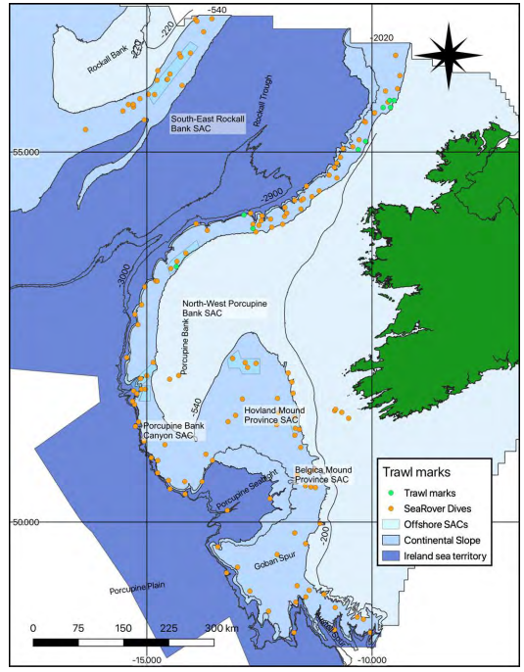  Figure i: Trawl marks were observed in areas with partially flattened to dead coral rubble, including at one of the ROV dives on carbonate mounds on the Northwest Porcupine Bank Special Area of Conservation (SAC; from Picton et al., 2021).  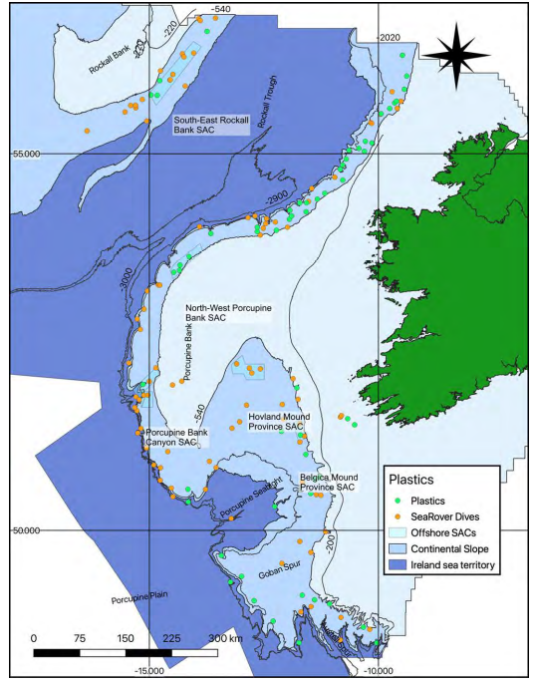  Figure ii: Observations of marine litter from the SeaRover surveys (from Picton et al., 2021), many which co-occurred in Special Areas of Conservation (SACs) for carbonate mounds.  Thus, there is some very good starter evidence (submitted by ICES to OSPAR’s BDC and through the SeaRover surveys reported in Picton et al., 2021) to assess the threats and impacts of key pressure of demersal fisheries in Region V under Category 1 – Direct data-driven.  EIHA feeder reports on commercial fisheries extraction describing extent, distribution and intensity of the activity, socio-economic data, trend information and assessments of measures were produced for the purposes of the QSR 2023 by EIHA and drafts have been shared with all deep-sea habitat groups. Global Fishing Watch (GFW) proxy data on potential demersal fisheries activities in Region V was analysed (Category 2 – Indirect data-driven). Methods for indirect analysis of fisheries threats to proxy impacts are explained in the above section in the Audit Trail for the Criterion “Condition”.  Notably, ODIMS’ “Bottom Fishing Intensity – Surface” datasets currently terminate at 2017 whereas VMS data could give the habitat groups more recent estimates of threats. Categories 3 and 4 sources of evidence sources could not be found on fisheries, but pressures threats and impacts posed by climate change in Category 5 were used.  But since the last 2010 assessment, a large body of knowledge on key pressures from climate change has developed falling under Category 5 – Expert judgement. This includes, habitat suitability modelling (Morato et al., 2020; see Figure iii) and climate change impacts (Soetaert et al. 2016; Morato et al., 2020; Puerta et al., 2020, see Figures iv and v) from international research consortia such as the EU H2020 project ATLAS, study areas which included carbonate mounds in the Belgica Mound Province, and on Logachev Mound, and at Rockall Bank.  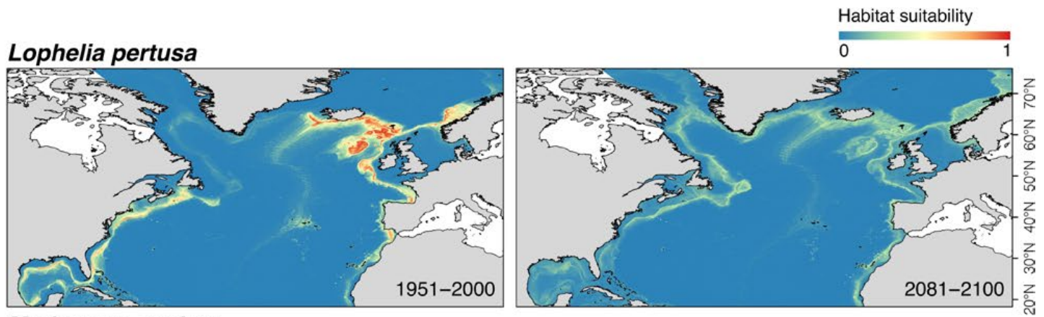  Figure iii: Habitat suitability index predicted under present-day (1951–2000) conditions and then projected under future (2081–2100; RCP8.5) conditions (from Morato et al., 2020)  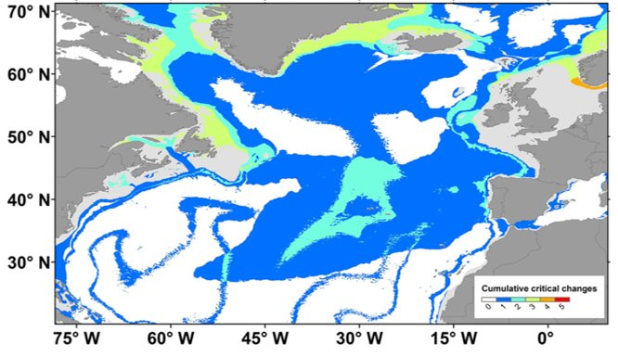  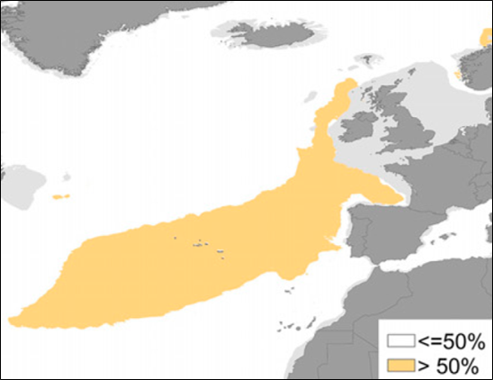  Figure iv: Under RPC8.5 (worst case scenario) of climate change, most areas of Region V with carbonate mounds are likely to experience >50% reduction in food supply to the corals on these mounds (from Puerta et al., 2020).  Figure v: Critical changes in temperature, particulate organic matter supply, aragonite saturation shoaling among other environmental variables were predicted to change under RPC8.5 scenarios, which by proxy and close geographic (overlapping) match, will detrimentally impact the main ecosystem engineer of carbonate mounds, the reef framework-forming scleractinian coral Lophelia pertusa (or Desmophyllum pertusum) (from Puerta et al., 2020).  For these reasons, Category 1 – Direct data-driven evidence on key pressures was a good starter source of information, with Categories 2 – Indirect data-driven (EIHA feeder report on commercial fisheries and Global Fishing Watch data analyses), providing more recent time frames of information on demersal fisheries pressure, Category 3 due to the climate change modelling showing potential threat to Region V, and Category 5 – Expert judgement providing much needed information on trends and future prospects related to climate change.
Measures that address key pressures from human activities or conserve the species/ habitat  (additional information) | All spatial data layers delineating the boundaries of the OSPAR Maritime Area and any regions represented in the present status assessment for management measures and implementation were downloaded from ODIMS. All point and polygon data were reprojected from their native coordinate reference systems (usually WGS 84, EPSG:4326) to the ETRS89-LAEA Europe coordinate reference system (EPSG:3035).  The habitat group was provided with a Microsoft Excel spreadsheet on Contracting Parties reporting for the Implementation period to 2019. This was used to assess to what extent Spain, the UK and Ireland have reportedly implemented the 8 recommendations listed in OSPAR Recommendation 2014/10, “On furthering the protection and conservation of carbonate mounds in Region V of the OSPAR maritime area”.  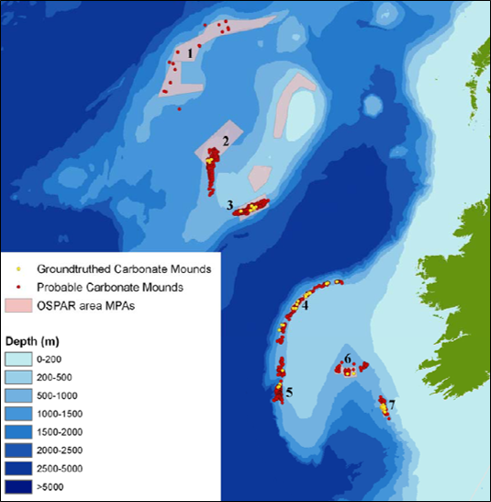  At the time of the last assessment in 2010, many Special Areas of Conservation had already been designated as well as some NEAFC fisheries closures, the latter which are reviewed annually (OSPAR Commission, 2010; Figure vi).  Figure vi: By the time of the last OSPAR assessment for carbonate mounds, several fisheries closures were implemented covering areas of this listed feature including: 1. Hatton Bank NEAFC closure, total area: 1099000 Ha, date closed: 01/2007; 2. West Rockall Mound NEAFC closure, total area: 97000 Ha, date closed: 01/2007; 3. Logachev Mound NEAFC closure, total area: 217000 Ha, date closed: 01/2007; 4. North-West Porcupine SAC, total area: 71000 Ha, date closed: 10/2007; 5. South-West Porcupine SAC, total area: 32400 Ha, date closed: 10/2007; 6. Hovland Mound Province SAC, total area: 105000 Ha, date closed: 10/2007; 7. Belgica Mound Province SAC, total area: 40300 Ha, date closed: 10/2007 (from OSPAR Commission, 2010).  For this latest status assessment, more areas have been designated as marine protected areas including SACs and the latest SCI for Galicia Bank following on from the discoveries made by Somoza et al. (2014). Several NEAFC fisheries closures also remain in place or have been implemented (Figure vii), and a close up for Galicia Bank is also shown (Figure viii).  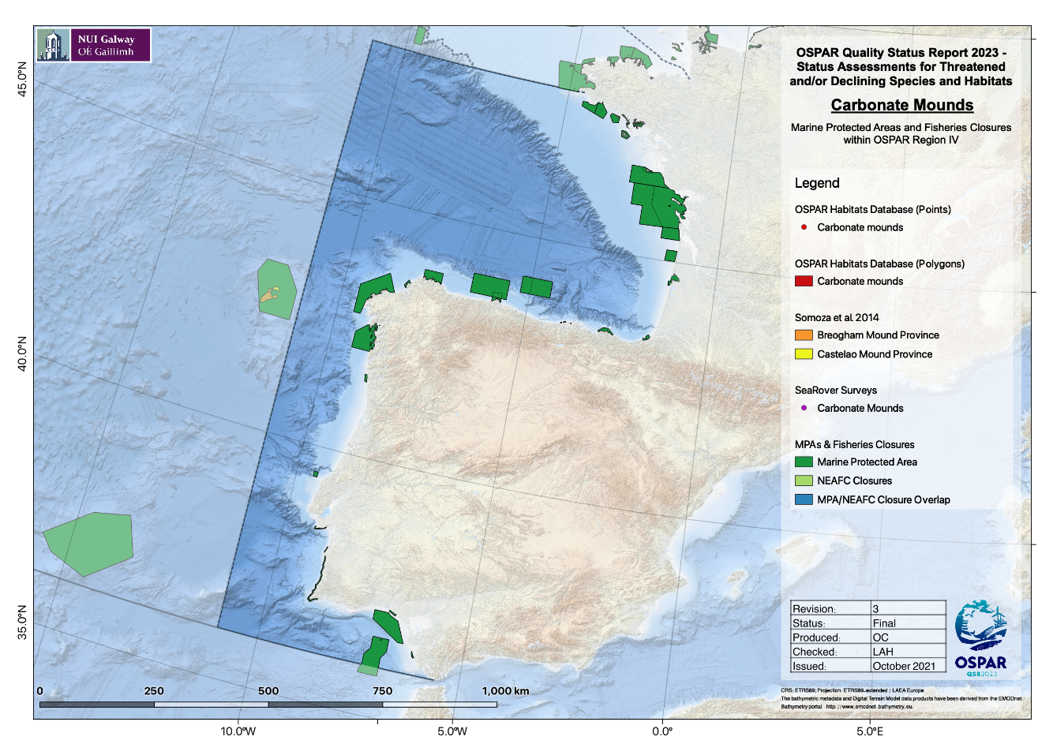  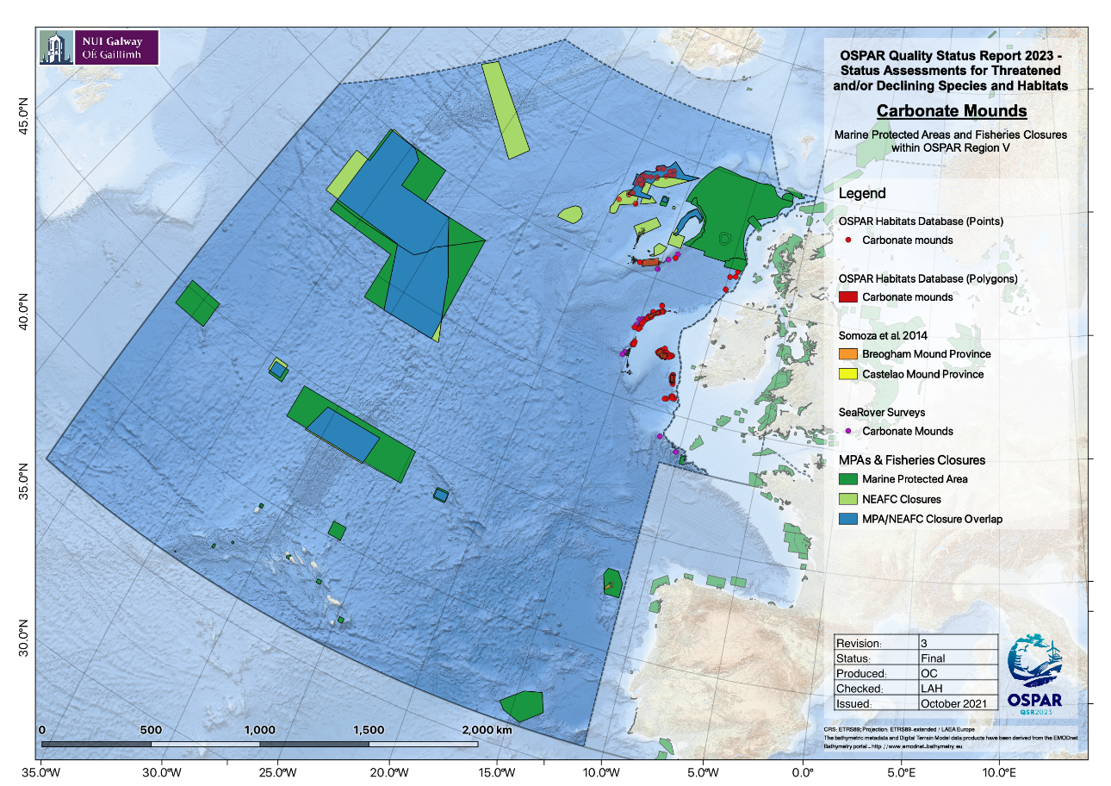  Figure vii: Marine protected areas and fisheries closures overlap with carbonate mounds in  Figure viii: Marine protected area overlapping the carbonate mound provinces on Galicia Bank in Region V that were ground-truthed by Somoza et al. (2014), in close proximity to OSPAR Region IV shown here in closer detail.  When the overlap between MPAs and fisheries closures are combined, it was calculated that 58.62% of carbonate mounds in Region V still remain without any type of management measure besides the Deep Sea Regulation 2016/2336, which bans trawling below 800m water depth but which does set out requirements to protect VMEs from fishing operations that use bottom-contacting gear below 400 m water depth.
Knowledge gaps (additional information)
References | Bonneau, L., Colin, C., Pons-Branchu, E., Mienis, F., Tisnerat-Laborde, N., Blamart, D., Elliot, M., Collart, T., Frank, N., Foliot, L., Douville, E. 2018. Imprint of Holocene climate variability on cold-water coral reef growth at the SW Rockall Trough Margin, NE Atlantic. Geochemistry, Geophysics, Geosystems 19: 2437-2452  Cyr, F., van Haren, H., Mienis, F., Duineveld, G., Bourgault, D. 2016. On the influence of cold-water coral mound size on flow hydrodynamics, and vice versa, Geophysical Research Letters 43: 775–783  Lim, A., Huvenne, V.A.I., Vertino, A., Spezzaferrie, S., Wheeler, A.J. 2018. New insights on coral mound development from groundtruthed high resolution ROV-mounted multibeam imaging. Marine Geology 403: 225-237  Mohn, C. Rengstorf, A., White, M., Duineveld, G., Mienis, F., Soetaert, K., Grehan, A. 2014. Linking benthic hydrodynamics and cold-water coral occurrences: a high-resolution model study at three cold-water coral provinces in the NE Atlantic. Progress in Oceanography 122: 92-104  Morato, T. et al. 2020. Climate-induced changes in the suitable habitat of cold-water corals and commercially important deep-sea fishes in the North Atlantic. Global Change Biology 26: 2181-2202  OSPAR Commission. 2010. Background document for carbonate mounds. 21pp  Picton, B.E., Morrow, C.C., Scally, L., Pfeiffer, N., McGrath, F. 2021. Sensitive Ecosystem Assessment and ROV Exploration of Reef (SeaRover), Synthesis Report. Report prepared by MERC Consultants Ltd. on behalf of the Marine Institute, Galway 161 pp  Puerta, P., Johnson, C., Carreiro-Silva, M., Henry, L.-A., Kenchington, E., Morato, T., Kazanidis, G., Rueda, J.L., Urra, J., Ross, S., González-Irusta, J.-M., Arnaud-Haond, S., Orejas, C. 2020. Influence of water masses on the biodiversity and biogeography of deep-sea benthic ecosystems in the North Atlantic. Frontiers in Marine Science 7: 239  Soetaert, K., Mohn, C., Rengstorf, A., Grehan, A., van Oevelen, D. 2016. Ecosystem engineering creates a direct nutritional link between 600-m deep cold-water coral mounds and surface productivity. Scientific Reports 6: 35057  Somoza, L., Ercilla, G., Urgorri, V., León, R., Medialdea, T., Paredes, M., Gonzalez, F.J., Nombela, M.A. 2014. Detection and mapping of cold-water coral mounds and living Lophelia reefs in the Galicia Bank, Atlantic NW Iberia margin. Marine Geology 349: 73-90

