Sheet reference | BDC2022/seamounts
Area Assessed | OSPAR Regions where the habitat occurs: I, IV, V  OSPAR Regions where such habitats are under threat and/or in decline: All where they occur
Title | Status Assessment 2022 - Seamounts

Key message  – 50 words maximum | Seamounts are assessed as having a poor status overall in Arctic Waters (Region I), Bay of Biscay and Iberian Coast (Region IV) and Wider Atlantic (Region V), due to their continued vulnerability to fishing impacts. This is continuing to damage habitats found in association with the seamounts and removing both target and non-target species particularly in Regions IV and V.  Explanation to table:  Distribution, Population size, Condition  Trends in status (since the assessment in the background document)  ↓ decreasing trend or deterioration of the criterion assessed  ↑ increasing trend or improvement in the criterion assessed  ←→ no change observed in the criterion assessed  ? trend unknown in the criterion assessed  Previous status assessment: If in QSR 2010 then enter Regions where species occurs ( ○) and has been recognised by OSPAR to be threatened and/or declining (● ) based on Chapter 10 Table 10.1 and Table 10.2 . If a more recent status assessment is available, then enter ‘poor’/’good’  Status*(overall assessment)  red – poor  green – good  ? – status unknown  NA- Not Applicable  *applied to assessments of status of the feature or of a criterion, as defined by the assessment values used in the QSR 2023 or by expert judgement.  Key Pressure  ↓ key pressures and human activities reducing  ↑ key pressures and human activities increasing  ←→ no change in key pressures and human activities  ? Change in pressure and human activities uncertain  Threats or impacts (overall assessment)  red – significant threat or impact;  green–no evidence of a significant threat or impact  Blue cells – insufficient information available  NA – not applicable  Method of Assessment  1 – direct data driven  2 – indirect data driven  3 – third party assessment, close-geographic match  4 – third party assessment, partial-geographic match  5 – expert judgement
  Assessment of status |  | Distribution | Extent | Condition | Previous OSPAR status assessment | Status (overall assessment)
  Region | I | ←→^{1,2} | ←→^{1,2} | ↓^{3,5} | ● | poor
  Region | II
  Region | III
  Region | IV | ←→^{1,2} | ←→^{1,2} | ↓^{2,5} | ● | poor
  Region | V | ←→^{1,2} | ←→^{1,2} | ↓^{2,4,5} | ● | poor
  Assessment of threats |  | Habitat damage | Removal of target/non-target species | Threat or impact
  Region | I | ↓¹ | ↓¹ | ↓
  Region | II
  Region | III
  Region | IV | ←→^{1,5} | ←→^{1,5} | ←→
  Region | V | ←→^{1,5} | ←→^{1,5} | ←→

Confidence | Overall: Low confidence is placed on the assessment overall.  Distribution: High confidence that the distribution has not changed.  Condition: Low – medium confidence on the overall condition, based on data for some seamounts. Many seamounts have no data associated with them. The assessment on condition has been based on the seamount communities and not on the seamount feature itself.  Habitat Damage / Removal of target and non-target species: There is low confidence in the scale of fishing pressure currently implemented on the seamounts and therefore of the habitats being damaged and the removal of both target and non-target species. Available fishing data sets are not comprehensive, and analyses therefore rely on a series of assumptions.
Background Information  - 100 words maximum | - Seamounts were added to the OSPAR list in 2003 with the habitat listed as threatened or declining in all Regions where they occur: I, IV, V: https://www.ospar.org/documents?v=7222  - Seamounts were placed on the OSPAR List because of the biological communities found on/in association with them as opposed to the seamount features themselves. Through trawling, commercial pelagic and benthic fish species are targeted, however suspension feeding fauna are also impacted from the physical impact.  - Seamounts were nominated in a joint submission by three Contracting Parties citing decline, sensitivity, and ecological significance, with information also provided on threat.  - Major threats were listed to be habitat damage and removal of target and non-target species, as listed in Table 10.3 of the OSPAR QSR 2010.  - In 2010, seamounts were assessed as particularly sensitive to human impacts, and that their associated biological communities were currently threatened.
Geographical Range and Distribution  - 100 words + map/infographic) | Seamounts are defined as topographic features that rise 1 000 m or more from the surrounding seafloor, but do not penetrate the sea surface. They are found extensively throughout Regions I and V with fewer located in IV (Figure 1), although it should be noted that area IV is notably smaller by comparison to those of Region I and V. In total, 100 distinct seamounts are found in the OSPAR Maritime Area (Kutti et al., 2019) based on the literature and bathymetric database. However, Harris et al. (2014) predicted that 161 seamounts would occur within the OSPAR Maritime Area and approximately 1 700 in the Atlantic region altogether. As more mapping is undertaken, the confidence in the number of seamounts in the OSPAR Regions will increase. Few seamounts in the three Regions where the seamounts are found have been extensively studied.  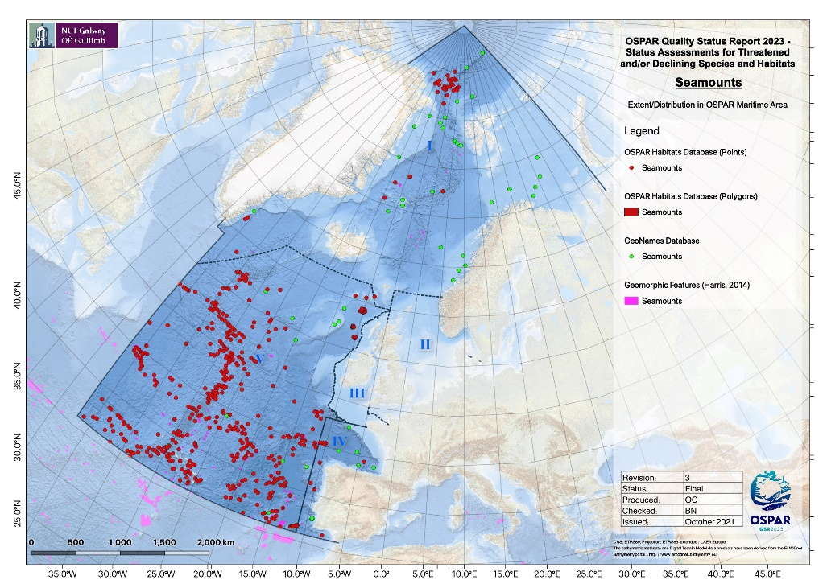Figure 1. Distribution of seamounts in the OSPAR maritime area based on the OSPAR threatened and/or declining habitats database (points and polygons), the GeoNames database and geomorphic features from Harris (2014).  Seamounts, however, are not just associated with the OSPAR Maritime Area. They are found throughout the global oceans with estimates ranging between 10 000 to 30 000 (Yesson et al., 2011; Harris et al., 2014).  Method of assessment:  1 b
Extent (habitats)  - 100 words + figure) | Seamounts in the OSPAR Maritime Area are not specifically monitored, however, they may be included in Spain and the United Kingdom’s monitoring of MPA regions (OSPAR 2014). Formigas and Castro Bank in the Azores region, and El Cachucho in Spanish waters are thought to be studied regularly and the results often provide information regarding the protection of these seamounts (Santos et al., 2010a,b). However, at present this is not a coordinated monitoring programme.  The physical extent of the habitat is not changing, however, the seamount communities are being impacted and their condition is declining.  Method of assessment:  3 c
Condition  - 100 words + figure | Overall habitat condition is considered to be declining in all Regions.  The presence and abundance of key species on seamounts and quality of abiotic components across the OSPAR Regions are not known, due to limited monitoring data. Due to data paucity, direct condition assessments are challenging. However, in the absence of in-situ measurements, condition could be inferred from the presence of pressure-causing activities (where pressure-receptor links are known).  Anton Dohrn, Rosemary Bank, and the Hebrides Terrace seamounts (all in Region V) as large-scale features, are not considered to be at significant risk and their condition is viewed as favourable (Brooks, 2013). However, the condition of the communities found on the OSPAR Region V seamounts is deemed to be unfavourable as a result of both mobile- and static-gear commercial fishing activity (JNCC unpublished data).  Since implementation of management strategies in the mid-2000s, deep-water fisheries in the northern part of Region V have reduced the excessive fishing pressure that this area was experiencing (Vieira et al. 2019).  A proportion of seamounts exist within Marine Protected Areas and/or NEAFC closures in all OSPAR Regions, however only in Region V do the seamounts fall within both an MPA and NEAFC closure (Figure 2).  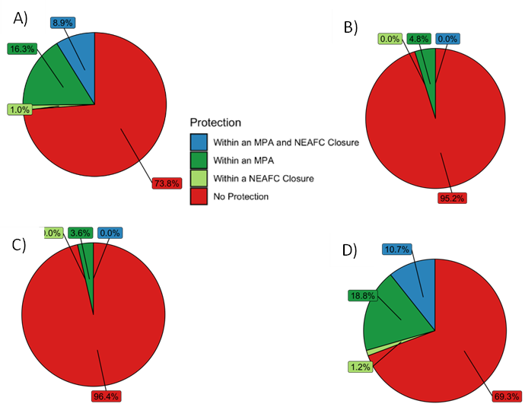  Figure 2. Proportion of seamounts in the OSPAR Marine Protected Area and/or NEAFC closure across, (A) OSPAR regions I, IV & V combined; (B) OSPAR Region 1; (C) OSPAR Region IV and (D) OSPAR Region V.  Method of assessment:  - Assessment derived from third party assessment  - based mainly on expert opinion with very limited data
Threats and impacts  - 100 words | Key pressures to seamounts in the QSR 2010 were habitat damage and removal of target and non-target species. Additional threats included hunting, harvesting, bioprospecting and extraction of mineral resources.  Seamount communities are very sensitive to the impacts from trawling and commercial fisheries, and these continue to be a threat to seamount habitats, with fisheries activities occurring across all OSPAR Regions. Deep-water fisheries have expanded since the 1960s (Vieira et al., 2019) and are a continued threat to commercial deep-water fish species through overexploitation (Menezes et al., 2013). Deep water fish are especially vulnerable to overexploitation due to their typical life history of slow growing, late reproducing species. Bottom trawling also abrades the seafloor and its biological assemblages, increases sediment resuspension, and results in removal of non-target species as by-catch (Clark et al., 2016).  In OSPAR Region V, impacts of fishing activity to seamounts in the Azores have been recorded (Menezes et al., 2013; Santos et al., 2021) and fishing is known to occur across UK seamounts such as the Hebrides Terrace and Anton Dohrn (ICES, 2006). Fishing activity is also prominent in Region IV across seamounts such as Gorringe Bank (Vieira et al., 2015) (Figure 3). A small number of seamounts in Region I around the Mid Atlantic Ridge are also considered commercially important for fisheries, however, fishing activity on the Mid Atlantic Ridge has declined since 2010 (ICES, 2020).  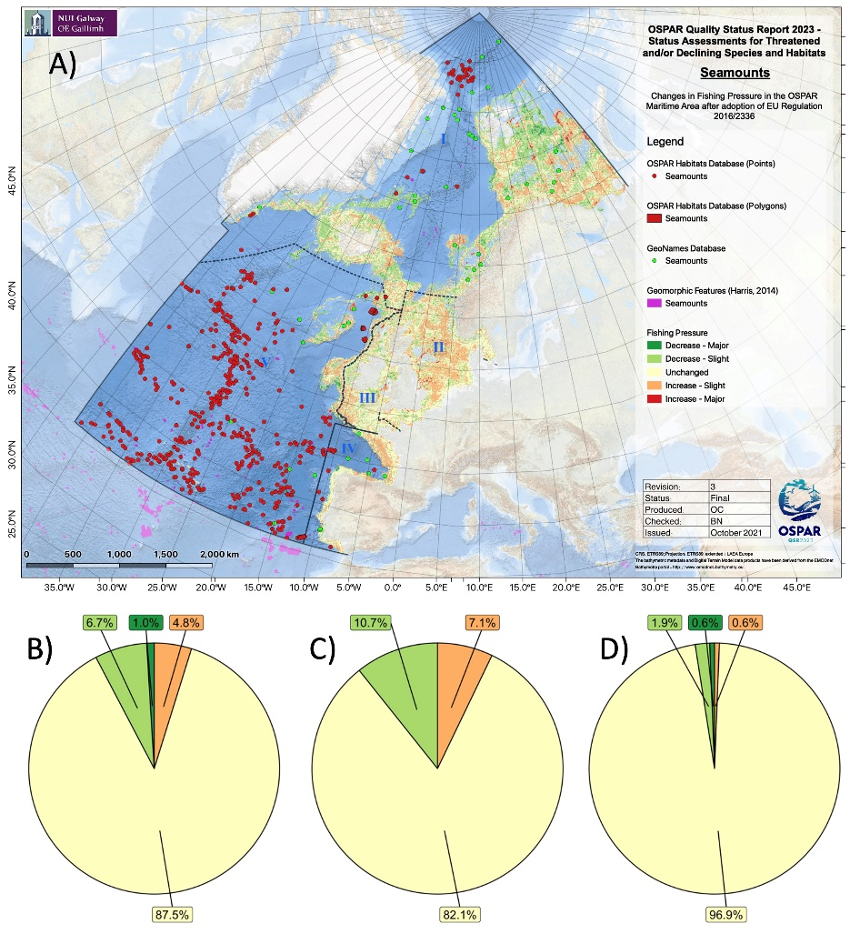  Figure 3. A) Relative change in fishing pressure in the OSPAR Region after introduction of EU regulation 2016/2236 with seamounts overlaid, and change in fishing pressure in cells known to contain seamounts for (B) OSPAR Region I, (C) OSPAR Region IV and (D) OSPAR Region V.  There are other less significant current and future threats.
Measures that address key pressures from human activities or conserve the species/habitat  - 100 words | 3.1a France has introduced legislation to protect habitats including Seamounts in the OSPAR area, whilst Norway has partially implemented the legislation and Iceland are considering it. In the United Kingdom, seamounts are also protected under “The Conservation of Habitats and Species Regulations 2017”.  3.1b Spain has already protected Le Danois seamount through the El Cachucho SAC. EU regulation 2016/2336 also implements a ban on bottom trawling below 800 m in EU waters of the NE Atlantic which includes areas on seamounts.  3.1c Spain is currently revising and updating its management plan for the El Cachucho SAC which will determine whether current measures are suitable or if further measures are needed to address key threats. Iceland has no direct management plans in place as it is felt that the seamounts are not being impacted by fisheries or other human activity.  3.1d France, Norway and Spain all have various programmes running either monitoring seamounts (Spain) or mapping VMEs (France/Norway). The most recent surveys undertaken by the United Kingdom were on Rosemary Bank (2016/2018) and Anton Dohrn (2018). Iceland has not surveyed their seamount habitats because of lack of infrastructure and cost associated with this work.  3.1e Increasing the knowledge of the occurrence and threats to seamounts is being looked at by Norway and Spain through their current/to be revised management plans for marine areas. The knowledge base of seamounts in Icelandic waters will be undertaken by individual research programmes.  3.1f Iceland has indicated that there are potentially vulnerable habitats/species on their seamounts but they have yet to be explored, whilst Le Danois seamount (Bay of Biscay, Region IV) has been designated as a SAC and is also part of the OSPAR MPA Network (Figure 4).  3.1g Spain has implemented conservation measures for the El Cachucho SAC that looks to minimise impacts on the protected seamounts. VMEs are covered by general regulations implemented for deep-sea fishing and human activities in Norway. The United Kingdom published all the site conservation and advice on operations documents for UK MPAs in 2018.  3.1h Iceland, Norway and Spain are raising awareness of seamounts through current research, management plans, and specific projects that have had workshops, e.g., the general public.  3.1i Spain is already working with the relevant competent authorities to fulfill this recommendation. Iceland has looked into this, however, there is no human pressure on the seamounts in their EEZ, whilst Norway is aggregating the knowledge around this.  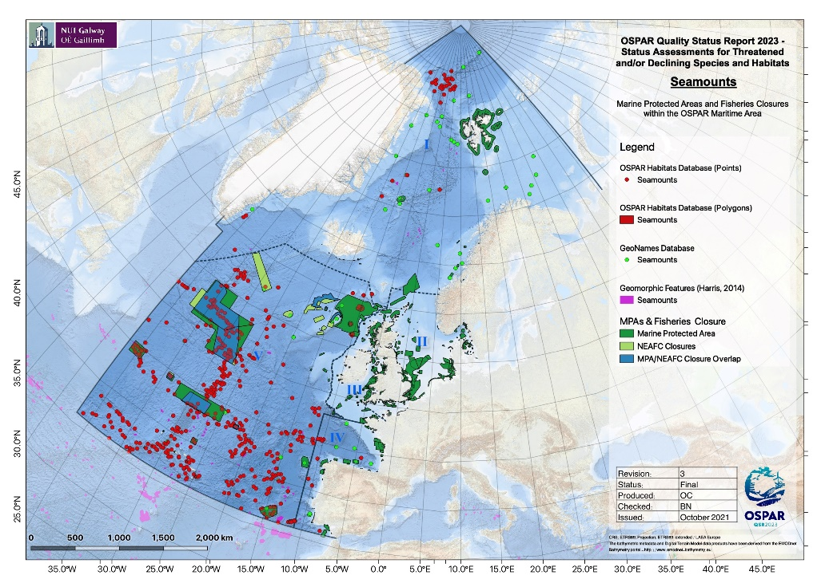  Figure 4. Distribution of seamount records with respect to MPA and Fisheries closures within the OSPAR Area.  NEAFC closures to bottom-contacting fishing gear are in place for 2 seamounts: Altair and Antialtair in Region V.  Within EU waters, Regulation (EU) 2016/2336 restricts bottom fishing >400 m to the 2009-2011 fishing footprint, prohibits bottom fishing >400 m where VMEs are known or likely to occur (through designation of VME closures) and places a complete ban on bottom trawling deeper than 800 m. Within UK waters, regulation (EU) 2016/2336 is transposed into the Common Fisheries Policy and Aquaculture (Amendment etc.) (EU Exit) Regulations 2019, with the same fishing restrictions and prohibitions in place. In Norwegian waters, Regulation 2011/755 restricts fishing with bottom contacting gear on vulnerable benthic habitats in areas deeper than 1 000 m (or 800 m) applies in the Norwegian Economic Zone, including the Fisheries Protection Zone near Svalbard and in the Fisheries Zone around Jan Mayen.
Conclusion (including management considerations)  - 250 words | There has been an increase in research expeditions surveying seamounts and their biological communities, which has increased our overall knowledge. The distribution and extent of seamounts has not changed; however, the condition of the seamount communities is considered to be declining based on the impact of on-going fishing pressure targeting specific seamounts, particularly in Regions VI and V. While fishing pressure has reduced in some parts of the OSPAR Maritime area as a result of new legislation, there remain extensive numbers of seamounts outside areas protected by some form of legislation. The confidence in our assessment of the fishing pressure is low.  MPAs protect some of the biological communities found on the seamounts in the OSPAR Regions, but not all MPAs have management plans.  Additional survey work would be beneficial to ground truth the modelled seamount distribution maps. Some of the seamounts are unlikely to be currently targeted by deep-sea fisheries, particularly those with summits deeper than 1 500 m. Other pressures such as climate change and mining may still present a threat to the biological communities and the underlying seamount itself.  Given the slow growth rate of biological communities found in association with seamounts, reassessment of recovery / improvement could be on a longer time-scale (e.g., 5 to 10 years) in order to detect any changes and assess the effectiveness of management measures. Detection of damage or deterioration from e.g., fishing may require a more frequent assessment cycle to ensure timely intervention.
Knowledge gaps (brief)  - 100 words | Seamounts in the OSPAR Regions are not regularly monitored and any information about them is collected from research cruises (e.g., Davies et al., 2015; McIntyre et al., 2016), as well as mining of historical data (e.g., Vieira et al., 2019). This lack of regular monitoring makes it increasingly difficult to determine what changes are taking place and whether changes are a result of natural variability or anthropogenic impact. Repeat monitoring of seamounts would better inform future prospects of this habitat.  In addition, there are numerous seamounts that have not been mapped or investigated in any detail. Doing so would provide much needed baseline information.
References | Brooks AJ. (2013) Assessing the sensitivity of geodiversity features in Scotland’s seas to pressures associated with human activities. Scottish Natural Heritage Commissioned Report No 590.  Davies JS, Stewart HA, Narayanaswamy BE, Jacobs C, Spicer J, Golding N & Howell KL. (2015) Benthic Assemblages of the Anton Dohrn Seamount (NE Atlantic): Defining Deep-Sea Biotopes to Support Habitat Mapping and Management Efforts with a Focus on Vulnerable Marine Ecosystems. PLoS ONE 10(5): e0124815. doi:10.1371/journal.pone.0124815  Harris PT, Macmillan-Lawler M, Rupp J, Baker EK. (2014) Geomorphology of the oceans. Marine Geology, 352, 4-24. doi: 10.1016/j.margeo.2014.01.011  ICES (2006) Report of the Working Group on the Biology and Assessment of Deep-sea Fisheries Resources (WGDEEP), 2–11 May 2006, ICES HQ, Copenhagen, Denmark. ICES CM 2016/ACFM:28, p. 504.  ICES (2016) Report of the Working Group on Biology and Assessment of Deep-sea Fisheries Resources (WGDEEP), 20–27 April 2016, ICES HQ, Copenhagen, Denmark. ICES CM 2016/ACOM:18, p. 648.  ICES (2020) Working Group on the Biology and Assessment of Deep-sea Fisheries Resources (WGDEEP). ICES Scientific Reports. 2:38. p 928.  McIntyre FD, Drewery J, Eerkes‐Medrano D, Neat FC. (2016) Distribution and diversity of deep‐sea sponge grounds on the Rosemary Bank Seamount, NE Atlantic. Marine Biology, 163:143 DOI10.1007/s00227-016-2913-z  Menezes GM, Diogo H, Giacomello E. (2013) Reconstruction of demersal fisheries history on the Condor seamount, Azores archipelago (Northeast Atlantic). Deep Sea Research I, 98: 190-203  OSPAR (2014) OSPAR threaetened and/or declining species and habitats implementation report. Habitat: Seamounts. OSPAR recommendation 2014/09. https://www.ospar.org/site/assets/files/44271/seamounts_reporting.pdf  Santos R, Medeiros-Leal W, Novoa-Pabon A, Silva H, Pinho M. (2021) Demersal fish assemblages on seamounts exploited by fishing in the Azores (NE Atlantic). Journal of Applied Ichthyology, 37(2): 198-215  Santos RS, Tempera F, Menezes G, Porteiro F, Morato T. (2010a) Mountains in the Sea: Sedlo Seamount, Azores. Oceanography, 23 (1): 148-149.  Santos RS, Tempera F, Colaço A, Cardigos F, Morato T. (2010b). Mountains in the Sea: Dom João de Castro Seamount, Azores. Oceanography, 23 (1): 146-147.  Vieira RP, Trueman CN, Readdy L, Kenny A, Pinnegar JK. (2019) Deep-water fisheries along the British Isles continental slopes: status, ecosystem effects and future perspectives. J. Fish Biol. 94, 981–992. doi: 10.1111/jfb.13927  Vieira RP, Raposo IP, Sobral P, dos Santos Gonçalves JM, Bell KLC, Cunha MR. (2015) Lost Fishing Gear and Litter at Gorringe Bank (NE Atlantic). Journal of Sea Research, 100:91-98 10.1016/j.seares.2014.10.005  Yesson C, Clark MR, Taylor ML, Rogers AD. (2011) The global distribution of seamounts based on 30 arc seconds bathymetry data. Deep Sea Research I, 58(4): 442-453
(explanatory notes associated to rows above, if the category is indicated for : Method used)
AUDIT TRAIL  Optional.  No word limit  Archived | Additional Evidence and Information
Assessment methods  (additional information, in particular how the overall assessment in the summary table was reached) | Assessed as part of a group of deep-sea habitat assessments led by Ireland, chaired by Louise Allcock (National University of Ireland Galway, Ireland). Seamount habitat assessment by Bhavani Narayanaswamy (Scottish Association of Marine Science, United Kingdom; habitat lead), Brian Bett (National Oceanography Centre, United Kingdom), Laura Robson (Joint Nature Conservation Committee, United Kingdom), David Stirling (Marine Scotland Science, United Kingdom), Liam Matear (Joint Nature Conservation Committee, United Kingdom), David Lyons (National Parks and Wildlife Service, Ireland), Kerry Howell (University of Plymouth, United Kingdom), Louise Allcock (NUI Galway, Ireland), with further contributions from the participants of the OSPAR deep-sea habitat assessment workshop, held online 6 to 8 September 2021. GIS analyses by Oisín Callery (NUI Galway, Ireland) and Anthony Grehan (NUI Galway, Ireland).
Geographical range and distribution (additional evidence & information) | Geographic range and distribution information was drawn from the following sources:  Habitat Distributions  The primary sources of data on the distribution of deep-sea habitats used in this assessment were i) the latest version (2020) of the OSPAR Threatened or Declining Habitats Database (Downloaded from the EMODnet Seabed Habitats website, www.emodnet-seabedhabitats.eu) ii) from Harris et al. (2014) and iii) the Geonames Database (www.geonames.org). Note that some features included in the Geonames Database (e.g., La Chapelle Bank) do not conform to conventional definitions of a seamount, these were excluded from subsequent analyses presented here  Marine Protected Areas  Spatial data on Marine Protected Areas (MPAs) were obtained from the OSPAR Marine Protected Areas database. These data were downloaded from the OSPAR Data & Information Management System (ODIMS, https://odims.ospar.org/en).  Fisheries Closures  Fisheries closure data were downloaded as shapefiles from the North East Atlantic Fisheries Commission (NEAFC) website (https://www.neafc.org).  Bathymetry  Bathymetric data for the OSPAR area were extracted from the GEBCO_2021 Grid obtained from the GEBCO website (www.gebco.net/data_and_products/gridded_bathymetry_data). This is a global terrain model compiled using data from various sources to provide full global coverage for ocean and land at a resolution of 15 arc-seconds.  OSPAR Boundaries  Spatial data layers delineating the boundaries of the OSPAR Maritime Area and its Regions were downloaded from ODIMS (https://odims.ospar.org/en/maps/map-maritime-area-and-its-regions).  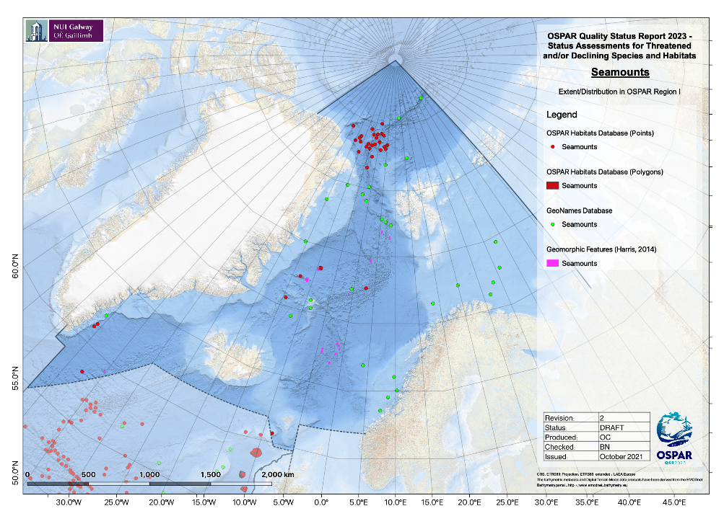Figure 5. The extent and distribution of Seamounts in the OSPAR Region I.  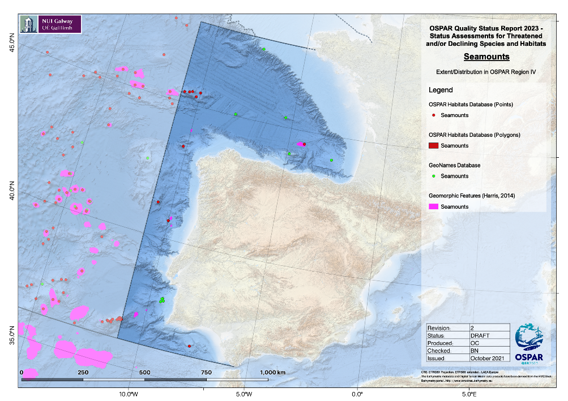  Figure 6. The extent and distribution of Seamounts in the OSPAR Region IV.  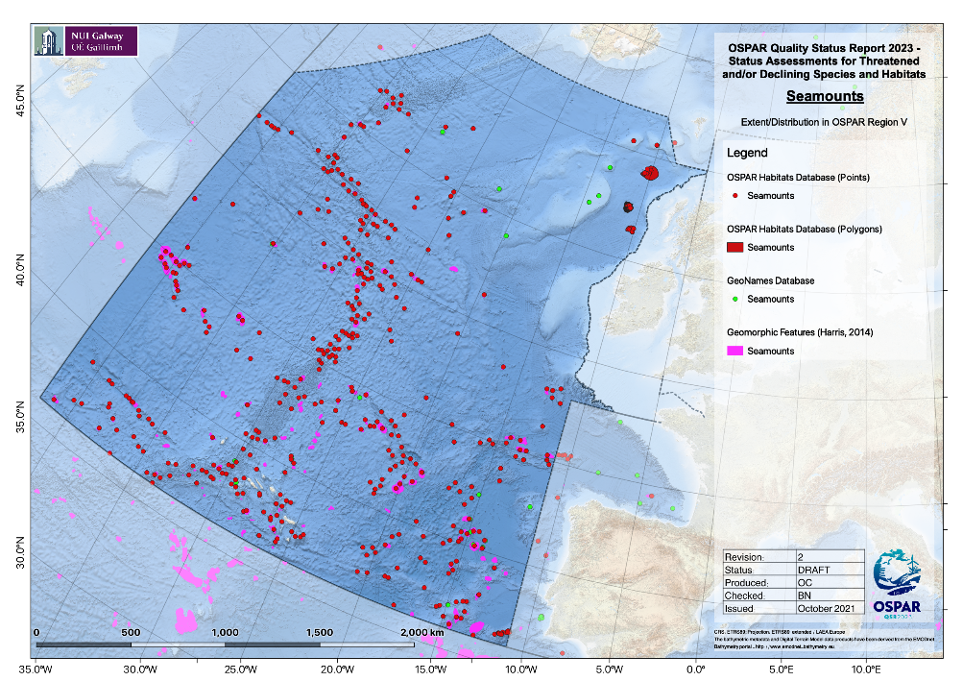  Figure 7. The extent and distribution of Seamounts in the OSPAR Region V.  Reprojection and Aggregation of Data  All point and polygon data were reprojected from their native coordinate reference systems (usually WGS 84, EPSG:4326) to the ETRS89-LAEA Europe coordinate reference system (EPSG:3035). Before any spatial analyses were conducted, habitat data obtained as points were first aggregated to an equal-area square grid which was specifically created for the purposes of conducting the assessments; this grid covered the entirety of the OSPAR Area with a grid-cell resolution of 25km² (see accompanying R-script). Aggregating the point data in this manner ensured that any data represented in multiple databases were not “double counted”. Also, where multiple point occurrences of a habitat were recorded in close proximity to one another, for example along the path taken by a remotely operated underwater vehicle (ROV) over the course of a survey transect, these habitats in a single small area would be considered (for the purposes of these analyses) as part of a single contiguous habitat.
Population/abundance (species)  (additional evidence & information) | N/A
Condition  (additional evidence & information) | Condition assessments from two UK MPAs (West of Scotland MPA and The Barra Fan and Hebrides Terrace Seamount MPA) in Region V was supplied by JNCC.  The changes in fishing pressure in OSPAR Regions where seamounts also occur, following adoption of EU Regulation 2016/2236 overall indicate little change (Figures 8-10).  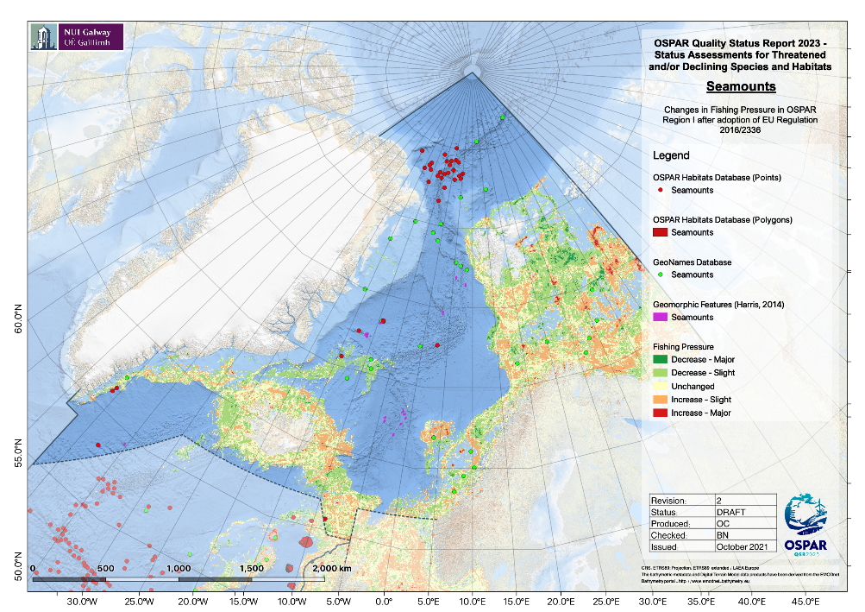  Figure 8. The changes in fishing pressure in OSPAR Region I following adoption of EU Regulation 2016/2236.  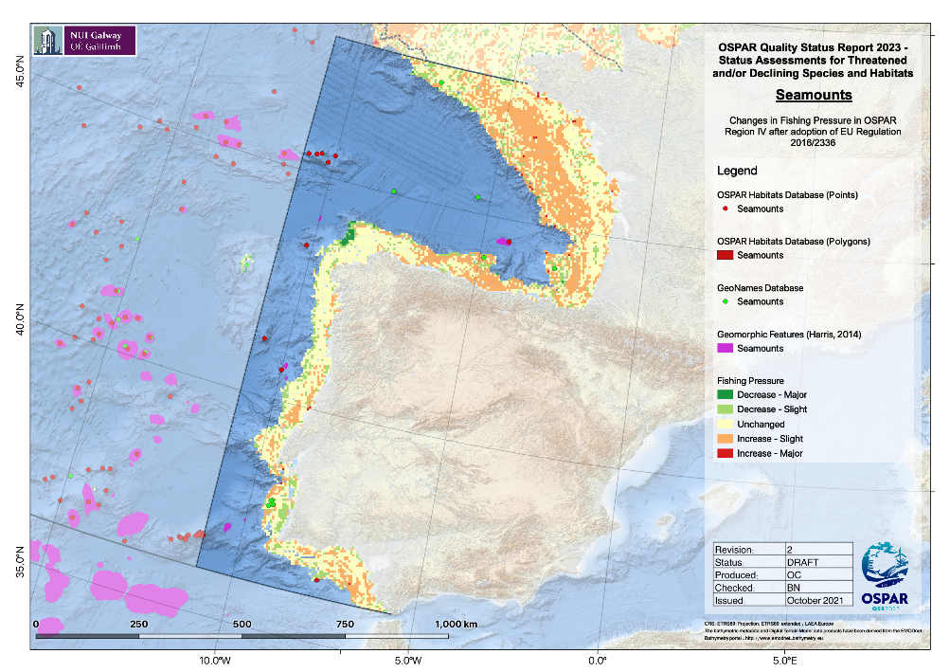  Figure 9. The changes in fishing pressure in OSPAR Region IV following adoption of EU Regulation 2016/2236.  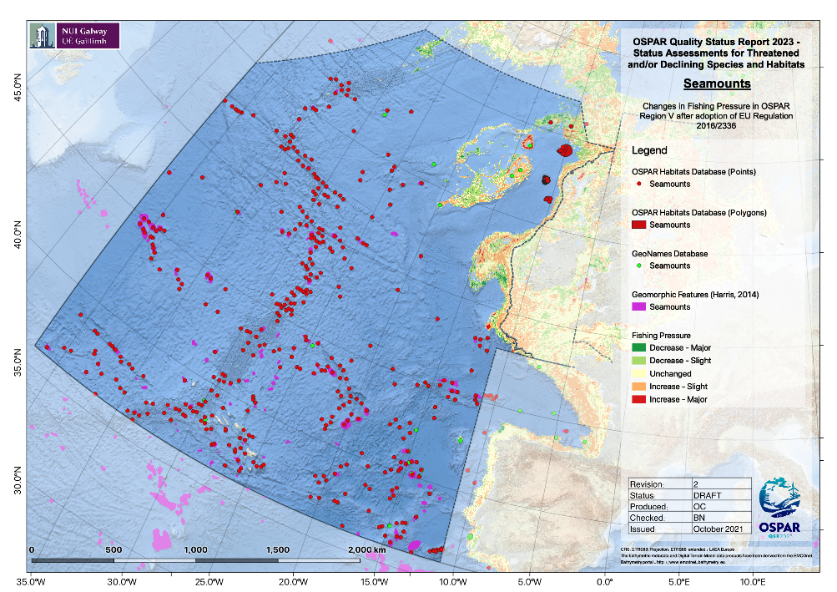  Figure 10. The changes in fishing pressure in OSPAR Region V following adoption of EU Regulation 2016/2236.  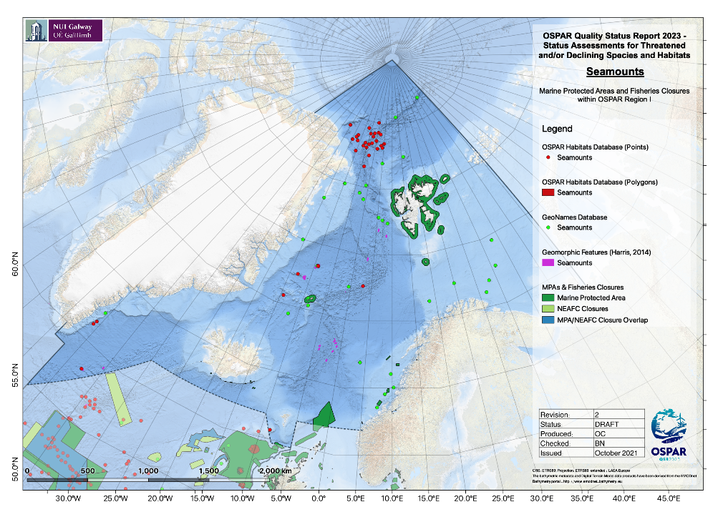  Figure 11. Occurrence of seamounts in Marine Protected Areas and NEAFC closures in OSPAR Region I.  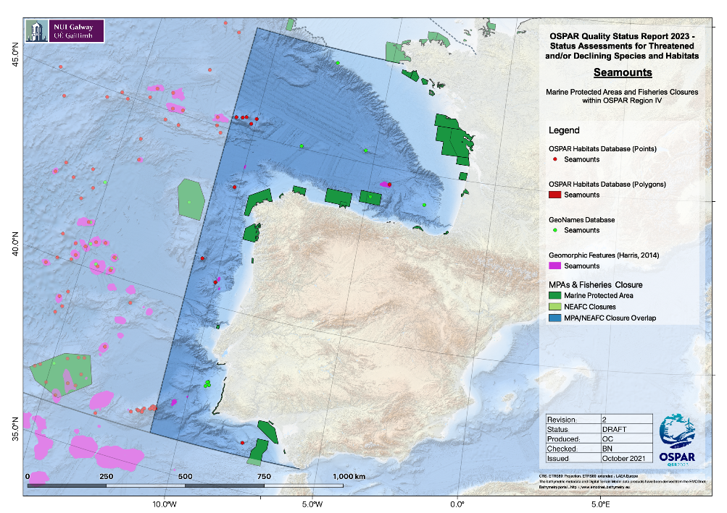  Figure 12. Occurrence of seamounts in Marine Protected Areas and NEAFC closures in OSPAR Region IV.  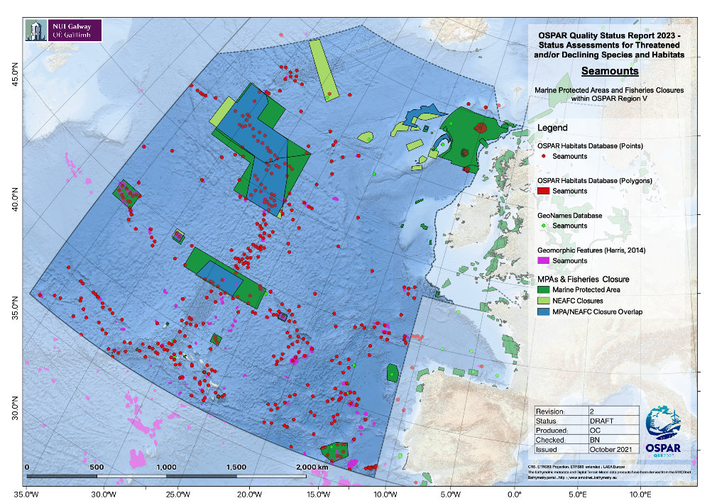  Figure 13. Occurrence of seamounts in Marine Protected Areas and NEAFC closures in OSPAR Region V.  Fishing Effort and MPA Overlap Analyses  To analyse the overlap between apparent fishing effort and known habitat occurrences, a simple spatial overlay was conducted in R. The “extract” function of the Raster R package was used to return the relative fishing pressure at each point datum in the habitat distribution datasets (these having already been aggregated as described above to avoid duplicates within individual squares of the OSPAR grid). To simplify analysis for habitats with polygon data available, polygons were converted to points located at the centroids of all grid cells in which those polygons were present. In this manner, multiple small polygons within a single grid cell would be counted as a single point record (i.e. following the same manner in which the point data were aggregated) and large polygons overlapping multiple grid cells would be counted as multiple point records placed at the centroids of each grid cell overlapped by the large polygon. For the MPA/fisheries closure analyses, the same aggregation approach for point and polygon data was applied, and it was determined whether each habitat point datum was (i) within an MPA, (ii) within a NEAFC closure, (iii) within an overlap between both an MPA and a NEAFC closure, or (iv) outside a protected area. The results of these analyses were used to produce pie charts summarising the percentage of habitat occurrences in each of the aforementioned four categories.
Threats and impacts  (additional evidence & information) | Changes in Fishing Pressure  Spatial data layers of apparent fishing effort based on automatic identification system (AIS) transmissions were prepared using data downloaded from the Global Fishing Watch website (www.globalfishingwatch.org). The data provided by Global Fishing Watch (GFW) are produced by running AIS data through two convolutional neural networks: (i) a “vessel characterisation” model which identifies and classifies fishing vessels, and (ii) a “fishing detection” model which predicts when these vessels are fishing and when they are in non-fishing positions (e.g. transiting, in port etc.).  The “vessel characterisation” model identifies fishing vessels using a comprehensive database of vessel registry information and also outputs predictions of fishing gear types and vessel sizes allowing for separation of different fishing activities (e.g. trawling, longlining, etc.). The “fishing detection” model identifies when vessels are fishing based on vessel movements and other parameters such as distance to shore and bathymetry. For this analysis, only fishing activity identified by GFW as “trawling” was considered. Detailed information on these models can be found in the supplementary materials of GFW’s Science paper (Kroodsma et al., 2018).  With fishing vessels and fishing activity identified, the sum of the fishing hours for all fishing vessels in an area can be computed to produce maps of apparent fishing activity across a range of fishing gear types. These outputs are grided at a resolution of 0.01°x0.01° and are provided by GFW in CSV format (see the accompanying R-script for “rasterising” GFW CSV data).  There are a number of important limitations and caveats associated with using AIS data to monitor fishing activity:  1) Only a small fraction of fishing vessels use AIS, with coverage being higher for larger vessels, however, such vessels (i.e. those with AIS) do account for a large proportion of fishing effort beyond 100 nautical miles from land (up to ~70% (Kroodsma et al., 2018)).  2) AIS reception is affected by numerous factors including satellite coverage, interference from other vessels’ transmissions, and the strength and frequency of the AIS broadcast.  3) The number of vessels transmitting AIS data has increased year-on-year since GFW began their analyses (2012) and, when comparing data from one time period to data from another, it is difficult to differentiate between increases in AIS availability and actual increases in the intensity of fishing activity.  4) It is not possible to distinguish between demersal and pelagic trawling activity. To address this (in so far as possible) all trawling activity in water depths greater than 1500m was assumed to be pelagic and was therefore not considered in this assessment.  There has been relatively little change in fishing pressure over the period (95% unchanged) (Figure 14a-c) and little change overall in individual OSPAR regions.  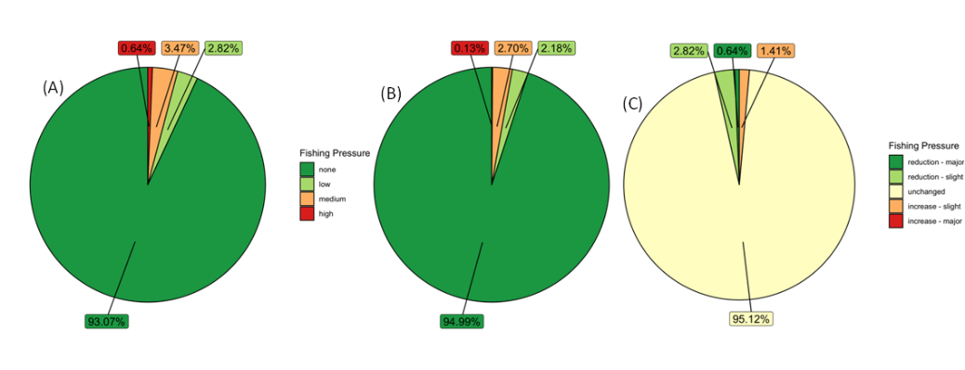  Figure 14. Overlap of Fishing Pressure and Seamounts based on Global Fishing Watch Data Aggregated to a Resolution of 25km² for the entire OSPAR Area (A) before introduction of 2016 Deep-Sea Access Regulations (based on data for 2012-2016), (B) after introduction of 2016 Deep-Sea Access Regulations (based on data for 2017-2020), (C) overlap pre- and post-introduction of 2016 Deep-Sea Access Regulations.  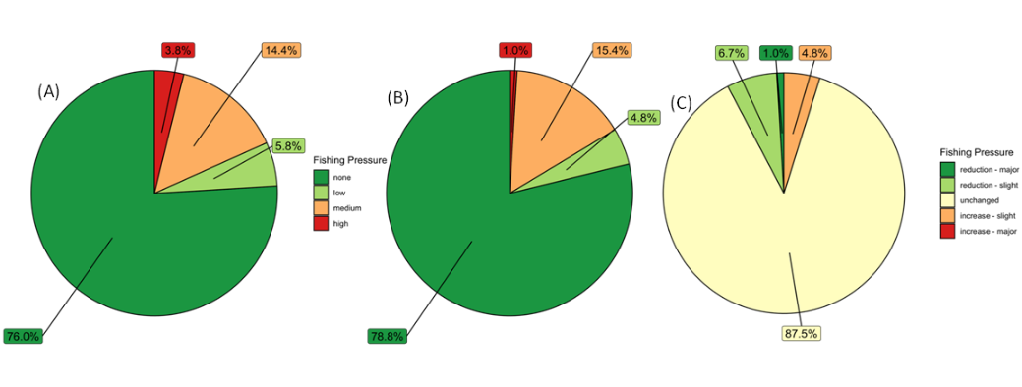  Figure 15. Overlap of Fishing Pressure and Seamounts based on Global Fishing Watch Data Aggregated to a Resolution of 25km² for OSPAR Area I (A) before introduction of 2016 Deep-Sea Access Regulations (based on data for 2012-2016), (B) after introduction of 2016 Deep-Sea Access Regulations (based on data for 2017-2020), (C) overlap pre- and post-introduction of 2016 Deep-Sea Access Regulations.  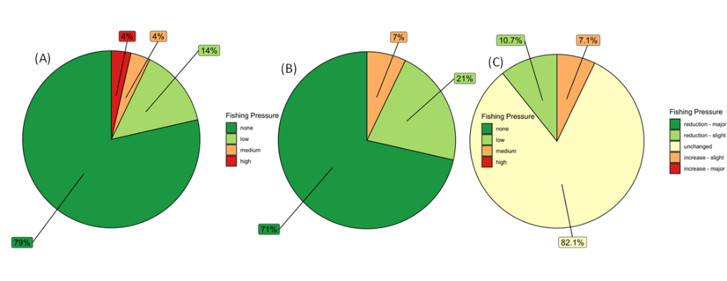  Figure 16. Overlap of Fishing Pressure and Seamounts based on Global Fishing Watch Data Aggregated to a Resolution of 25km² for OSPAR Area IV (A) before introduction of 2016 Deep-Sea Access Regulations (based on data for 2012-2016), (B) after introduction of 2016 Deep-Sea Access Regulations (based on data for 2017-2020), (C) overlap pre- and post-introduction of 2016 Deep-Sea Access Regulations.  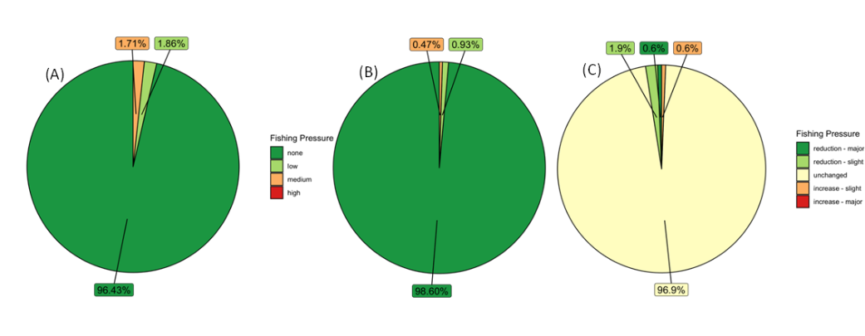  Figure 17. Overlap of Fishing Pressure and Seamounts based on Global Fishing Watch Data Aggregated to a Resolution of 25km² for OSPAR Area V (A) before introduction of 2016 Deep-Sea Access Regulations (based on data for 2012-2016), (B) after introduction of 2016 Deep-Sea Access Regulations (based on data for 2017-2020), (C) overlap pre- and post-introduction of 2016 Deep-Sea Access Regulations.  Pre-processing of Fishing Effort Data  Fishing effort in each 25km² square of the OSPAR area grid was taken to be the sum of the effort of all 0.01°x0.01° cells of the GFW dataset that were within that square. Where a cell from the GFW dataset was only partially overlapped by a 25km² square of the OSPAR area grid, the contribution of that cell to the total fishing effort within the square was taken to be the product obtained by multiplying the fishing effort in the 0.01°x0.01° cell by the fraction of that cell covered by the square. Once the fishing effort data had been aggregated to the resolution of the 25km² OSPAR area grid, cells with zero or very low fishing effort (taken to be values below the 5% quantile as calculated using the quantile function in R with default settings) were discarded.  As described above, one of the limitations associated with using the GFW fishing effort layers is that the amount of activity in the AIS dataset has increased each year, the result being that apparent year-on-year increases in the amount of fishing activity within a grid-square do not necessarily represent actual increases in fishing activity; such increases may simply reflect greater data availability. To allow for comparisons to be made between different time periods, annual fishing effort data within each 25km² square were standardised in R using the empirical cumulative distribution function (ECDF). The ECDF function at any fishing effort value returns the proportion of effort values that are less than or equal to that value based on all fishing activity recorded in the OSPAR area in that year. This method identified areas of comparatively high/low fishing effort within the OSPAR region, thereby allowing for year-to-year comparisons to be made based on changes in relative annual fishing effort.  To ascertain any potential effects of Regulation (EU) 2016/2336 in 2016 – hereafter referred to as the Deep-Sea Access Regulations (DSAR) – mean fishing effort in each grid cell was calculated for the pre-DSAR period (2012-2017 inclusive), and the post-DSAR period (2018-2020 inclusive); despite the DSAR being established in 2016, there was a “cross-over” period where fishing permits already issued were still valid during 2017, and for this reason data from 2017 was included in the pre-DSAR period. Variations in fishing pressure of less than 10% were considered as no change; changes in fishing pressure between 10 and 50% were considered as minor increases or decreases; changes in fishing pressure of greater than 50% were considered as major increases or decreases.  Marine Litter  Discarded or lost fishing gear can cause extensive damage to seamount communities (Angiolilli & Fortibuoni 2020) and microplastics are known to have been ingested by octocorals and macrofauna (e.g., Taylor et al. 2016; Courtene-Jones et al. 2019) which could have detrimental effects (for review see Soares et al. 2020). The deep sea is the ultimate sink for all debris including microplastics, which have been found in deep waters in high concentrations. The OSPAR IA 2017 found litter to be widespread on the seafloor across areas II, III and IV.  Deep-sea mining  Exploration contracts have been granted internationally for deep-sea mining activity, with potential threats to seamounts and their communities from physical disturbance and sediment plumes. Currently there is no commercial deep-sea mining within the OSPAR area, however, under the Subsea Minerals Act, the Norwegian government has initiated an opening process for offshore mineral activity, including an impact study (EIHA (WP) 21/01/02-Add.5Rev1). Given the demand for key metals in applications such as renewable technologies, deep-sea mining is likely to increase in coming decades, but our understanding of the environmental impacts is as yet uncertain.  References  Angiolillo M, Fortibuoni T (2020). Impacts of marine litter on Mediterranean reef systems: From shallow to deep waters. Frontiers in Marine Science. 29: doi.org/10.3389/fmars.2020.581966  Courtene-Jones W, Quinn B, Ewins C, Gary SF, Narayanaswamy BE (2019). Consistent microplastic ingestion by deep-sea invertebrates over the last four decades (1976-2015), a study from the North East Atlantic. Environmental Pollution, 244: 503-512. doi.org/10.1016/j.envpol.2018.10.090  Kroodsma, D.A., Mayorga, J., Hochberg, T., Miller, N.A., Boerder, K., Ferretti, F., Wilson, A., Bergman, B., White, T.D., Block, B.A., Woods, P., Sullivan, B., Costello, C., Worm, B., 2018. Tracking the global footprint of fisheries. Science 359, 904–908. doi.org/10.1126/science.aao5646  Soares MO, Matos E, Lucas C, Rizzo L, Allcock L, Rossi S (2020). Microplastics in corals: An emergent threat. Marine Pollution Bulletin, 161: Part A: 111810: doi.org/10.1016/j.marpolbul.2020.111810  Taylor ML Gwinnett C, Robinson LF, Woodall LC (2016). Plastic microfibre ingestion by deep-sea organisms. Scientific Reports, 6(1):1-9. doi.org/10.1038/srep33997
Measures that address key pressures from human activities or conserve the species/habitat  (additional information) | West of Scotland Deep-sea Marine Reserve, JNCC Conservation Objectives & Management Advice:  https://data.jncc.gov.uk/data/37955242-d60b-4494-8e2c-94e93fb0de6f/west-of-scotland-conservation-objectives-management-advice.pdf  The Barra Fan and Hebrides Terrace Seamount Nature Conservation Marine Protected Area, JNCC Statements on conservation benefits, condition & conservation measures:  https://data.jncc.gov.uk/data/30df3aa8-df35-44ff-af82-ee30b12167dd/BFHTS-4-ConservationStatements-V1.0.pdf
Knowledge gaps (additional information)
References

