Sheet reference | BDC2022/Oceanic_Ridges_with_hydrothermal_vents
Area Assessed | OSPAR Regions where the habitat occurs: I and V  OSPAR Regions where the habitat was under threat and/or decline: V
Title | Status Assessment 2022: Oceanic Ridges with hydrothermal vents

Key message | Oceanic ridges with hydrothermal vents are assessed as being in good status, but low confidence is placed overall on the assessment. Any trends in status associated with climate change and ocean acidification are unknown, and future plans to explore and exploit vents for deep-seabed minerals are of concern. In order to improve or maintain the good status, conservation measures for deep-sea hydrothermal vents are necessary to protect these important but rare, sensitive, island-like ecosystems with unique biotic and abiotic features.  Explanation to table:  Distribution, Population size, Condition  Trends in status (since the assessment in the background document)  ↓ decreasing trend or deterioration of the criterion assessed  ↑ increasing trend or improvement in the criterion assessed  ←→ no change observed in the criterion assessed  ? trend unknown in the criterion assessed  Previous status assessment: If in QSR 2010 then enter Regions where species occurs ( ○) and has been recognised by OSPAR to be threatened and/or declining (● ) based on Chapter 10 Table 10.1 and Table 10.2 . If a more recent status assessment is available, then enter ‘poor’/’good’  Status*(overall assessment)  red – poor  green – good  ? – status unknown  NA- Not Applicable  *applied to assessments of status of the feature or of a criterion, as defined by the assessment values used in the QSR 2023 or by expert judgement.  Key Pressure  ↓ key pressures and human activities reducing  ↑ key pressures and human activities increasing  ←→ no change in key pressures and human activities  ? Change in pressure and human activities uncertain  Threats or impacts (overall assessment)  red – significant threat or impact;  green –no evidence of a significant threat or impact  Blue cells – insufficient information available  Method of assessment:  1 – direct data driven,  2 – indirect data driven,  3 – third party assessment close-geographic match,  4 - third party assessment partial-geographic match  5 – expert judgement.
  Assessment of status |  | Distribution | Extent | Condition | Previous OSPAR status assessment | Status (overall assessment)
  Region | I | ←→ ^{3,5} | ←→ ⁵ | ←→ ^{2,5} | ° | Good
  Region | II |  |  |  |  | NA
  Region | III |  |  |  |  | NA
  Region | IV |  |  |  |  | NA
  Region | V | ←→ ^{3,5} | ←→ ⁵ | ↑ ^{2,5} | • | Good
  Assessment of threats |  | Fishing, particularly demersal trawling and long lining (long lining not assessed here) | Climate change | Threat or impact
  Region | I | ↓^{1,5} | ?^{3,5} | ↓^{1, 5}
  Region | II |  |  | NA
  Region | III |  |  | NA
  Region | IV |  |  | NA
  Region | V | ←→^{1,5} | ?^{3,5} | ←→^{1,5}
Confidence | Overall: Low confidence is placed overall on the assessment.  Distribution: High confidence that the distribution has not changed.  Extent: Low confidence, due to data paucity.  Condition: Low confidence of the overall condition across the regions, as time series data are only available for one vent field in Wider Atlantic (Region V) and can’t be extrapolated. Since >50% of vents in Region V are protected from anthropogenic impacts, we conclude that the condition and overall status has improved in Region V. However, effects of climate change and ocean acidification on these habitats are unknown.  Fishing Pressure: Low confidence in the scale of fishing pressure currently acting on the habitat. Available fishing data sets are not comprehensive and analyses rely on a series of assumptions. Assessment of fishing pressure using Global Fishing Watch data focussed only on demersal trawling. There was no assessment of impacts from long lining at the regional level. Information from Iceland for Arctic Waters (Region I) indicates long lining takes place on shallower vents.
Background Information  - 100 words maximum | - Year added to OSPAR List: 2007 https://www.ospar.org/site/assets/files/44271/oceanic_ridges_hydrothermal_vents.pdf  - The key criteria for their inclusion were:  -Their regional importance, based on the evidence of a very localized regional distribution at spreading centers, but impact of vents beyond the localized distribution  -The potential decline due to the small geographic area that the habitat covers and the fragility of the structures.  -Their rarity based on the unique microbial and animal communities associated with hydrothermal vents (most endemic).  -Their sensitivity based on the specialized adaptations which allow organisms to exploit vent habitats, resulting in specialized faunas, which are rarely found in other environments.  -The main threats to hydrothermal vent systems and their associated biological communities are from scientific research (including collecting), seabed mining, tourism and bioprospecting (InterRidge, 2000). In 2006, InterRidge published a “code of conduct” for responsible research at vents, which is followed voluntarily by scientists.  - Major threats were considered to be fishing and habitat damage, listed in Table 10.3 of QSR 2010. More specifically these threats stem from physical disturbance or damage to seabed, and extraction of, or mortality/injury to species by fishing.  - In 2010, Oceanic ridges were assessed as being under threat or declining https://qsr2010.ospar.org/en/ch10_02.html for Region V but not referring to Region I.
Geographical range and distribution  - 100 words + map/infographic) | 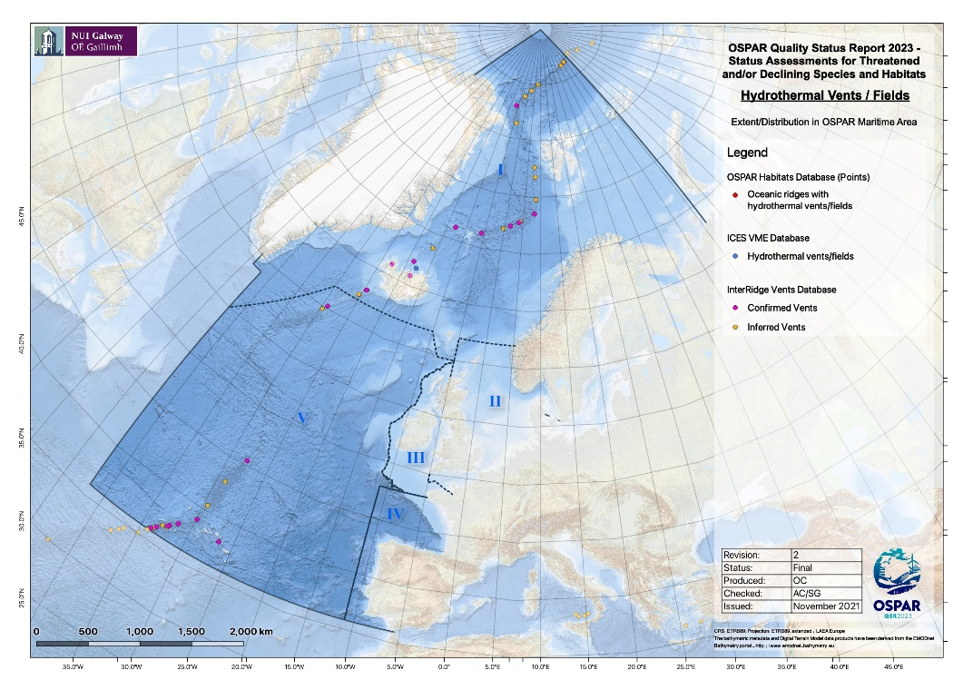  Figure 1 Distribution of known Oceanic ridges with hydrothermal vent fields in the OSPAR Maritime Area, and occurrence of inferred vent fields that might be indicative of hydrothermal vent presence.  The geographic range and distribution of Oceanic ridges with hydrothermal vents remains unchanged.  Oceanic ridges with hydrothermal vents, occur along the Mid-Atlantic Ridge in Regions I and V. Active vents are small in size, but impact the surrounding areas. The distance between the vent fields ranges from several to hundreds of kilometers.  Whilst the distribution of active vent fields has remained constant, several new vent fields have been discovered since the last assessment. In addition, multiple vent fields that are currently listed in the InterRidge database as inferred (no visual confirmation, but plume anomaly detected), or (shallow) vents that are known but nowhere formally registered, may be added to the list of confirmed active vent fields in the near future. Further, based on animals’ genetic connectivity data, the finding of additional vent fields is expected.  At the time of the first assessment in 2010 there was no information and knowledge on inactive vents in the OSPAR Regions, so these were not included in the first assessment. New information on inactive vents in the OSPAR Regions have not been assessed in 2021, as no OSPAR background document is in place.  Method of assessment: 3b
Population/abundance (species)  Extent (habitats)  - 100 words + figure) | Overall, it is expected that populations remain stable, as long as they are not affected by anthropogenic impact (i.e. fishing, direct and indirect impact by potential future deep-seabed mining, change of currents due to climate change and associated change in larval dispersal).  Deep-sea hydrothermal vent fields are globally rare and extremely small in area but are typically rich in extraordinary life based on chemosynthesis rather than photosynthesis. Population densities at active hydrothermal vents are considered high compared to densities in non-vent surrounding areas. Species are often vent endemic/obligate (restricted to the active vent habitat). In general, deeper vent fields have more endemic species compared to shallower vent fields. Underlying reasons for this trend are not known.  With the exception of one vent field (Lucky Strike, Region V), time series data on population densities are not available in Region I and V. Currently, no conclusion on trends can be drawn.  Method of assessment: 1d
Condition  - 100 words + figure | Overall the condition is expected to remain stable but without time series analyses, the response to any environmental changes linked to climate change, fisheries or other impacts, cannot be assessed.  The definition of active vent habitat represents a range of habitats, each with varied characterizing species. Therefore, abundance and density are likely species-specific, without thresholds of “good” habitat condition. Due to data paucity, direct condition assessments are challenging. However, in absence of robust data, conditions could be inferred from absence/presence of pressure-causing activities.  The assessment of the condition (e.g., density, biomass, body-size distribution) of ocean ridges with hydrothermal vents across Regions I, V is quite challenging, especially because no time series (with a few exceptions) exist on the identified hydrothermal vent fields.  The Lucky Strike hydrothermal vent field inside the OSPAR and Azorean marine park protected areas have a deep-sea observatory installed, and some temporal studies were performed showing that the populations are quite stable, and that the changes observed are due to fluid dynamics. However, studies on the temporal variability of benthic invertebrates at hydrothermally active habitats have to date focused on the megafauna, with little known about the temporal variability of the macrofauna or meiofauna.  The few well studied vent fields in Regions I and V, i.e. vent fields visited on an annual basis, are unimpacted by human activities (except for very minor disturbance by scientific research). Based on expert knowledge and on the analyses of pressures that indicated low risk of impact, it is inferred that vents are in good overall condition. Very little is known about the resilience of vent communities to stress and disturbance in the OSPAR Maritime Area. Recent small-scale disturbance experiments conducted in the Lucky Strike vent field, demonstrated that recovery patterns in response to even small-scale disturbances on the northern Mid-Atlantic Ridge, are slow, very complex and not yet understood. Direct comparisons of resilience of vent communities in different oceanic settings (e.g. Mid-Atlantic Ridge and East Pacific Rise) should not be made, as the natural rate of disturbance as well as communities differ significantly.  In Region I, the upper bathyal oceanic ridges with hydrothermal vents are potentially impacted by longline fishing that could break the fragile chimneys.  A proportion of oceanic ridges with hydrothermal vents is located within Marine Protected Areas and/or NEAFC closures in the OSPAR Maritime Area, but the proportion protected varies from 0% in Region I to 54,5% in Region V (Figure 2, 3). These figures do not account for other protective actions taken beyond the scope of the OSPAR measures.  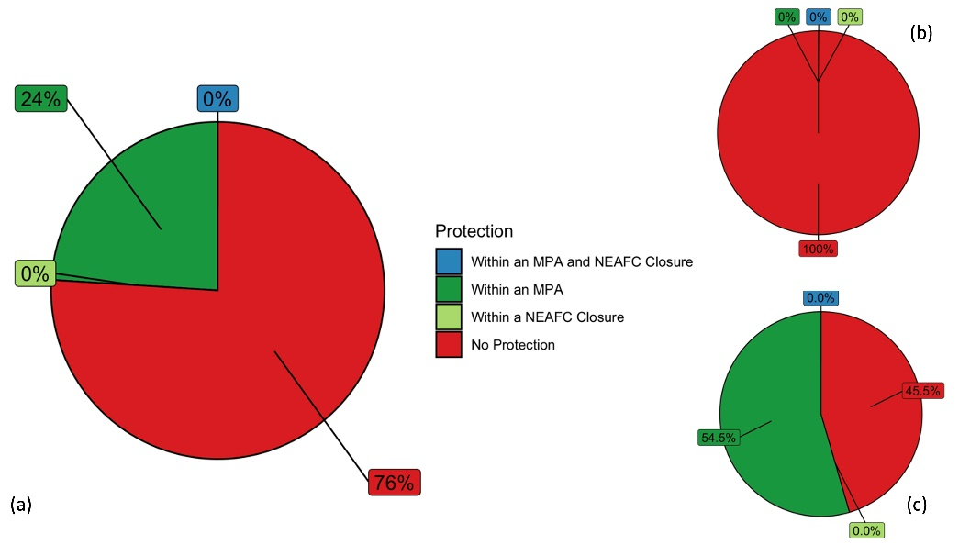  Figure 2 Proportion of Oceanic ridge with hydrothermal vents within an OSPAR Marine Protected Area and/or NEAFC Closure (a) OSPAR Region ; (b) OSPAR Region I; (c) OSPAR Region V.  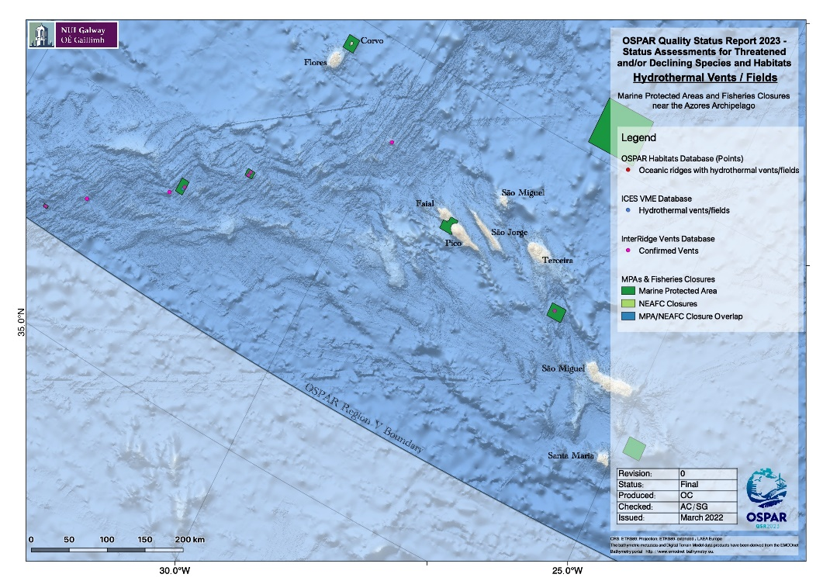  Figure 3 Location of MPAs in relation to hydrothermal vents in the Azores  Repeat monitoring of known oceanic ridges with hydrothermal vents is essential for future assessment of the condition of this habitat. At present in Region V an uncabled observing system at Lucky Strike hydrothermal vent field (EMSO-Azores) was first deployed in 2010. In Region I, the University of Bergen will deploy a permanent observatory (EMSO-Mohn) in 2022 at one of the deep vent fields. It will have several modules to measure abiotic and biotic parameters continuously at least until 2025  Method of assessment: 3c
Threats and impacts  - 100 words | Key threats to oceanic ridges with hydrothermal vents in the QSR 2010 were fishing, particularly demersal trawling and long lining, and habitat damage (QSR 2010). Climate change, ocean acidification, marine litter, deep-seabed mining, were not identified in 2010, but pose additional threats.  Fishing  Not all the identified hydrothermal vents are at fishable depths, and some of the identified areas are under protection.  Analysis of the overlap of global fishing watch data on bottom trawling with oceanic ridges with hydrothermal vent habitat records suggests there has been little change in the overall impact of fishing on the habitat since 2016, when Regulation EU 2016/2336 was adopted.  Assessment of fishing pressure using Global Fishing Watch data focussed only on demersal trawling. There was no assessment of impacts from long lining at the regional level.  Pressure from fishing on this habitat appears to remain steady in Region V or slightly improving due to conservation measures in Region I.  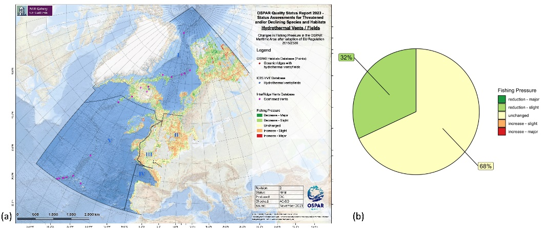  Figure 4 (a) Relative change in fishing pressure across OSPAR Region after introduction of EU regulation 2016/2336 and (b) change in fishing pressure in those cells known to contain oceanic ridges with hydrothermal vents  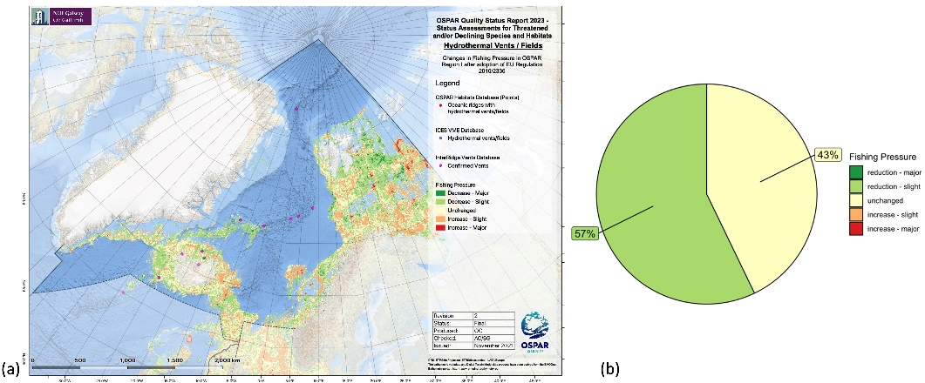  Figure 5 (a) Relative change in fishing pressure across OSPAR Region I after introduction of EU regulation 2016/2336 and (b) change in fishing pressure in those cells known to contain oceanic ridges with hydrothermal vents  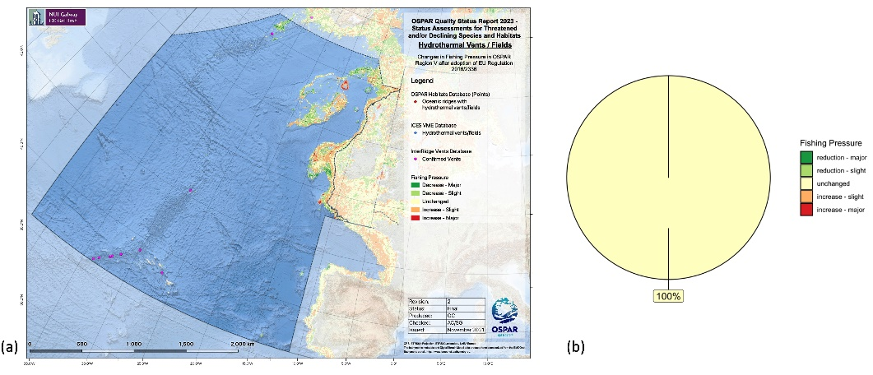  Figure 6 (a) Relative change in fishing pressure across OSPAR Region V after introduction of EU regulation 2016/2336 and (b) change in fishing pressure in those cells known to contain oceanic ridges with hydrothermal vents  Climate change  Although all OSPAR Regions are affected by climate stressors, ocean acidification, temperature increase, changes in POC flux, and in dissolved oxygen, the contemporary and immediate future impacts on oceanic ridges with hydrothermal vents are difficult to quantify. Scientific literature showed that contemporary climate velocities (1955 to 2005) were faster in the deep sea than at the surface. The same authors reported that projected climate velocities in the near future (2050 to 2100) will be faster at all depth layers with the exception of the surface. The different regions of the North Atlantic are predicted to experience impact differently. Whilst adult vent organisms are adapted to oscillations and variable low pH, high temperature and low oxygen of the vent fluids, it is not known if species are adapted to permanent change of environmental variables. To what degree and if vent larvae that disperse via ocean currents are adapted to changes in pH, temperature and oxygen of the ocean, is unknown. Changes induced by climate stressors, such as for example changes in circulation due to the slowdown of the Atlantic Meridional Overtunig Circulation (AMOC), can impact connectivity at regional scales and even may increase the risk of species extinction, especially due to the fragmented nature of these environments, and the planktonic nature of many vent species.  Potential future key-pressures include Deep-seabed mining and Litter. Currently there is no commercial deep-seabed mining within the OSPAR Maritime Area but, under the Seabed Minerals Act, the Norwegian government has initiated an opening process for offshore mineral activity, including an impact study (EIHA (WP) 21/01/02-Add.5Rev1). The opening process may lead to licenses being issued for mineral exploration as of mid-2023.
Measures that address key pressures from human activities or conserve the species/habitat  - 100 words | - OSPAR measures:  Since 2010, 34 MPAs encompassing deep-sea areas have been designated. These encompass important deep-sea habitat topographic elements such as mid-ocean ridge and fracture zones (Charlie-Gibbs North and South, and Mid Atlantic Ridge North of the Azores High Seas MPAs), and four hydrothermal vent fields (Menez Gwen, Lucky Strike , D. João de Castro, and the water column above Rainbow hydrothermal vent field) in Region V. None of the vent fields in Region I currently has OSPAR measures.  Despite the existing MPAs and NEAFC closure areas, 76% of active hydrothermal vents remain unprotected, with considerable variability across Region I and V. The proportion of records under protection (by one or both measures) varies between 0% in Region I and 54% in Region V. However, these values do not account for other protective actions taken beyond the scope of the OSPAR/NEAFC measures.  (ii) Actions taken beyond the scope of the OSPAR measures  In 2006, the United Nations General Assembly called upon States to take action through Regional Fisheries Management Organisations (RFMOs) to, inter alia, protect vulnerable marine ecosystems (VMEs) from destructive fishing practices and prevent significant adverse impacts (SAIs) (UNGA Resolution 61/105). VMEs and SAIs are further defined in FAO (2009) and VMEs include the OSPAR habitats deep-sea sponge aggregations, coral gardens, cold-water coral reefs, seamounts and hydrothermal vents/fields.  Within the North East Atlantic Fisheries Commission (NEAFC) Regulatory Area, measures to protect VMEs include the implementation of bottom fishing closure areas and the use of “move-on” rules for fishing vessels, related to encounters of specific quantities of VME indicators within by-catch from bottom-contacting gears.  Within EU waters, Regulation (EU) 2016/2336 restricts bottom fishing >400 m to the 2009 to 2011 fishing footprint, prohibits bottom fishing >400 m where VMEs are known or likely to occur (through designation of VME closures) and places a complete ban on bottom trawling deeper than 800 m. Within UK waters, regulation (EU) 2016/2336 is transposed into the Common Fisheries Policy and Aquaculture (Amendment etc.) (EU Exit Regulations 2019), with the same fishing restrictions and prohibitions in place. Council regulation no. 1568/2005 established a ban on the use of bottom-contacting gears (gillnet, entangling and trammel nets, bottom trawl or similar towed nets) at depths below 200 m in certain areas of the Atlantic Ocean including the Azores archipelago (Region V).  In Portugal, since 2016, the Marine Park of the Azores which is currently constituted by 17 MPAs, covers an area of approximately 246 000 km² (Decreto Legislativo Regional n.º 28/2011/A, modified by the Decreto Legislativo Regional n.º 13/2016/A and Portaria Portaria n.º 68/2019)  In Norway, none of the hydrothermal vent fields are protected by law. In Norwegian waters, Regulation 2011/755 restricts fishing with bottom gear on vulnerable benthic habitats in areas deeper than 1 000 m in the Norwegian Economic zone, including the Fisheries Protection Zone near Svalbard, and the Fisheries Zone around Jan Mayen.  In Iceland, the Strýtan and Arnarnesstrýturnar hydrothermal vent sites are protected from fishing activities cf. regulation no. 249/2001. All bottom trawling is prohibited on the Steinahóll vent field and within the fjord Eyjafjörður but bottom trawling for shrimp is allowed at the Grímsey and Kolbeinsey vent locations with data on fishing activities indicating regular trawling on or close to the Grímsey vent field. At present there is ongoing policy work on protecting Steinahóll from all bottom-fishing activities and preparations are being made to request for increased protection for the Grímsey and Kolbeinsey vent sites.
Conclusion (including management considerations)  - 250 words | The overall condition of oceanic ridges with hydrothermal vents is considered to be stable or improving with regard to fishing impact across all OSPAR Regions. Impacts from climate change are difficult to assess but presumed to become detrimental in the future, alongside with other emerging pressures such as potential future deep-seabed mining.  Oceanic ridges with hydrothermal vent fields continue to meet the Texel-Faial criteria, and new research further emphasises their regional and global importance.  High scientific knowledge on fundamental ecological processes at active vents gives high confidence that active vents are of high regional importance, are rare and sensitive.  Vent fields host small, island-like ecosystems with unique biotic and abiotic features. Given the very small and discrete areas they inhabit, vent-endemic species are globally rare. All active hydrothermal vents support primary production by microorganisms, serve as discrete feeding areas, and are essential for the growth, survival, reproduction, and persistence of vent endemic species. All active vent fields are fragile ecosystems that are geographically isolated and discrete, hosting populations of benthic invertebrate species that rely on dispersal through pelagic larval stages for maintenance of populations and genetic connectivity. Habitat degradation and fragmentation due to anthropogenic disturbance may result in local loss of biodiversity and ecosystem services. Connectivity among metapopulations of species is characterized by source-sink dynamics, making these systems sensitive to reduction or loss of source populations, with ecological consequences on the structure and function of metacommunities.  Various area-based management tools (OSPAR MPAs) and other effective conservation measures (NEAFC closures) have been developed, but these are only located in Region V, whereas all of the habitat that occurs within Region I is unprotected by OSPAR/NEAFC measures. Increased protection in Region I is desirable. In Region V, the new MPA’s from the Azores Marine Park give an additional protection to this habitat in water under portuguese jurisdiction. However the only deep-sea hydrothermal vent field situated at the MidAtlantic Ridge north of the Azores remains unprotected.  Status reassessments should be performed on a mid-term cycle (six years) to allow for substantial new data to be collected and changes in condition to be noticeable. The discovery of new vent fields is expected and the potential start of mineral exploration in Region I is planned for 2023.  Coastal active vent fields have been excluded from this assessment, as those are typically a secondary manifestation of volcanism, and fauna is typically a subset of fauna present in the vent-surroundings. Oceanic ridges with hydrothermal vents were proposed as a A6 Eunis habitat, which means deep-sea hydrothermal vents. However, coastal vents are very little studied. Contracting Parties may wish to consider assessing the habitat against the Texel-Faial criteria with a view to nominating it for inclusion on the OSPAR list of threatening and declining habitats.  Inactive vents were not considered in this assessment, as they fall outside the scope of definition of the 2010 background document. However, inactive vents are geographically located very close to active vents, within the same vent field, and will face similar threats as active vents. Contracting Parties may wish to consider assessing the habitat against the Texel-Faial criteria with a view to nominating it for inclusion on the OSPAR list of threatening and declining habitats.  The chemosynthetic environment “cold seeps” are not assessed against Texel-Faial criteria. This habitat occurs in several margins at the OSPAR Maritime Area and is an important and localized habitat, with endemic fauna, and in some cases under threat of climate change or of future gas hydrate exploration. Contracting Parties may wish to consider assessing the habitat against the Texel-Faial criteria with a view to nominating it for inclusion on the OSPAR list of threatening and declining habitats.
Knowledge gaps (brief)  - 100 words | Given the remote location and high costs to access hydrothermal vent fields (requiring usage of remotely operated vehicles or small submersibles), most data is point data - from a few locations at one time point. Multiple sampling operations at multiple times (monitoring) would be needed to address knowledge gaps of biodiversity, connectivity, life histories (including for example reproduction and growth rates), function and resilience of communities to disturbance and change (e.g. fishing, climate change, potential future deep-seabed mining). Only for few vent fields ia such data (partly) available or currently researched. There is a trend of deeper vent fields having more endemic species compared to shallower vent fields. Underlying reasons for this trend is not known. A comparison between the OSPAR active vent fields is currently not possible.
References | Barreyre, T., Fer, I. and Ferré, B., 2020, May. The Norwegian node for the European Multidisciplinary Seafloor and water column Observatory. In EGU General Assembly Conference Abstracts (p. 7248).  Beaulieu, S.E., Szafranski, K. (2020) InterRidge Global Database of Active Submarine Hydrothermal Vent Fields, Version 3.4. World Wide Web electronic publication available from http://vents-data.interridge.org Accessed 2021-01-22.  Boschen-Rose RE and Colaço A (2021) Northern Mid-Atlantic Ridge Hydrothermal Habitats: A Systematic Review of Knowledge Status for Environmental Management. Front. Mar. Sci. 8:657358. doi: 10.3389/fmars.2021.657358  Breusing C, Biastoch A, Drews A, Metaxas A, Jollivet D, Vrijenhoek RC, Bayer T, Melzner F, Sayavedra L, Petersen JM, Dubilier N, Schilhabel MB, Rosenstiel P, Reusch TBH (2016) Biophysical and Population Genetic Models Predict the Presence of “Phantom” Stepping Stones Connecting Mid-Atlantic Ridge Vent Ecosystems. Curr Biol 26:2257–2267  Brito-Morales, I., Schoeman, D.S., Molinos, J.G., Burrows, M.T., Klein, C.J., Arafeh-Dalmau, N., Kaschner, K., Garilao, C., Kesner-Reyes, K. and Richardson, A.J., 2020. Climate velocity reveals increasing exposure of deep-ocean biodiversity to future warming. Nature Climate Change, 10(6), pp.576-581.  Colaço, A.; Cannat, M.; Blandin, J.; Sarradin, P.M. (2011) A technological challenge to monitor in real time Lucky Strike hydrothermal vent field. ICES Journal of Marine Science, 68(2): 416-424.  Colaço, A.; Desbruyères, D.; Comtet, T.; Allayse, A.-M. (1998) Ecology of the Menez Gwen hydrothermal field (Mid-Atlantic Ridge/Azores Triple Junction). Cahiers de Biologie Marine, 3-4(39): 237-240  Cuvelier, D., Sarrazin, J., Colaço, A., Copley, J., Glover, A., Tyler, P., et al. (2011b). Community dynamics over 14 years at the Eiffel Tower hydrothermal edifice on the Mid-Atlantic Ridge. Limnol. Oceanogr. 56, 1624–1640. doi: 10.4319/lo.2011.56.5.1624  Desbruyères, D.; Biscoito, M.; Caprais, J.-C.; Comtet, T.; Colaço, A.; Crassous, P.; Fouquet, Y.; Khripounoff, A.; Le Bris, N.; Olu, K.; Riso, R.; Sarradin, P.-M.; Vangriesheim, A. (2001) Variations in deep-sea hydrothermal vent communities on the mid-Atlantic Ridge when approaching the Azores Plateau. Deep-Sea Research I, 48(5): 1325-1346.  Fricke, H., Giere, O., Stetter, K., Alfredsson, G. A., Kristjansson, J. K., Stoffers, P., & Svavarsson, J. (1989). Hydrothermal vent communities at the shallow subpolar Mid-Atlantic ridge. Marine Biology, 102(3), 425–429. https://doi.org/10.1007/BF00428495  Gollner, S., Colaço, A., Gebruk, A., Halpin, P.N., Higgs, N., Menini, E., Mestre, N.C., Qian, P.Y., Sarrazin, J., Szafranski, K., Van Dover, C.L., (2021). Application of scientific criteria for identifying hydrothermal ecosystems in need of protection. Marine Policy 132, 104641.  Hannington, M., Herzig, P., Stoffers, P., Scholten, J., Botz, R., Garbe-Schönberg, D., Jonasson, I., Roest, W., Becker, K.P., Blascheck, H., Hauzel, B., Hissmann, K., Huber, R., Kristjansson, J.K., Krüger, O., Marteinsson, V., Petursdottir, S., Schauer, J., Schmidt, M., Zimmerer, M., 2001. First observations of high-temperature submarine hydrothermal vents and massive anhydrite deposits off the north coast of Iceland. Marine Geology - MAR GEOLOGY 177, 199-220.  Kongsrud, J. A., & Rapp, H. T. (2012). Nicomache (Loxochona) lokii sp. nov. (Annelida: Polychaeta: Maldanidae) from the Loki’s Castle vent field: An important structure builder in an Arctic vent system. Polar Biology, 35(2), 161–170. https://doi.org/10.1007/s00300-011-1048-4  Legrand, J., Sarradin, P.M. and Cannat, M., 2019, April. EMSO Azores Deep-sea Observatory: 9 years of operations. In EGU General Assembly 2019. 7-12 April 2019, Vienna..  Marticorena, J., Matabos, M., Ramirez-Llodra, E., Cathalot, C., Laes-Huon, A., Leroux, R., et al. (2021). Recovery of hydrothermal vent communities in response to an induced disturbance at the Lucky Strike vent field (Mid-Atlantic Ridge). Mar. Env. Res. 168:105316. doi: 10.1016/j.marenvres.2021.105316  Menini, E., Van Dover, C.L. (2019), An atlas of protected hydrothermal vents, Mar. Policy 108 , 103654.  Pedersen, Rolf B., Rapp, H. T., Thorseth, I. H., Lilley, M. D., Barriga, F. J. A. S., Baumberger, T., Flesland, K., Fonseca, R., Früh-Green, G. L., & Jorgensen, S. L. (2010). Discovery of a black smoker vent field and vent fauna at the Arctic Mid-Ocean Ridge. Nature Communications, 1(8). https://doi.org/10.1038/ncomms1124  Pedersen, R.B, et al. (2021). Fagutredning mineralressurser in norskehavet landskapstrekk, naturtyper og bentiske økosystemer. Rapport utarbeidet av Universitetet i Bergen til Olje- og energidepartementet.  Puerta, P., Johnson, C., Carreiro-Silva, M., Henry, L.-A., Kenchington, E., Morato, T., Kazanidis, G., Rueda, J.L., Urra, J., Ross, S., Wei, C.-L., González-Irusta, J.M., Arnaud-Haond, S.,Orejas, C. (2020) Influence of Water Masses on the Biodiversity and Biogeography of Deep-Sea Benthic Ecosystems in the North Atlantic. Front. Mar. Sci. 7:239. doi: 10.3389/fmars.2020.00239  Ramirez-Llodra, E., Shank, T. M., & German, C. R. (2007). Biodiversity and biogeography of hydrothermal vent species: Thirty years of discovery and investigations. Oceanography, 20(SPL.ISS. 1), 30–41. https://doi.org/10.5670/oceanog.2007.78  Stanulla, R., Stanulla, C., Bogason, E., Pohl, T., & Merkel, B. (2017). Structural, geochemical, and mineralogical investigation of active hydrothermal fluid discharges at Strýtan hydrothermal chimney, Akureyri Bay, Eyjafjörður region, Iceland. Geothermal Energy, 5(1). https://doi.org/10.1186/s40517-017-0065-0  Tarasov, V. G., Gebruk, A. v., Mironov, A. N., & Moskalev, L. I. (2005). Deep-sea and shallow-water hydrothermal vent communities: Two different phenomena? Chemical Geology, 224(1–3), 5–39. https://doi.org/10.1016/j.chemgeo.2005.07.021  Taylor, J., Devey, C., Le Saout, M., Petersen, S., Kwasnitschka, T., Frutos, I., Linse, K., Lörz, A.-N., Pałgan, D., Tandberg, A.H., Svavarsson, J., Thorhallsson, D., Tomkowicz, A., Egilsdóttir, H., Ragnarsson, S.Á., Renz, J., Markhaseva, E.L., Gollner, S., Paulus, E., Kongsrud, J., Beermann, J., Kocot, K.M., Meißner, K., Bartholomä, A., Hoffman, L., Vannier, P., Marteinsson, V.Þ., Rapp, H.T., Díaz-Agras, G., Tato, R., Brix, S., 2021. The Discovery and Preliminary Geological and Faunal Descriptions of Three New Steinahóll Vent Sites, Reykjanes Ridge, Iceland. Frontiers in Marine Science 8.  Van Dover, C.L., Arnaud-Haond, S., Gianni, M., Helmreich, S., Huber, J.A., Jaeckel, A.L., Metaxas, A., Pendleton, L.H., Petersen, S., Ramirez-Llodra, E. and Steinberg, P.E., 2018. Scientific rationale and international obligations for protection of active hydrothermal vent ecosystems from deep-sea mining. Marine Policy, 90, pp.20-28.  Wheeler, A.J., Murton, B., Copley, J., Lim, A., Carlsson, J., Collins, P., Dorschel, B., Green, D., Judge, M., Nye, V. and Benzie, J., 2013. Moytirra: Discovery of the first known deep‐sea hydrothermal vent field on the slow‐spreading Mid‐Atlantic Ridge north of the Azores. Geochemistry, Geophysics, Geosystems, 14(10), pp.4170-4184.
AUDIT TRAIL  Optional.  No word limit  Archived | Additional Evidence and Information  Please insert below any relevant additional evidence and information that provides essential background and rationale to the assessments above. Include citations of the sources of evidence and information and provide full references in the relevant section below  The audit trail is not published as part of the assessment. It is archived for future reference purposes. The assessment in the rows above needs to be written so that it can be read without accessing information in the audit trail.
Assessment methods  (additional information, in particular how the overall assessment in the summary table was reached) | Assessed as part of a group of deep-sea habitat assessments led by Ireland, chaired by Louise Allcock (National University of Ireland Galway, Ireland). Oceanic ridges and hydrothermal vent habitat assessment by Ana Colaço (Universidade dos Açores, Portugal; habitat lead), Sabine Gollner (Royal Netherlands Institute for Sea Research, Netherlands), Hrönn Egilsdóttir (Marine and Freshwater Research Institute, Iceland), Pedro Ribeiro (University of Bergen, Norway), with further contributions from the participants of the OSPAR deep-sea habitat assessment workshop, held online 6 to 8 September 2021. GIS analyses by Oisín Callery (NUI Galway, Ireland) and Anthony Grehan (NUI Galway, Ireland). Marjolaine Matabos (IFREMER) commented on the completed draft.
Geographical range and distribution (additional evidence & information) | Geographic range and distribution information was drawn from the following sources: (1) The ICES VME database (public and restricted data with permission) accessed August 2021; (2) OSPAR Threatened or Declining Habitats Database v2020, point records published 2021-07-12, polygon records published 2021-06-30 (3) Interridge data base ver 3.4  Bathymetric data for the OSPAR area were extracted from the GEBCO_2021 Grid obtained from the GEBCO website. This is a global terrain model compiled using data from various sources to provide full global coverage for ocean and land at a resolution of 15 arc-seconds.  Spatial data layers delineating the boundaries of the OSPAR Maritime Area and its Regions were downloaded from ODIMS.  All point and polygon data were reprojected from their native coordinate reference systems (usually WGS 84, EPSG:4326) to the ETRS89-LAEA Europe coordinate reference system (EPSG:3035)  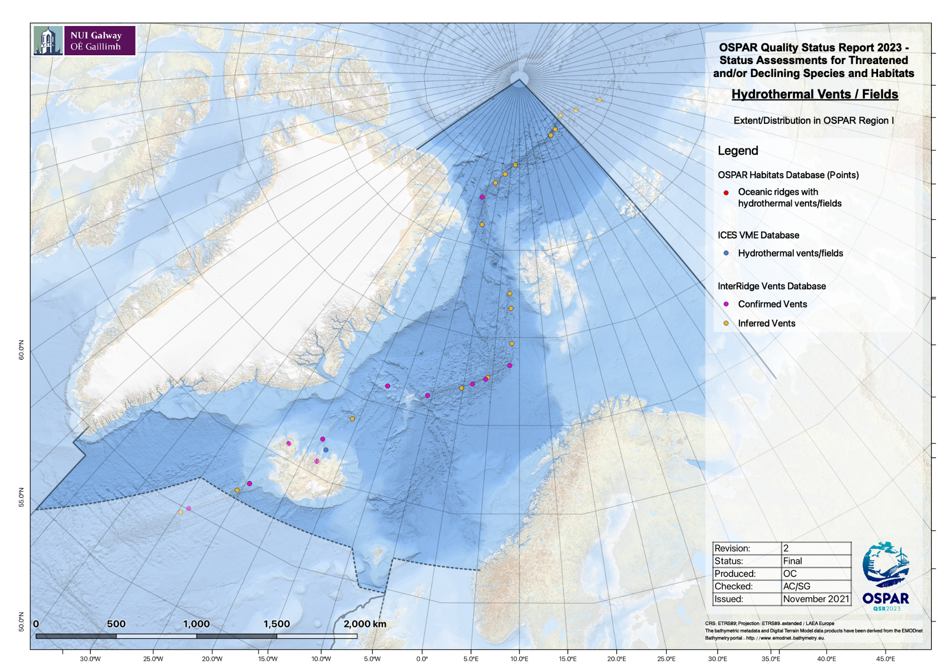  Figure 4 Distribution of known oceanic ridges with hydrothermal vents in OSPAR Region I, and occurrence of inferred ones that might be indicative of hydrothermal vent presence. .  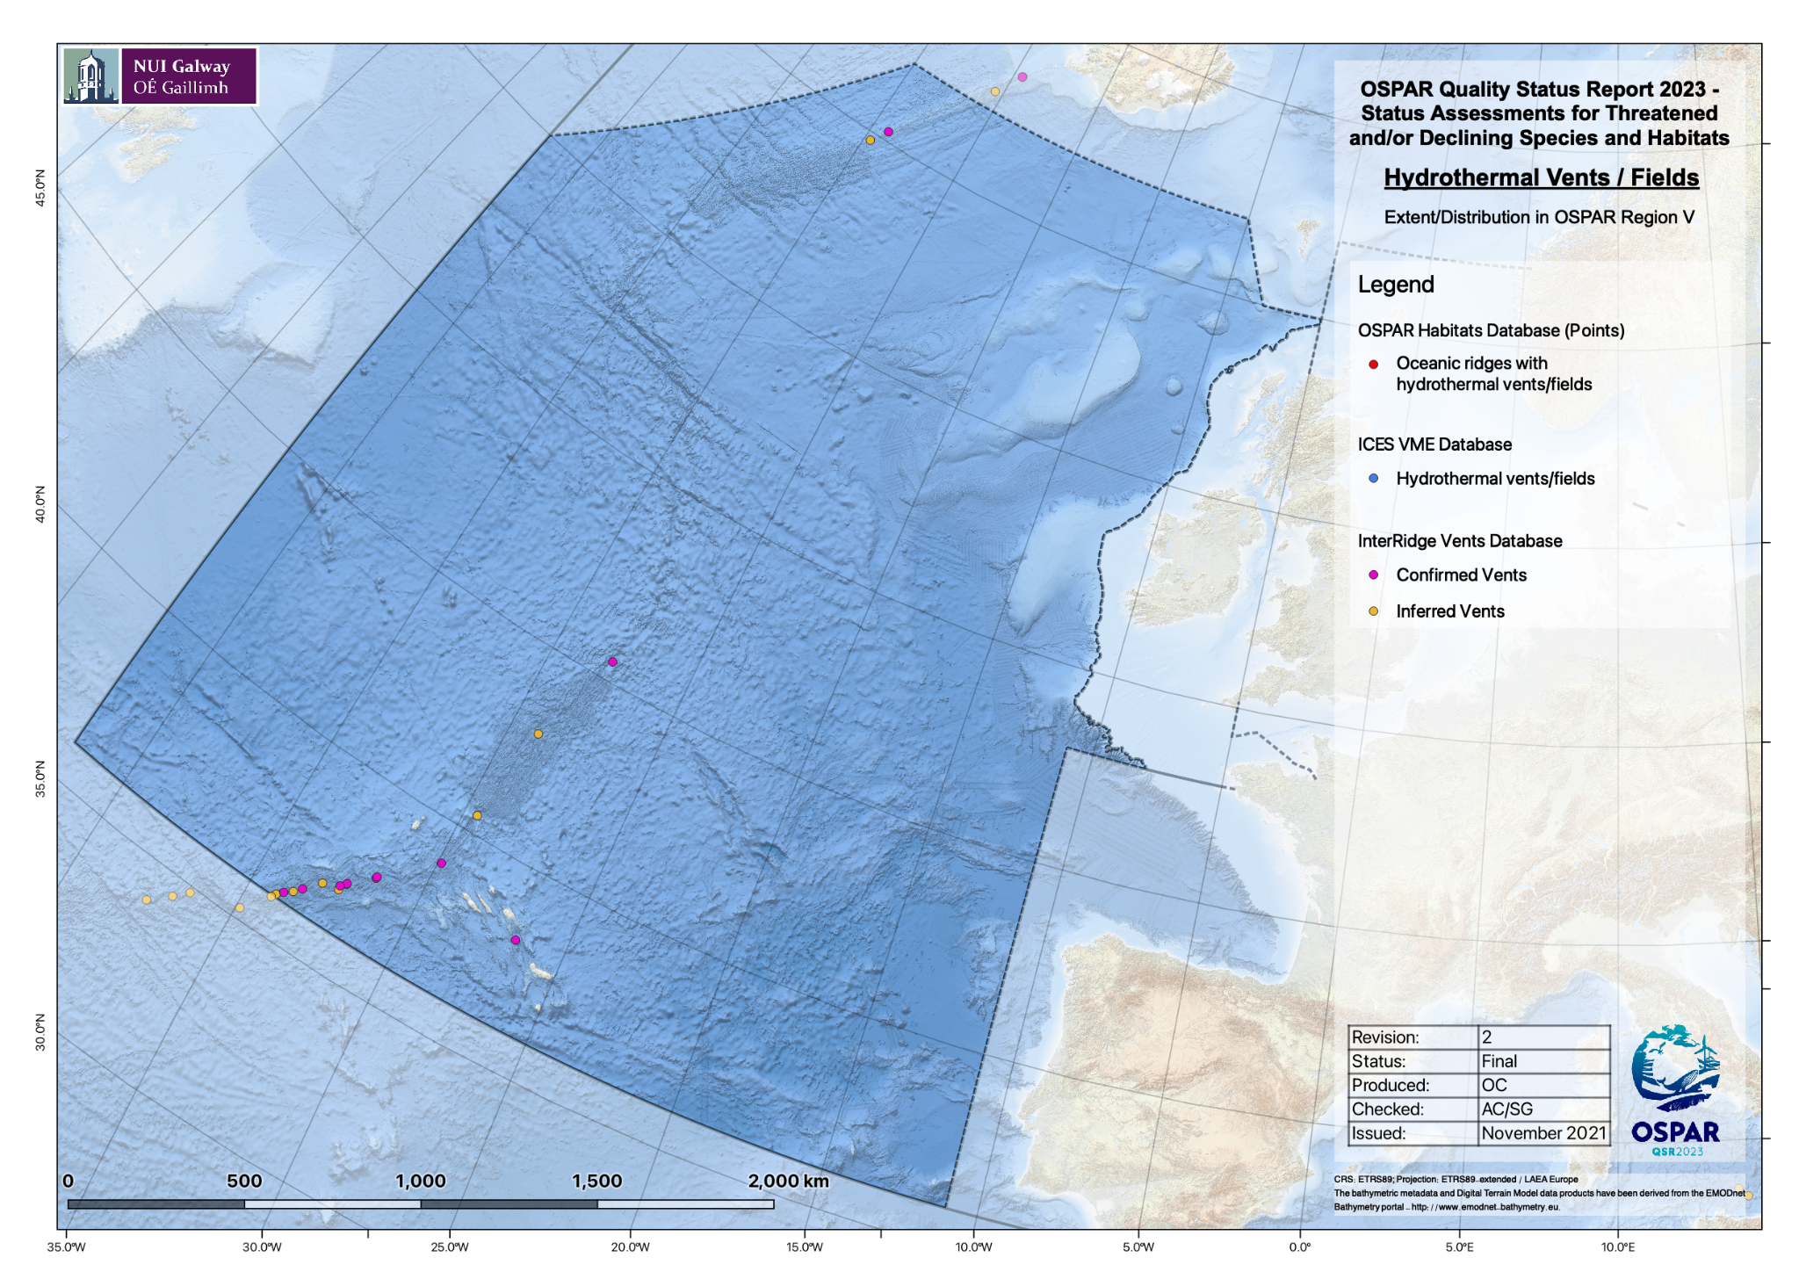  Figure 5 Distribution of known oceanic ridges with hydrothermal vents in OSPAR Region V, and occurrence of inferred ones that might be indicative of hydrothermal vent presence.  References  ICES VME Database:  https://vme.ices.dk/download.aspx  OSPAR Threatened or Declining Habitats Database v2020:  https://www.emodnet-seabedhabitats.eu  Interridge database ver 3.4  https://vents-data.interridge.org/
Population/abundance (species)  (additional evidence & information) | NA
Condition  (additional evidence & information) | Condition assessment was based on fisheries data, MPA/NEAFC closure presence and time series and recovery literature available for the vent fields at OSPAR area.  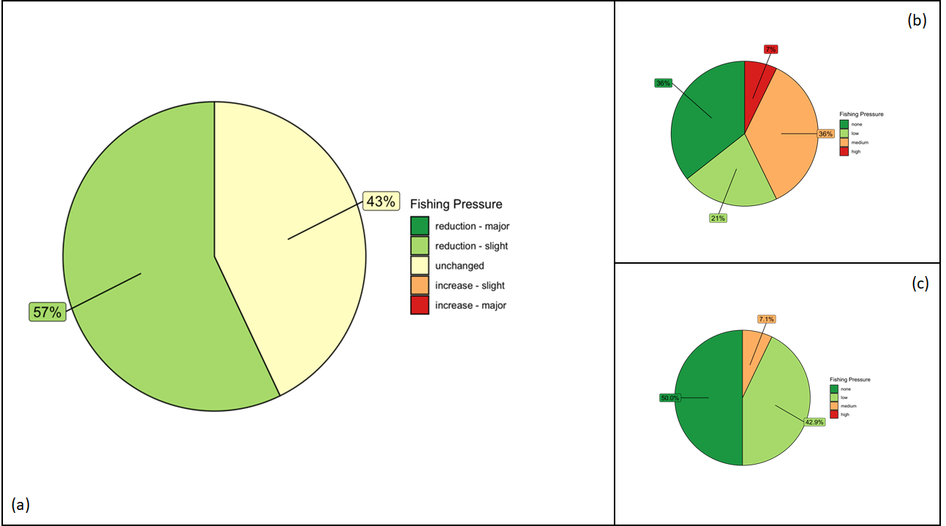  Figure 6 Fishing pressure in OSPAR region I (a) Changes in fishing pressure since the introduction of Regulation EU 2016/2336 in grid cells that contain oceanic ridges with hydrothermal vent habitat.; (b) Relative fishing pressure prior to the introduction of Regulation EU 2016/2336 in grid cells that contain oceanic ridges with hydrothermal vent habitat; (c) Relative fishing pressure after the introduction of Regulation EU 2016/2336 in grid cells that containoceanic ridges with hydrothermal vent habitat.  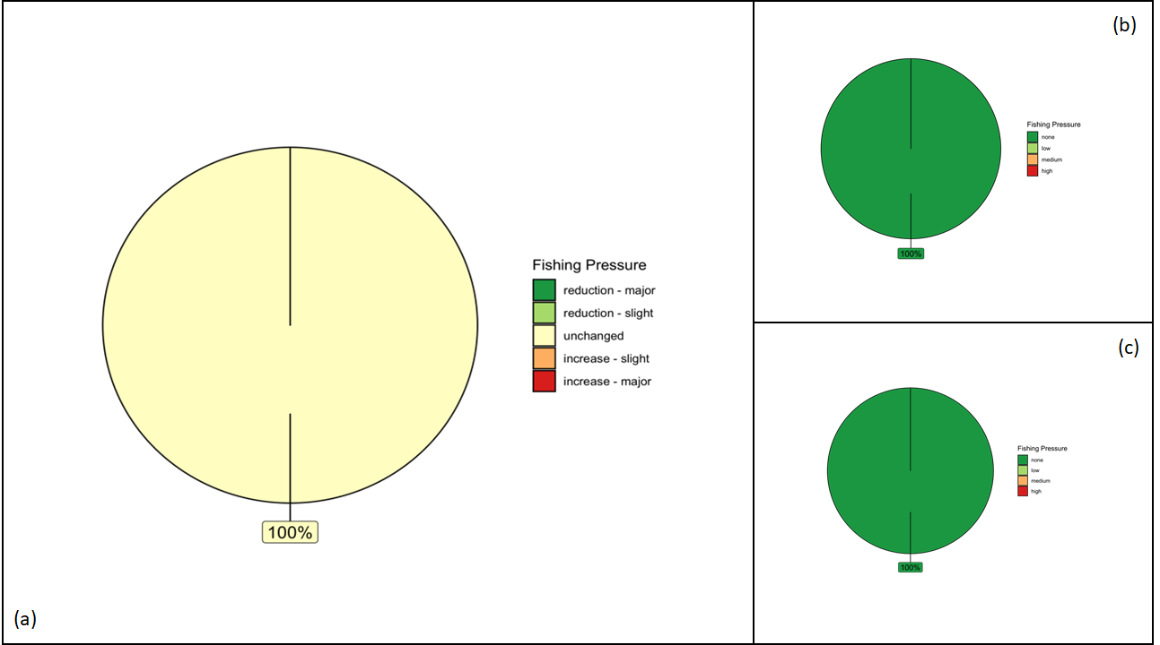  Figure 7 Fishing pressure in OSPAR region V (a) Changes in fishing pressure since the introduction of Regulation EU 2016/2336 in grid cells that contain oceanic ridges with hydrothermal vent habitat.; (b) Relative fishing pressure prior to the introduction of Regulation EU 2016/2336 in grid cells that contain oceanic ridges with hydrothermal vent habitat; (c) Relative fishing pressure after the introduction of Regulation EU 2016/2336 in grid cells that contain oceanic ridges with hydrothermal vent habitat.  For analysis of overlap of ocean ridges with hydrothermal vents with OSPAR Marine Protected Areas and NEAFC Closures, the OSPAR Marine Protected Areas Network (2021-07-16) was accessed from ODIMS (ODIMS, https://odims.ospar.org/en), and a layer of NEAFC Closures obtained from (https://www.neafc.org).  The analysis included the OSPAR, Ices database and Interidge database, corrected to only those hydrothermal vents that were stated as confirmed on the Interidge databases, and not the inferred ones due to the uncertainty of their presence.  All point and polygon data were reprojected from their native coordinate reference systems (usually WGS 84, EPSG:4326) to the ETRS89-LAEA Europe coordinate reference system (EPSG:3035). To analyze the overlap between MPAs and known habitat occurrences, a simple spatial overlay was conducted in R. For the MPA analyses it was determined whether each habitat point datum was (i) within an MPA, (ii) within a NEAFC closure, (iii) within an overlap between both an MPA and a NEAFC closure, or (iv) outside a protected area. The results of these analyses were used to produce pie charts summarizing the percentage of habitat occurrences in each of the aforementioned four categories.  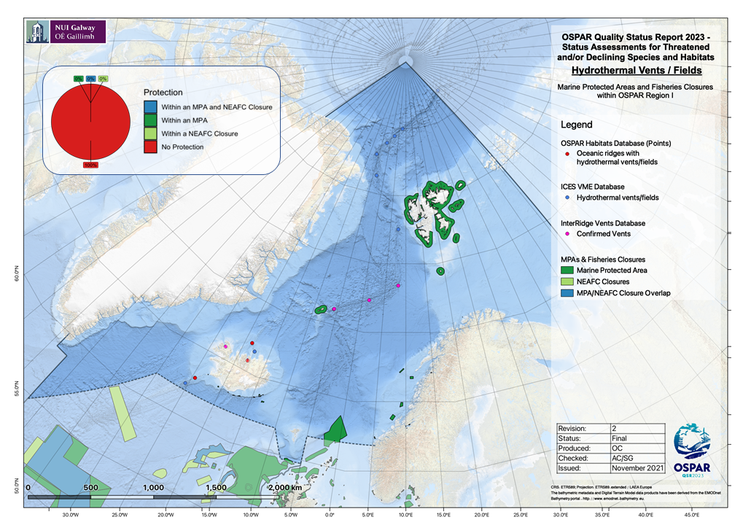  Figure 8 Proportion of oceanic ridges with hydrothermal vent habitat that occur within an OSPAR Marine Protected Area or NEAFC Closure in OSPAR Region I.  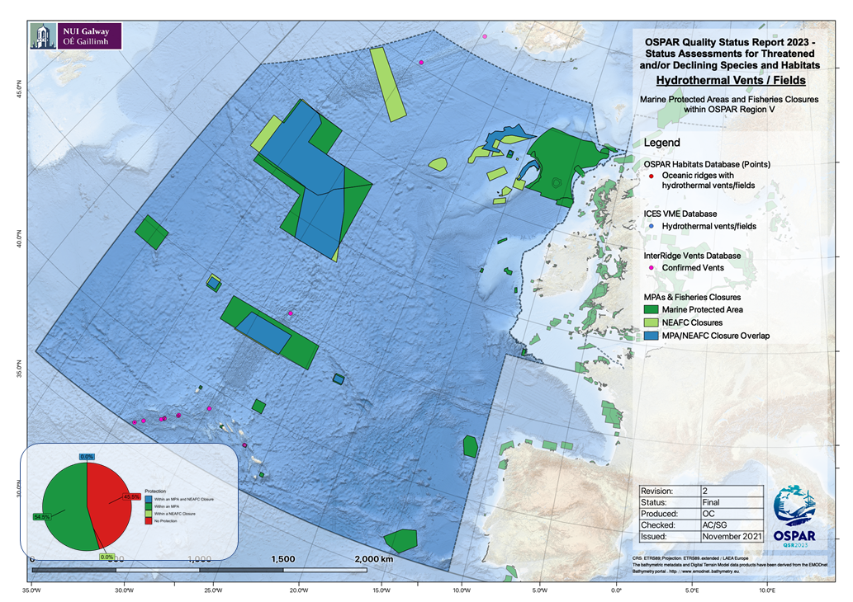  Figure 8 Proportion of oceanic ridges with hydrothermal vent habitat that occur within an OSPAR Marine Protected Area or NEAFC Closure in OSPAR Region V.
Threats and impacts  (additional evidence & information) | Regulation EU 2016/2336, restricts deep-sea fishing to areas already fished in the past, bans trawling below 800m depth, and requires closure of bottom fishing below 400 m in areas with vulnerable marine ecosystems. However, VME closures have not yet been put in place. Global Fishing Watch data were analysed to determine any change in the overlap of fishing on oceanic ridges with hydrothermal vents since the adoption of the Regulations in 2016.  Fishing Effort data processing  Assessment of fishing pressure using Global Fishing Watch data focussed only on demersal trawling. There was no assessment of impacts from long lining at the regional level.  Spatial data layers of apparent fishing effort based on automatic identification system (AIS) transmissions were prepared using data downloaded from the Global Fishing Watch website (www.globalfishingwatch.org). The data provided by Global Fishing Watch (GFW) are produced by running AIS data through two convolutional neural networks: (i) a “vessel characterisation” model which identifies and classifies fishing vessels, and (ii) a “fishing detection” model which predicts when these vessels are fishing and when they are in non-fishing positions (e.g. transiting, in port etc.).  The “vessel characterisation” model identifies fishing vessels using a comprehensive database of vessel registry information and also outputs predictions of fishing gear types and vessel sizes allowing for separation of different fishing activities (e.g. trawling, longlining, etc.). The “fishing detection” model identifies when vessels are fishing based on vessel movements and other parameters such as distance to shore and bathymetry. For this analysis, only fishing activity identified by GFW as “trawling” was considered. Detailed information on these models can be found in the supplementary materials of GFW’s Science paper (Kroodsma et al., 2018).  With fishing vessels and fishing activity identified, the sum of the fishing hours for all fishing vessels in an area can be computed to produce maps of apparent fishing activity across a range of fishing gear types. These outputs are gridded at a resolution of 0.01°x0.01° and are provided by GFW in CSV format (see the accompanying R-script for “rasterizing” GFW CSV data).  There are a number of important limitations and caveats associated with using AIS data to monitor fishing activity:  1) Only a small fraction of fishing vessels use AIS, with coverage being higher for larger vessels, however, such vessels (i.e. those with AIS) do account for a large proportion of fishing effort beyond 100 nautical miles from land (up to ~70% (Kroodsma et al., 2018)).  2) AIS reception is affected by numerous factors including satellite coverage, interference from other vessels’ transmissions, and the strength and frequency of the AIS broadcast.  3) The number of vessels transmitting AIS data has increased year-on-year since GFW began their analyses (2012) and, when comparing data from one time period to data from another, it is difficult to differentiate between increases in AIS availability and actual increases in the intensity of fishing activity.  4) It is not possible to distinguish between demersal and pelagic trawling activity. To address this (in so far as possible) all trawling activity in water depths greater than 1500m was assumed to be pelagic and was therefore not considered in this assessment.  Fishing effort in each 25km2 square of the OSPAR area grid was taken to be the sum of the effort of all 0.01°x0.01° cells of the GFW dataset that were within that square. Where a cell from the GFW dataset was only partially overlapped by a 25km2 square of the OSPAR area grid, the contribution of that cell to the total fishing effort within the square was taken to be the product obtained by multiplying the fishing effort in the 0.01°x0.01° cell by the fraction of that cell covered by the square. Once the fishing effort data had been aggregated to the resolution of the 25km2 OSPAR area grid, cells with zero or very low fishing effort (taken to be values below the 5% quantile as calculated using the quantile function in R with default settings) were discarded.  As described above, one of the limitations associated with using the GFW fishing effort layers is that the amount of activity in the AIS dataset has increased each year, the result being that apparent year-on-year increases in the amount of fishing activity within a grid-square do not necessarily represent actual increases in fishing activity; such increases may simply reflect greater data availability. To allow for comparisons to be made between different time periods, annual fishing effort data within each 25km2 square were standardised in R using the empirical cumulative distribution function (ECDF). The ECDF function at any fishing effort value returns the proportion of effort values that are less than or equal to that value based on all fishing activity recorded in the OSPAR area in that year. This method identified areas of comparatively high/low fishing effort within the OSPAR region, thereby allowing for year-to-year comparisons to be made based on changes in relative annual fishing effort.  To ascertain any potential effects of Regulation (EU) 2016/2336 in 2016 – hereafter referred to as the Deep-Sea Access Regulations (DSAR) – mean fishing effort in each grid cell was calculated for the pre-DSAR period (2012-2017 inclusive), and the post-DSAR period (2018-2020 inclusive); despite the DSAR being established in 2016, there was a “cross-over” period where fishing permits already issued were still valid during 2017, and for this reason data from 2017 was included in the pre-DSAR period. Variations in fishing pressure of less than 10% were considered as no change; changes in fishing pressure between 10 and 50% were considered as minor increases or decreases; changes in fishing pressure of greater than 50% were considered as major increases or decreases. Further threats to ocean ridges with hydrothermal vents include marine litter, pollution, and deep-sea mining.  Deep-seabed mining:  Exploration contracts have been granted internationally for deep-sea mining activity, with potential threats to oceanic ridges with hydrothermal vents from physical disturbance and sediment plumes. Currently there is no commercial deep-sea mining within the OSPAR area however, under the Seabed Minerals Act, the Norwegian government has initiated an opening process for offshore mineral activity, including an impact study (EIHA (WP) 21/01/02-Add.5Rev1). Given the demand for key metals in applications such as renewable technologies, deep-sea mining is likely to increase in coming decades, but our understanding of the environmental impacts is as yet uncertain.  Marine Litter:  Litter was found to be present in deep-sea European waters. Pham et al (2014) reported the highest litter density occurring in submarine canyons, whilst the lowest density could be found on continental shelves and on ocean ridges. Plastic was the most prevalent litter item found on the seafloor. Litter from fishing activities (derelict fishing lines and nets) was particularly common on seamounts, banks, mounds and ocean ridges. Taylor et al, 2021 described lost fishing gear at a vent site.
Measures that address key pressures from human activities or conserve the species/habitat  (additional information) | Habitat distribution and MPA Overlap Analyses  For analysis of overlap of ocean ridges with hydrothermal vents with OSPAR Marine Protected Areas and NEAFC Closures, the OSPAR Marine Protected Areas Network (2021-07-16) was accessed from ODIMS (ODIMS, https://odims.ospar.org/en), and a layer of NEAFC Closures obtained from (https://www.neafc.org).  The analysis included the OSPAR, Ices data base and Interridge database, corrected to only those hydrothermal vents that were stated as confirmed on the Interridge databases, and not the inferred ones due to the uncertainty of their presence  To analyse the overlap between MPAs and known habitat occurrences, a simple spatial overlay was conducted in R. For the MPA analyses it was determined whether each habitat point datum was (i) within an MPA, (ii) within a NEAFC closure, (iii) within an overlap between both an MPA and a NEAFC closure, or (iv) outside a protected area. The results of these analyses were used to produce pie charts summarising the percentage of habitat occurrences in each of the aforementioned four categories.  Climate refugia:  Climate change refugium is a concept that gains momentum and it will be needed in the future to facilitate the survival of species under climate change conditions, and allow time for the biota to adapt to the climate change effects (Johnson et al., 2019). There are two complementary definitions: habitats that components of biodiversity retreat to, persist in, and can potentially expand from under changing environmental conditions (Keppel et al., 2012); areas relatively buffered from contemporary climate change over time that enable persistence of valued physical, ecological, and sociocultural resources (Morelli et al., 2016). Some current policies ask for identification of refugia to cold water areas, Johnson, D.E. and Kenchington, E.L., 2019 ask on their work that this should be considered for marine spatial planning and conservation measures development and applied, where appropriate, to all open ocean waters and deep sea habitats.
Knowledge gaps (additional information) | NA
References | References  Harris, P.T., Macmillan-Lawler, M., Rupp, J., Baker, E.K., 2014. Geomorphology of the oceans. Mar. Geol., 50th Anniversary Special Issue 352, 4–24.  https://doi.org/10.1016/j.margeo.2014.01.011  Kroodsma, D.A., Mayorga, J., Hochberg, T., Miller, N.A., Boerder, K., Ferretti, F., Wilson, A., Bergman, B., White, T.D., Block, B.A., Woods, P., Sullivan, B., Costello, C., Worm, B., 2018. Tracking the global footprint of fisheries. Science 359, 904–908. https://doi.org/10.1126/science.aao5646  Somoza, L., Ercilla, G., Urgorri, V., León, R., Medialdea, T., Paredes, M., Gonzalez, F.J., Nombela, M.A., 2014. Detection and mapping of cold-water coral mounds and living Lophelia reefs in the Galicia Bank, Atlantic NW Iberia margin. Mar. Geol. 349, 73–90. https://doi.org/10.1016/j.margeo.2013.12.017  Johnson, D.E. and Kenchington, E.L., 2019. Should potential for climate change refugia be mainstreamed into the criteria for describing EBSAs?. Conservation Letters, 12(4), p.e12634.  Keppel, G., Van Niel, K. P., Wardell-Johnson, G. W., Yates, C. J., Byrne, M., Mucina, L., … Franklin, S. E. (2012). Refugia: Identifying and understanding safe havens for biodiversity under climate change. Global Ecology and Biogeography, 21(4), 393– 404.  Morelli, T. L., Daly, C., Dobrowski, S. Z., Dulen, D. M., Ebersole, J. L., Jackson, S. T., … Beissinger, S. R. (2016). Managing climate change refugia for climate adaptation. PLoS ONE, 11(8), e0159909. https://doi.org/10.1371/journal.pone.0159909  Pham CK, Ramirez-Llodra E, Alt CHS, Amaro T, Bergmann M, Canals M, et al. (2014) Marine Litter Distribution and Density in European Seas, from the Shelves to Deep Basins. PLoS ONE 9(4): e95839. https://doi.org/10.1371/journal.pone.0095839

